For more information, please contact Marta de Paco
On +34 670 780 664 or email press@comunicahair.com

Important:
These images are only available for editorial content.
Credits must be included.
Notification of their publication is expected.

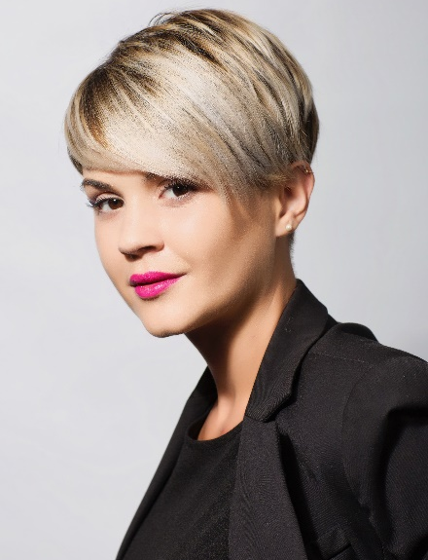
DAVINIA CUÑAT
HENKO Collection

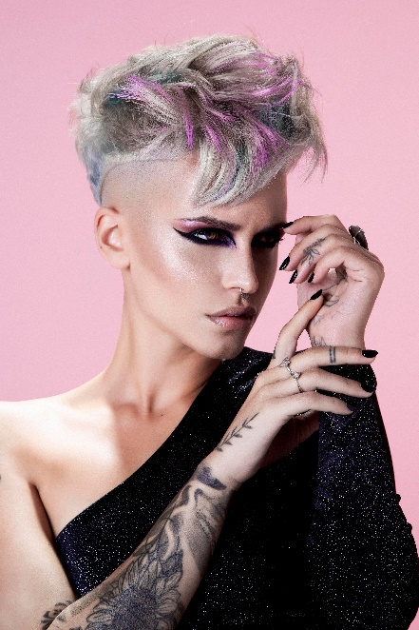
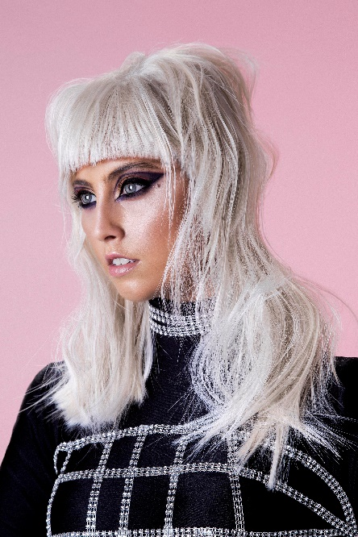
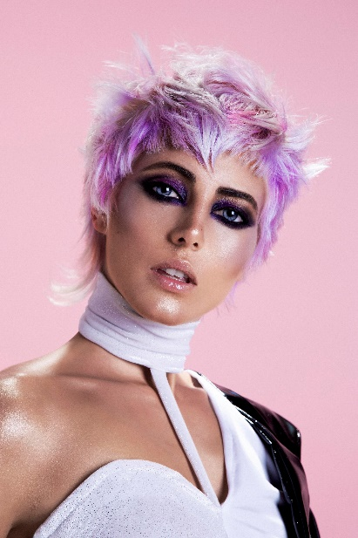
Hair: Davinia Cuñat Ripoll | @daviniacr_
Hair Instagram: @_salondebellezavanedis
Photography: Esteban Roca| @esteban_roca_photo
MUA: Cristina Garcia | @crismakeupgloss
Styling: Davinia Cuñat Ripoll | @daviniacr_
Designer: Maria Dolores Ripoll Miñana | @elatelierdeloles
Models: Carola Álvarez Gilabert @carolaalvarez19
Belén Vicente Saiz @beelen_vl3
Florencia Olivera Hernández @Floroliveraw
Rocío Torres Caro @roctocarude
Products: Revlon | @revlonprofesional_es
DAVINIA CUÑAT
HENKO Collection

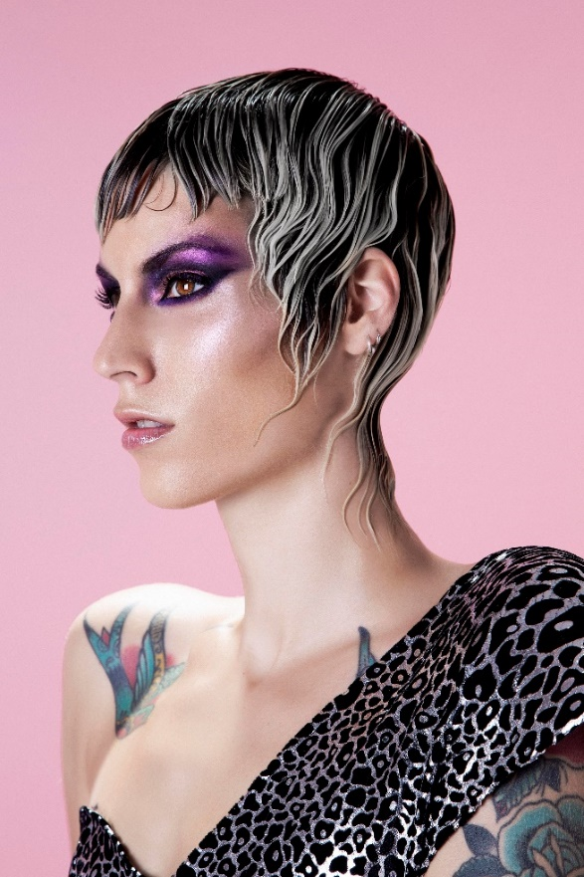

Henko is a Japanese word that refers to a transformative change in which there is no possibility of returning to the initial state. On many occasions it’s a very great advance in our personal growth and proof that we are capable of betting on ourselves, reflecting precisely this act of courage. This work speaks of that individual turning point that lifts us above fear and worries, transforming our attitude towards life. In looks, originality means the ability to be reborn, to give rise to our new self with textures loaded with strength and energy and tones that give impetus to this new intention.

