**MEDIA STATEMENT FOR RELEASE WITHOUT EMBARGO**

**ISSUED ON 11 SEPTEMBER BY THE DRAKENSBERG BOYS CHOIR SCHOOL**

**SOUTH AFRICA'S VOICES OF HOPE HEAD TO SCANDINAVIA IN LESS THAN ONE WEEK:   
DRAKENSBERG BOYS CHOIR ANNOUNCES 2025 INTERNATIONAL TOUR TO SWEDEN AND NORWAY**

**INVITATION: SEE THE DRAKIES OFF AT OR TAMBO BEFORE THEY DEPART 11:15 on 17 SEPTEMBER 2025**

**JOHANNESBURG, SOUTH AFRICA – SCANDINAVIA, HERE WE COME! The world yearns for unity, inspiration, and connection. The Drakensberg Boys Choir is preparing to take its powerful message of hope and harmony across borders. In less than one week, the internationally acclaimed Choir will embark on a landmark 2025 Scandinavian tour, performing in Norway and Sweden.**

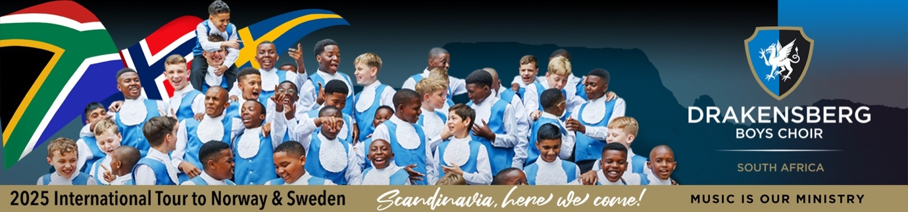

The tour promises more than a series of world-class concerts – it is a celebration of shared values, youth empowerment, and the enduring power of music to bridge cultures. From the fjords of Bergen to the concert halls of Stockholm and Uppsala, the Drakensberg Boys Choir will represent South Africa on some of Scandinavia's most prestigious stages, engaging in performances and collaborations that honour both history and hope. These countries share a historic bond with South Africa, rooted in solidarity, justice, and cultural exchange.

"This tour is more than a musical journey," says Hendrik Bekker, Executive Head of the Drakensberg Boys Choir School. "It is an opportunity to strengthen our international ties, honour our friends in Scandinavia, and present South African artistry with pride and purpose."

**A tour rooted in solidarity, built on legacy**

The Drakensberg Boys Choir's 2025 international tour is a living tribute to the enduring friendships formed during South Africa's struggle for democracy. Sweden and Norway were among the first Western nations to support South Africa's liberation movements. Their legacy of solidarity, cultural diplomacy, and human rights advocacy continues today, forming the foundation for this tour's meaningful engagement.

The Scandinavian Tour 2025 will reaffirm the Choir's mission: Music is our Ministry. The boys are ready to bring that spirit of hope and goodwill to Sweden and Norway with the customary Drakie passion, precision, and pure joy in their element. Audiences can expect soaring harmonies, powerful African drum beats, and exhilarating choreography that showcase why the Drakensberg Boys Choir remains one of the most sought-after choral ensembles globally. "The boys pour their hearts and souls into preparing for this yearly showcase. The combination of their hard work and the incredible performances makes for truly unforgettable experiences," states Jacques Linde, the DBC Head of Choral Activity and Conductor of the Choir.

The Drakensberg Boys Choir departs on 17 September 2025 for a 14-day musical journey through Norway and Sweden. Adding to the depth of this journey is the Choir's reunion with Håkon Matti Skrede, conductor of the Edvard Grieg Youth Choirs in Bergen and former choirmaster at DBCS. Skrede's early musical roots were shaped at the very school he is now returning to collaborate with. The Bergen leg of the tour will feature an exceptional performance at the Church Music Festival on 19 September 2025, in partnership with the Edvard Grieg Boys Choir. Some of the concerts are already fully booked out!

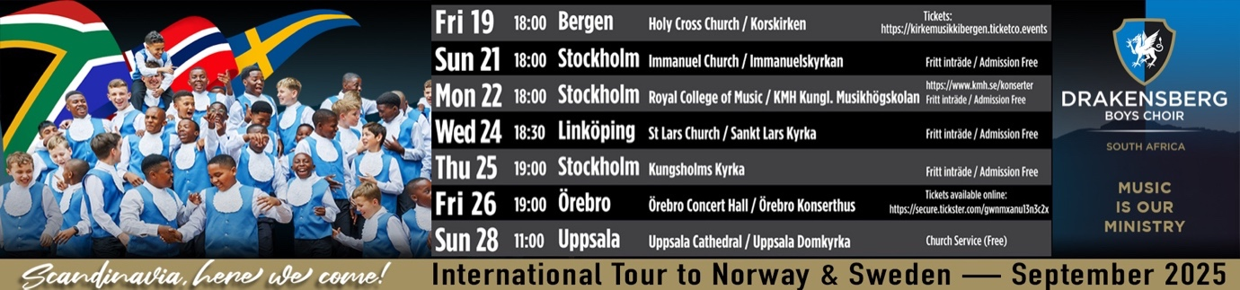

The Choir returns to South Africa on 30 September 2025. "The tour will also include educational workshops, cross-cultural exchanges, and joint performances, providing young South African choristers with a platform to engage in meaningful dialogue with Scandinavian youth through music," adds Linde. "This tour isn't just about performance, it's about purpose. We aim to honour South Africa's ties with global allies who stood with it during its most difficult moments," says Linde.

"The tour is about fostering intercultural understanding between the youth of South Africa and Scandinavia, celebrating the richness of African musical traditions on international stages, and creating lifelong memories and leadership opportunities for the young ambassadors of DBCS," Bekker adds. "This journey to Norway and Sweden is about so much more than travel – it's about telling a South African story to the world. A story of growth, unity, and the boundless potential of our youth. Music is our Ministry, and our boys carry that Ministry with integrity and joy, wherever they go," Bekker concludes.

**Call for sponsorship: partner with DBCS for a good purpose**

While DBCS parents partially fund the tour, contributing to cover just over 60% of the costs, the school seeks to raise the remaining R685,000 to ensure every boy selected can participate in this transformative opportunity. All contributions qualify for a Section 18A tax rebate. Visit <https://dbchoir.com/support-us> to donate. South African and Scandinavian businesses, institutions, embassies, and individual philanthropists are invited to partner with the Choir as part of a legacy of investment in arts, education, and international goodwill. DBCS is a registered Non-Profit Organisation (002-106 NPO) and a Level 1 B-BBEE contributor with over 75% black beneficiaries.

Founded in 1967, the Drakensberg Boys Choir School is more than a music academy – it's a launchpad for leaders. Set against the backdrop of the majestic Drakensberg Mountains in KwaZulu-Natal, the school integrates academic excellence, musical mastery, boarding, and sports with Christian values into a powerful, holistic education model. Touring is a key component of this model, enabling young choristers to develop into confident, compassionate, and globally minded young men.

FIN

**(799 words)**

**EDITORS' NOTES**

**Media release issued by Stone on behalf of the Drakensberg Boys Choir**

**Media contact for further media information or interview requests:**

Willem S Eksteen, Stone CE and Drakensberg Boys Choir School Director

Drakensberg Boys Choir School

or a member of the media team at Stone

Email: media@stone.consulting / willem@dbchoir.team

Phone: +27 11 447 0168 / +27 83 272 6304

**Enquire about enrolling at DBCS or marketing matters:**

Helga Cato

Drakensberg Boys Choir School

Email: hcato@dbchoir.com

Phone: +27 36 468 1012 / +27 83 773 7450

**Contribute to the DBCS bursary fund:**

Lizel Potgieter, DBCS Bursar

Drakensberg Boys Choir School

Email: accountant@dbchoir.com

Phone: +27 36 468 1012

**Book the Choir for performances:**

Elanza Joubert

Drakensberg Boys Choir School

Email: tours@dbchoir.com

Phone: +27 36 468 1012

**To purchase DBC concert tickets, visit** [**www.dbchoir.com**](http://www.dbchoir.com)

**More helpful website links for media reference:**

* Please visit the Facebook page for views of the sold-out performances and activity during the four-day Music in the Mountains festival that took place on the Freedom Day long weekend, and more information on the Choir – <https://www.facebook.com/dbchoir>
* The photo page on the Facebook page gives a good view of the diversity, life and extraordinary talent of the boys at Drakensberg Boys Choir School – <https://www.facebook.com/dbchoir/photos>
* Visit these links for a glimpse of the world-renowned Choir's international and local choral work, both in the classical and distinctly African genres – <https://www.youtube.com/user/DBCHOIR>, <https://youtu.be/C521O4XHO_I>, <https://www.facebook.com/dbchoir/videos/934329527988775/> and <https://dbchoir.com/web/videos/>