PR Monthly Report - Mexico February 2022

Quantitative KPIs

Total Articles  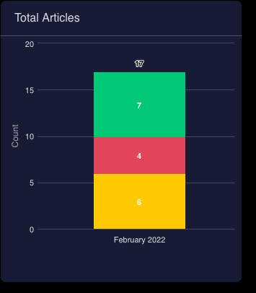  Coverage by tiers  Coverage by spokespeople  Coverage by ‘Competitor’ Mention | Coverage by focus areas  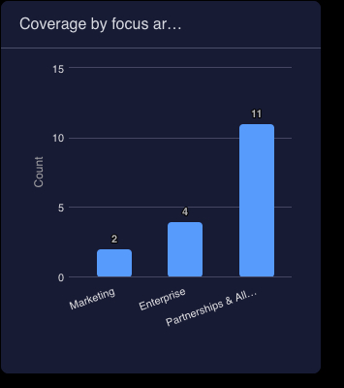  Coverage by organic vs. earned  Coverage by channels  Number of commentary and newsjacking

Qualitative KPIs
Pitching Journey

Name of Pitch: "monday.com participation on Super Bowl ads"

media list- # journalists pitched? | # expressed interest | # Interviews secured | # of days pitched | Total coverage
4 | 2 | 0 | 2 | 2
Actionable Insights:
- Information pitch
- Video
- Mail and phone Pitching

Name of Pitch: "monday.com announces its strategic alliance with KPMG"

media list- # journalists pitched? | # expressed interest | # Interviews secured | # of days pitched | Total coverage
40 | 25 | 0 | 5 | 13
Actionable Insights:
- Editorial Content
- Mail and phone Pitching

Name of Pitch: "monday.com Earnings"

media list- # journalists pitched? | # expressed interest | # Interviews secured | # of days pitched | Total coverage
4 | 2 | 0 | 5 | 1
Actionable Insights:
- Translated Post
- Mail and phone Pitching

Top Coverage - top 1-2 articles

- Market Minds: "Carlos Kamimura, Director of Alliances at monday.com for Latin America, joins us tonight and we will talk about the organization of teamwork for the best performance of companies" - This publication is product of Radio Interview
- Merca 2.0 "monday.com and the other powerful ads, which came to Super Bowl LVI after the contingency" - This publication is product of Super Bowl pitch
- Excelsior: "Counter" - This publication is product of alliance with KPMG

Monthly Report Discussion - date of meeting
Overall Actionable Insights:
- Maintaining ongoing communication with the media through releases will help increase our coverage and position monday.com in the conversation.
- A quick response to the media on a written interview or request will help us strengthen our relationship with the media.

monday.com insights
- Additional pitching efforts in February aside form KPMG? Earnings?
- Nice to see that there is more earned coverage from news announcements than previous months
- We need to stay focused on specific pitches and initiatives every two weeks and focus on goals/results for each initiative
- Also, let's be sure to define our strategy before execution, especially with bylines

