Leading the Pack: Xytech Launches Graphical UI for Media Orchestrator, Provides Customers with Industry-Leading Workflow Simplicity

Once again, Xytech anticipates the media industry’s need for an overarching, efficient solution, eclipsing lackluster competitive market offerings

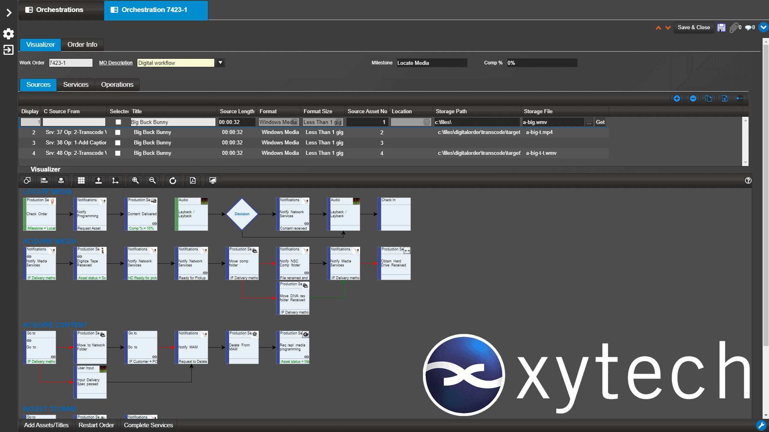
Los Angeles, August 25, 2020 — In today’s dynamic and global environment, it’s not acceptable for software providers to propagate old technology and offer paltry, infrequent updates. In stark contrast, leading resource management software provider Xytech continues to innovate its MediaPulse resource management system, this time with the release of a brand new, fully featured graphical user interface for the Media Orchestrator.

Seamlessly incorporated to the workflow software, the new graphical UI merges asset management, operations and resource management, allowing game-changing media services companies to monitor the people, facilities or equipment needed to complete a given task.
“All too often, companies are adversely effected by a lack of efficiency in their workflows, and this can have a direct impact on profit margins,” said Greg Dolan, Xytech CCO. “The media software industry demands intelligent solutions with the ability to dynamically adapt to customers’ constantly evolving needs. With offices in Los Angeles, London, France, Germany, Belgium, Canada and China, Xytech is uniquely positioned to meet customers at their point of need with unmatched technical service. Also, with regular, yearly upgrades and quarterly updates to the MediaPulse platform, we are not leaning on decades-old software like our competitors.”

Efficiency is Key
The new graphical UI takes the complication out of the workflow process by offering users an easily digestible and totally intuitive interface. Users can move an entire block of functionality instead of choosing from a menu item. A user can grab a visual block, plot out the appropriate steps and link it graphically through Visio.

The new UI also allows users to define, configure and monitor any media service workflow while adjudicating any discrepancies. It lets users monitor and resolve problems in the workflows of other systems and, if it finds a fault, sends notifications to the appropriate users to resolve.

“Having a robust resource management system featuring regular updates is key for companies looking to streamline and bolster operations,” Dolan explained. “Gone are the days when software providers could offer one update every few years. As such, Xytech has included countless advancements to the MediaPulse platform in the last year alone, and we are excited to continue this trend with the new graphical UI.”

The new graphical UI will be available to users this fall.

About Xytech
For more than 30 years, the world’s premiere media companies have depended on Xytech to run their businesses. MediaPulse is the only end-to-end solution for the complete content lifecycle. MediaPulse provides scheduling, automation, asset management, billing and cost recovery for broadcasters, media services companies and transmission facilities in a scalable platform-independent solution. For more information, visit xytechsystems.com.

Media Contacts:

Katie Kailus
Public Relations
Hummingbird Media
+1 (630) 319-5226
katie@hummingbirdmedia.com

Jeff Touzeau
Public Relations
Hummingbird Media
+1 (914) 602 2913
jeff@hummingbirdmedia.com

