Mix2Go: Inside The World’s Smallest 3D Mix Facility
WSDG Unveils the ‘Compact Studio of the Future’ — Mighty And Miniature

São Paulo, BRAZIL – October 29, 2018 – Mix2Go, WSDG’s latest commercial studio in Brazil, packs more sonic innovation per square inch than any other mix facility on the planet. Located in the heart of São Paulo, Brazil and encompassing just 440 total square feet, it is very likely the smallest 3D mixing facility in the world and, an innovative archetype for the compact studio of the future. One of the studio’s most recent projects at Mix2Go was for Brazilian artist Naiara Azevedo — whose recent album Contrast was just nominated for a Grammy award.

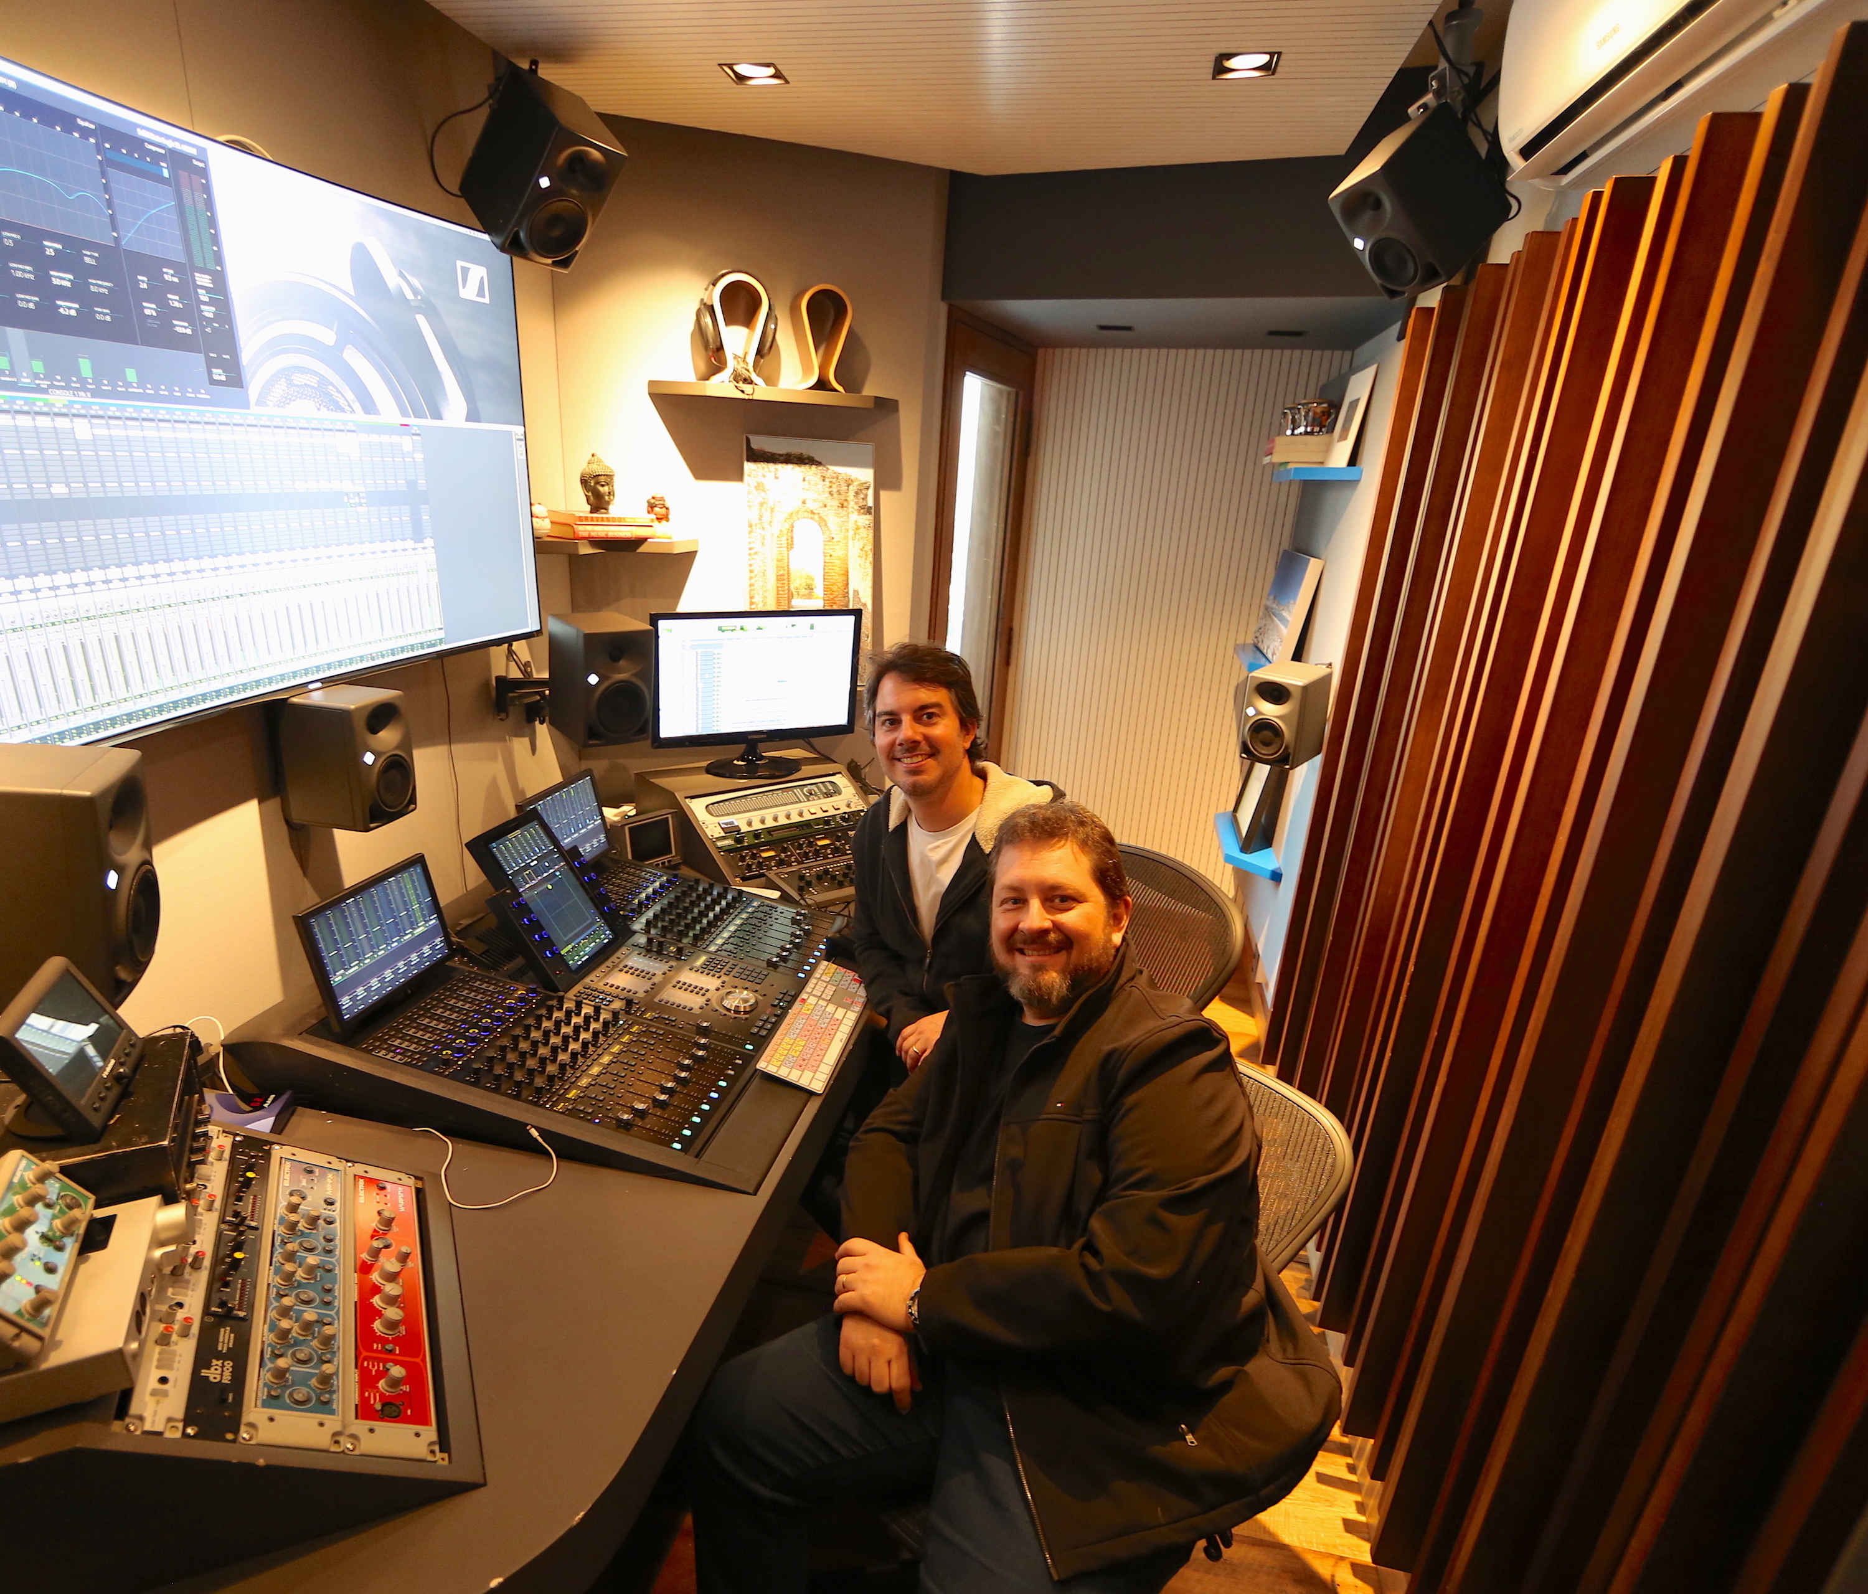
Despite its diminutive size, Mix2Go is a world-class heavyweight champion when it comes to acoustic design, equipment infrastructure, advanced ergonomics and amenities. It is a study in geometry and efficiency wherein every space has a function: from the 3D ‘cockpit’ listening position — which according to WSDG Partner/Director of Design, Renato Cipriano evokes an intimate sound akin to one might experience from a pair of open-air audiophile headphones, to the meticulously crafted furniture design — thus placing every knob and fader conveniently within reach.

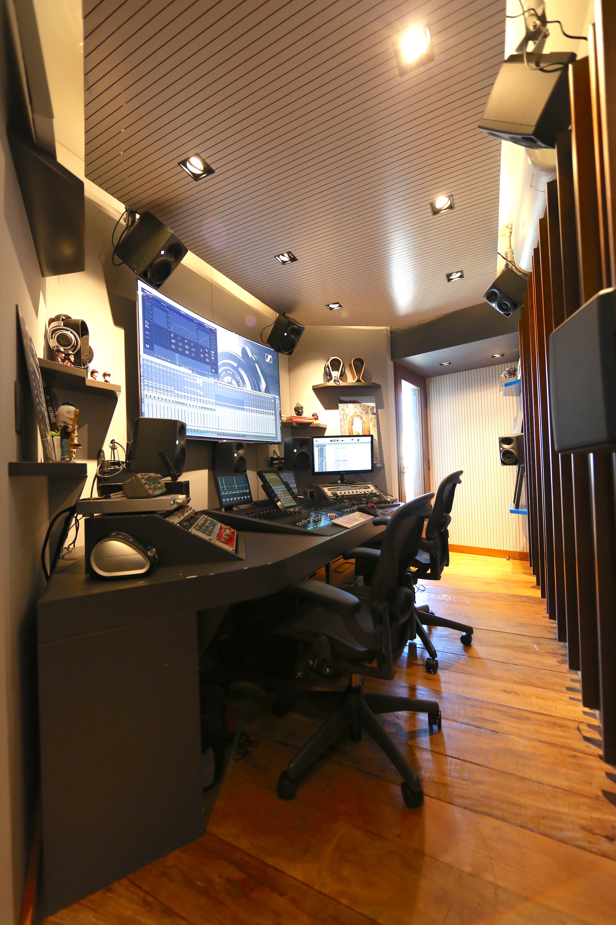
"Since the rooms are so small, there were some big acoustic challenges — particularly in the low frequencies,” says Cipriano. “Therefore, every surface — even the furniture — has a functional role in the acoustic design. What is most successful about Mix2Go is that you are mixing in 3D in a near field condition, something not so common for immersive audio. The proximity of everything is so close and everything sounds so clear that the listener is totally immersed in every note and whisper.”

The owners, Grammy-winning engineer Beto Neves and Daniel Reis, had two very specific goals for Mix2Go to achieve their standards for success. Firstly, it had to meet Dolby Atmos technical specifications, enabling the studio to produce not only standard stereo and 5.1 mixes, but also to deliver captivating 3D audio mixes for modern music and content creators. Secondly, it had to accommodate a more efficient and faster workflow model than traditional commercial studios, reflecting the compressed production schedules and near-immediate turnaround requirements in today’s music industry.

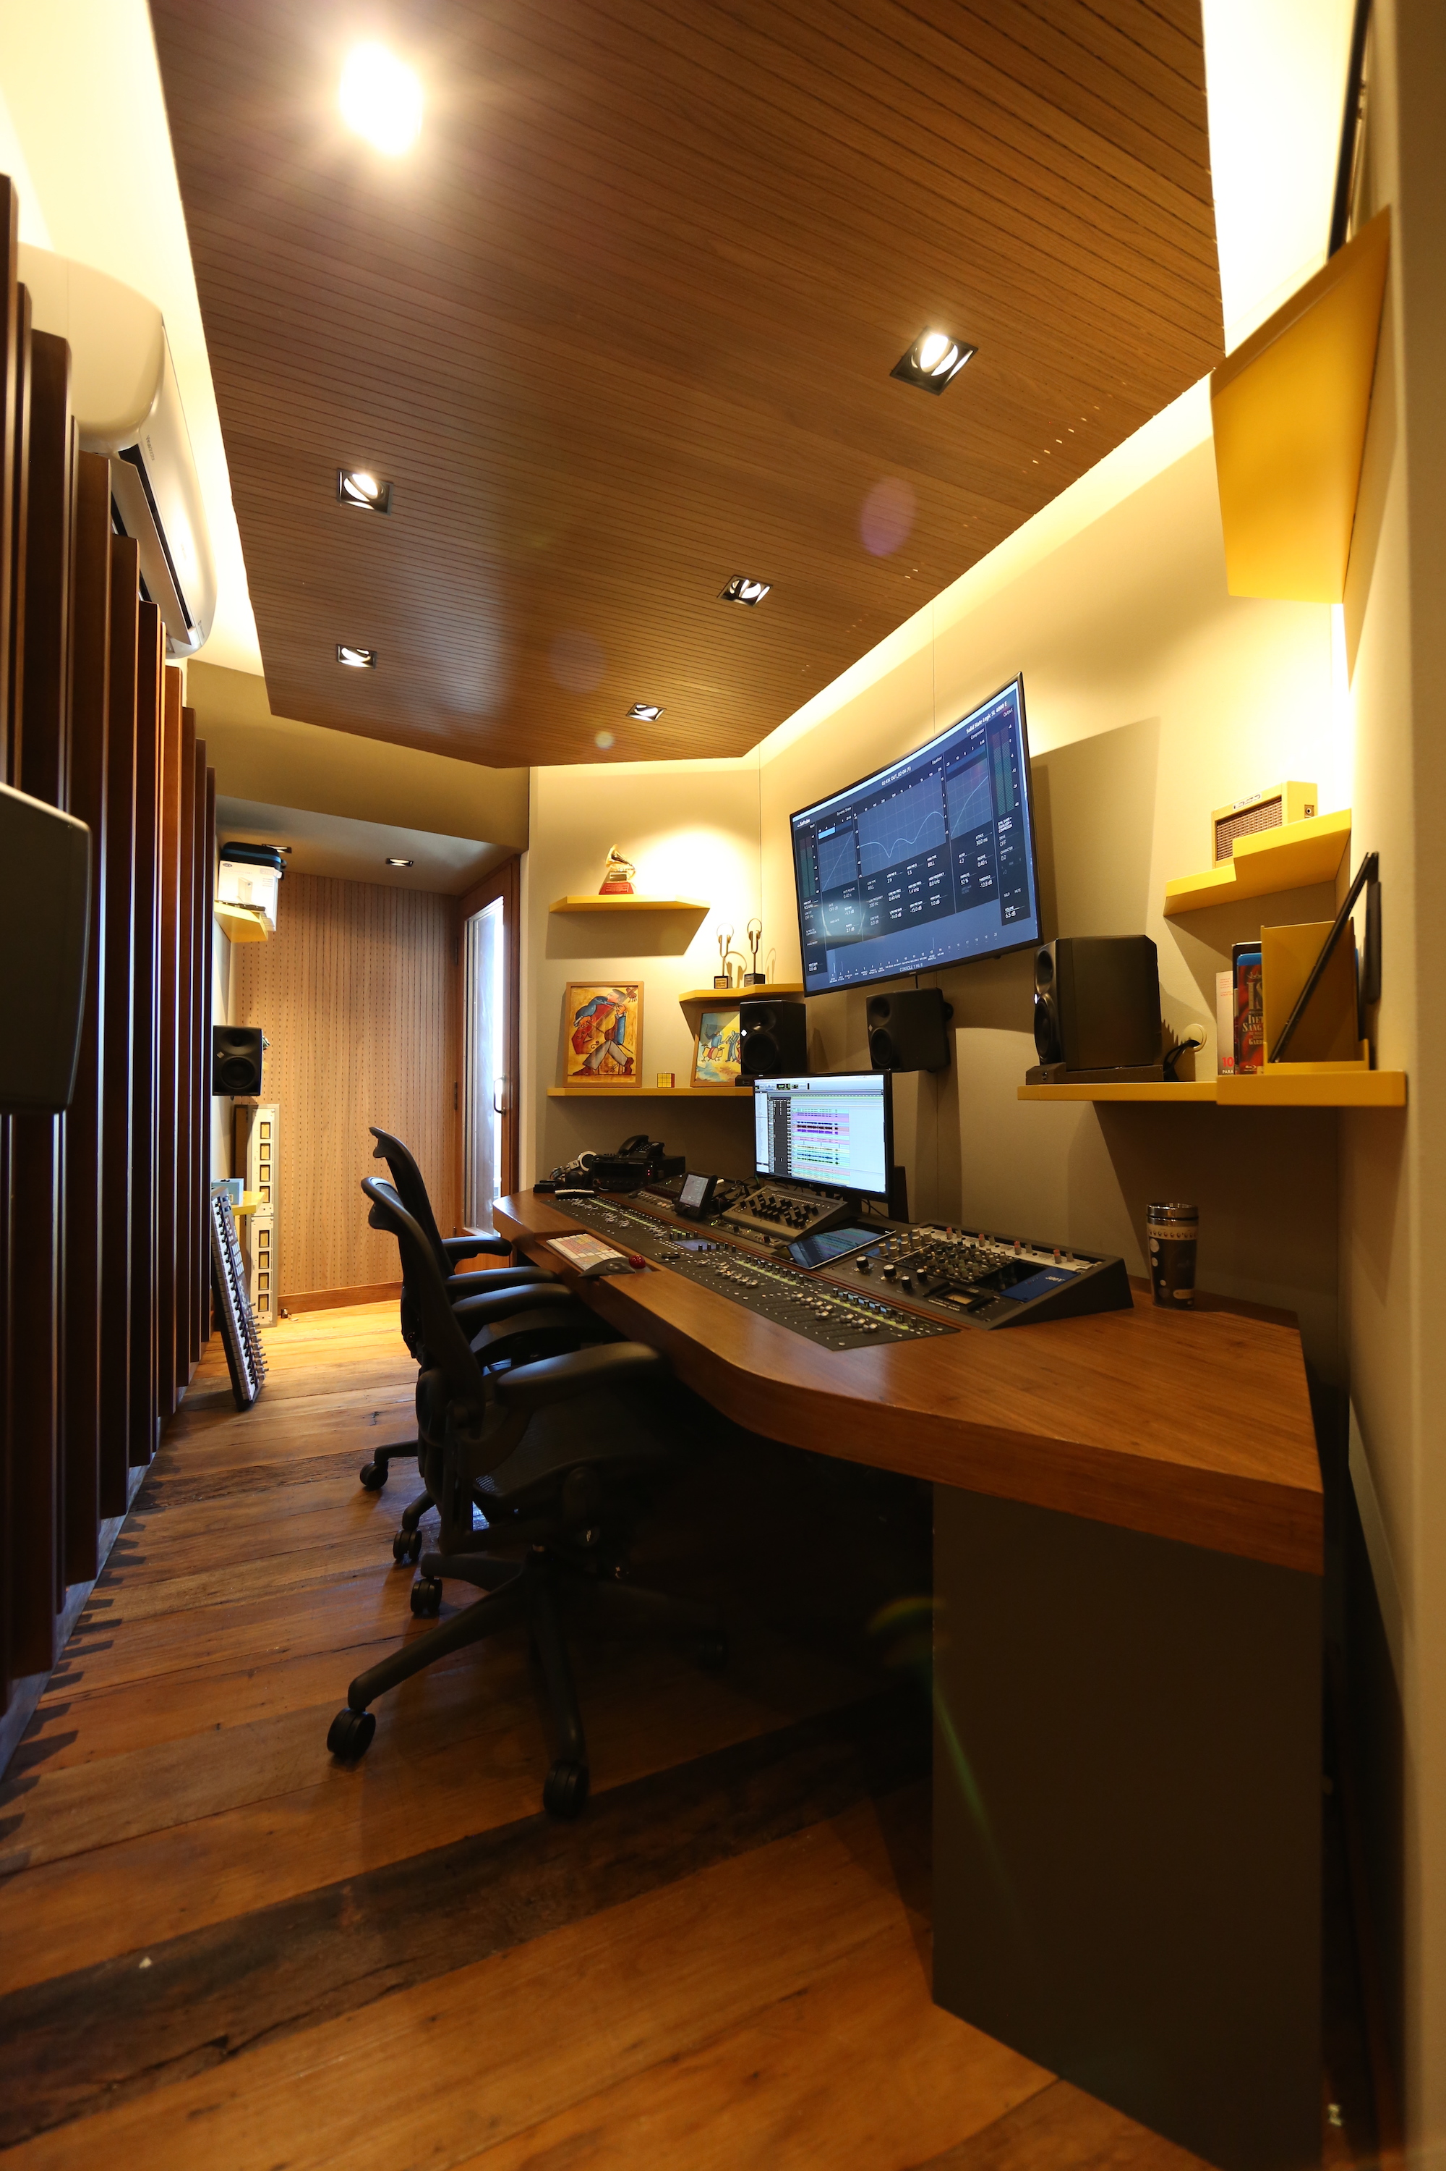
Neves and Reis had worked independently in a variety of environments over the years — including in very large mix facilities with massive, name-brand recording consoles. More recently, prior to conceiving Mix2Go, they paired up and decided to acquire a high-end recording truck, which they used on assignments for World Cup events, the Rock In Rio music festival and other remote projects. But as the music industry evolved, they saw their potential profits begin to diminish with the onset of fiber recording technologies. This served as the catalyst for them to depart the mobile recording world for a new focus on 3D audio and world class mixing technologies.

“The market shifted and we had to do something different,” Reis explains. “Nowadays, 95 percent of our work is ‘in the box’ – and clearly reflects changing times, technologies and client demands. Nowadays, in this mainstream music industry we work in, the world is much faster. It’s a BYOD (bring your own device) environment of smartphones and iPads, where songs are mixed, mastered and released in hyper-space turnaround time. This new methodology demands a new approach for in the box mixing Mix2Go represents a supercharged methodology to achieve this objective. ”

“We think the future of mixing is not in stereo or even in 5.1 surround, but in ‘object-based mixing’ rather than a ‘channel-based’ approach. Object-based mixing in our Atmos environment can translate more seamlessly to the consumer on a range of listening devices, whether it is a mobile device, an automobile sound system or a 3D soundbar. This is the future, and we are ready to deliver mixes for all these scenarios.” Currently, Mix2Go’s Studio A is fully equipped to meet Atmos specifications — the pair expects to bring Studio B up to Atmos specifications soon.

While Mix2Go’s design geometry eventually fell into place like perfect puzzle pieces, Cipriano says the biggest acoustic challenge was speaker placement and low frequency control: “The hardest part is to get the speakers in the right locations, because the studio is so compact,” he says. “Most of the work we did in terms of acoustics had to do with controlling the low and low-mid frequencies. I say low-mid because of the room is not large enough to have resonances at very low frequencies, and all of the modes occurs at around 100 Hz to 200 Hz - so this is where we focused most of the treatments.”

Aside from its flawless acoustic design, Mix2Go features a first-rate selection of equipment, including Avid MTRX converters and control surfaces in both rooms, Neumann KH 310 and KH 120 monitors, Dolby Atmos control and a Neve 8816 summing mixer. Both rooms are compatible with Dante and MADI formats and networked together for ease of file transfer. Further, a dedicated machine room closet functions as a file server for both mix rooms — providing seamless file storage, access and backup for all projects.

ABOUT WSDG, LLC
WSDG has designed nearly 4000 media production facilities worldwide. Projects range from Jimi Hendrix’s Electric Lady Studio and Jazz At Lincoln Center in New York, to broadcast facilities for The Food Network, CBS and WNET, over twenty teaching studios for The Art Institutes, and corporate clients such as Sony, IBM and Novartis. Recent credits include Jungle City in New York, The Church Studio, in London, private studios for Green Day, Jay-Z, Bruce Springsteen, Alicia Keys and Academy Award-nominated film composer Carter Burwell. WSDG has collaborated with such noted architects as Frank Gehry, Philippe Stark, Rafael Viñoly, Santiago Calatrava, Grimshaw, and Norman Foster. An eleven-time winner of the prestigious pro audio NAMM TEC Award for outstanding achievement in Acoustics/Facility Design, WSDG maintains U.S. offices in New York, Washington, DC,San Francisco and Miami and global offices in Barcelona, Basel, Beijing, Berlin, Belo Horizonte, Buenos Aires, Mexico City and Mumbai.

Contact:
Jeff Touzeau
Hummingbird Media, Inc.
+1 (914) 602-2913
jeff@hummingbirdmedia.com

