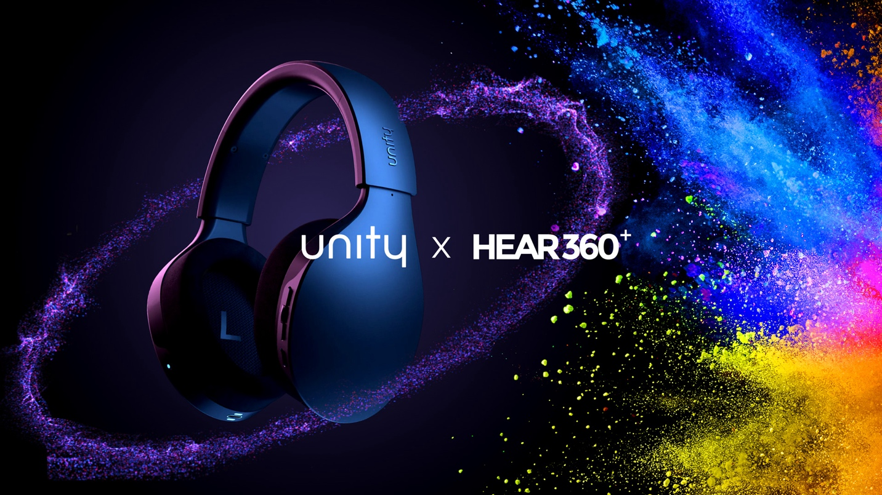

**HED UNITY PARTNERS WITH HEAR360 TO LAUNCH THE WORLD’S FIRST HEADPHONE FEATURING HI-RES LOSSLESS AUDIO OVER WI-FI WITH HEAD-TRACKABLE SPATIAL AUDIO**

**Los Angeles, California, January 25, 2024**— HED UNITY, the Swiss innovator of the Unity wireless lossless audio headphones, and HEAR360, a leader in spatial audio solutions, today announced a strategic partnership that sets a new bar for wireless headphone experiences incorporating their respective patented technologies.

The result is Unity, the first headset in the world to feature “Full-Fidelity™” - streaming true lossless audio over Wi-Fi - powered by HEAR360’s Spatial Audio Engine. Never before have audio aficionados been treated to hi-res lossless audio with unlimited wireless range and head-tracked spatial audio all in the same product. Full-Fidelity™ allows listeners to experience bit-perfect transmission of lossless content in spatial audio, completely untethered, in stunning clarity and rich detail.

On-board Wi-Fi means lossless audio can stream directly to the Unity headphones, bringing out the detail and nuance of your favorite music, and eliminating the side effects of compression, which can cause bass to sound bloated and highs to sound synthetically sharp. Now even listeners with the most discerning ears can experience music and movies the way artists and directors intended.  
  
With Unity, listeners are given ultimate flexibility. In addition to streaming hi-res lossless audio via Full-Fidelity Wi-Fi, users can also switch to lossy audio via Bluetooth or receive an untouched signal via the included wired dongle. In each case, the experience is enhanced with best-in-class immersive spatial audio via HEAR360’s Spatial Audio Engine.

HEAR360 and HED share an important mission that is apparent in Unity - enabling a premium experience without complicated workflows or proprietary codecs. HEAR360’s Spatial Audio Engine is designed to work seamlessly with existing content libraries, streaming audio, and OTT content delivery platforms, ensuring that all users can access unprecedented levels of immersion elevating any and all everyday listening scenarios, live or on demand.

“This flagship product sets the bar for the next generation of premium sonic experiences, and we are proud to be an integral part of Unity’s groundbreaking launch,” says Matt Marrin, CEO and Co-Founder of HEAR360. “We look forward to continuing to push boundaries through our joint innovation efforts with Tim and the HED team.”

Through the Unity app, users will have access to a full assortment of feature sets including, ANC, head-tracking, channel gain, dialogue enhancement and clarity, and EQ presets. HEAR360 takes advantage of Unity’s nine-axis motion sensor to deliver head-tracked spatial audio. The app also provides access to music services with its embedded streaming music capability. Not all features are currently available; go to getunity.com and follow to get updates on when new features will be released by free over-the-air software update.  
  
“I cannot be more thrilled,” HED’s CEO and Co-Founder, Tim Degraye shares. “Not only are we the first headset to offer Full-Fidelity, but with HEAR360’s proprietary Spatial Audio Engine, Unity’s sound quality has few equals, if any, in the wireless headphone world. It means we bring you even closer to the soundstage and real life. As we like to say, it is better than high fidelity, it is Full-Fidelity™.”

**About HEAR360**

HEAR360 is on a mission to make the world sound incredible. Specializing in designing both professional and consumer audio hardware and software products, HEAR360 seamlessly answers the increasing demand for premium audio experiences. Founded by Grammy award winning audio engineers, HEAR360's proprietary audio solutions power the world's most successful companies. Their latest innovation is the real time automated rendering engine that delivers best in class Spatial Audio for instant playback of both live and on demand content from any web or mobile platform. HEAR360 technology is pervasive powering headphones, video conferencing, in-flight entertainment systems, livestream music platforms, mobile apps, gaming, and XR environments.

For additional information, follow HEAR360 on [LinkedIn](https://www.linkedin.com/company/hear360/) and visit [http://hear360.io](http://hear360.io/).

**About HED**

HED Unity, a Swiss company, has shattered the status quo with headsets that let music lovers enjoy sound in a revolutionary and liberating way. Its first product, Unity, establishes the brand as a technological leader: Unity is the world’s first computational audio device, that pushes beyond the limits of conventional Bluetooth™ headphones to create the world’s first wireless headset that features Full-Fidelity™. The new Full-Fidelity™ standard streams true lossless audio over Wi-Fi, enabling listeners to hear the songs they love in stunning clarity and rich detail like never before—[www.getunity.com](http://www.getunity.com/).

**For more information, contact:**

Jonathan Gordon  
Head of Business Development & Strategic Partnerships  
Jonathan@hear360.io

Arlene Zeichner   
Marketing Lead   
arlene@hedunity.com