PRESENTS
ALL OF ME
Lucía doubts and wonders how many women live in her. She would like to know how many brides she can shape. When she looks for a total image to define her, she plunges into a sea of ​​restlessness.
And it is then when she discovers the infinite possibilities of the bride she can become.
She is like the light of a kaleidoscope that is projected with infinite nuances, all of which are equally true.
She is a multitude of brides, as many as the emotions and thoughts she has.
She is at the same time the depth of the sea, the first light of the morning, an open bottle that embraces the wind.
Lucía is everything she wants to be without giving up anything, specially not herself, and that is why she navigates through all her essences.

All of Me - Boho
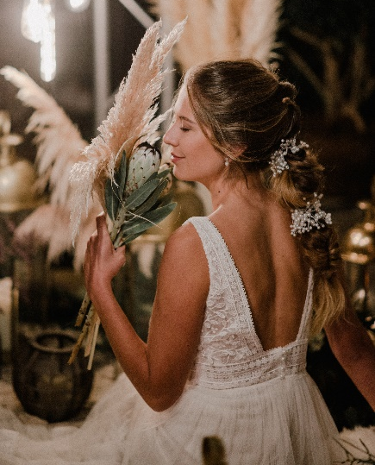

I can be soft as the caress of dawn and dress delicately without hiding my energy.
It is in those moments that I like to evoke memories, braid them and shape them. Thus I manage to create a new light, and perfume myself with its magic. Every detail, with its simplicity, shines like a star, and with my delicate presence I give all my strength.

That is why I feel like crowning myself with braids and semi updos with a messy effect. I give more importance to my essence flowing and falling like precious rain on others because I am natural, but I know that I am the protagonist. I do not renounce to jewelry for my hair either because it enhances the significance of this commitment.

All of Me - Low Pony Tail
I'm vaporous like drops that spray the breeze,
Like a veil of fine rain
That refreshes wherever it goes.

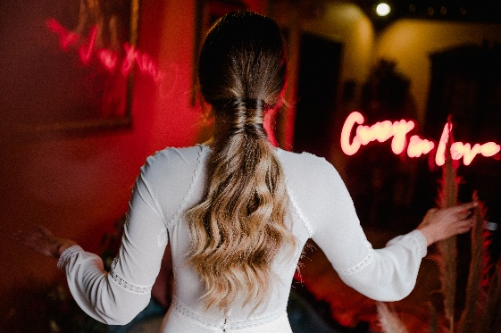

Thus, I stealthily impregnate with sweetness all gazes.
I dress with what I am, with my variety of attitudes, and I let myself be carried away by the whispers of the dim light. In every beam in the sky there is a part of me and I slide my most intimate desires through the sway of waves that fall down my back and then embrace them in a noose, collected, so that they do not start the flight without me.
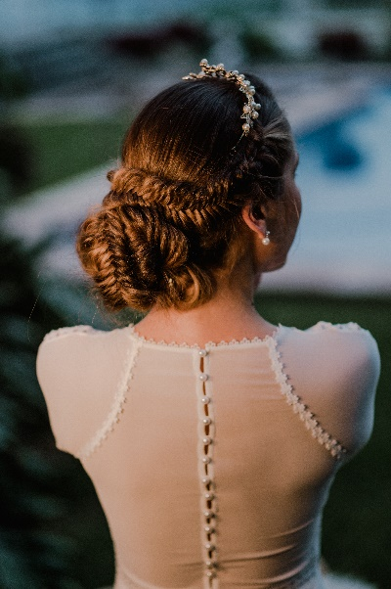
All of Me - Low Updo

I always walk in truth, I wear the dress of the authentic,
And I go where the light is born, free and powerful.
If you look at me from the heart
You can accompany me, I will perfume you with the breath of nature.
My hair is a jewel that crowns me, in it I write what I am, how I feel. I don't need to hide and I weave a nest of braids with it, I am a queen.
Sometimes I like to play with the silver mirrors that shine pearls and I feel that I have the growing power of the new moon.

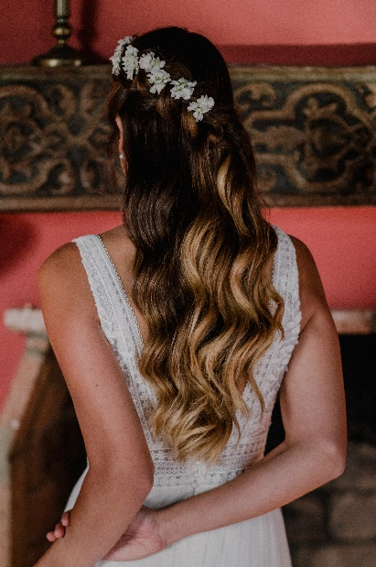

All of Me - Side Me Updo

I seem wild because I harbor all my essence,
also, the mantle of the calm sea.
I am the morning that is born calm and safe,
And at the same time the enigmatic sunset whose strength you do not know.
I collect my beauty to make it understandable
As a new life blossoms in me
And so I let the waves dance on my skin
As the serene flames of candles do.

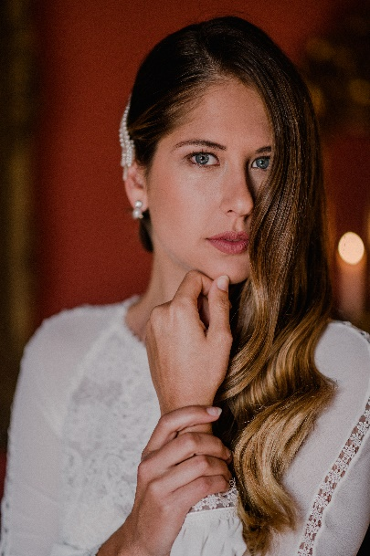

All of Me - Waves

I like to be the strength of a flower that opens,
Her joy when she grows, also the sensuality that embraces the mystery of what is loved without being known.
I hint at what I am and entrust my essence to precious gems. To later be a cascade of burning fire
That overflows until it contains itself.

CREDITS:
BRIDAL HAIR ARTIST: RAQUEL SAIZ
Instagram: @raquelsaizinwhite
Project Management and Communication: COMUNICAHAIR
Instagram: @comunicahair
Coordination: PRISCILLA SALAZAR
Instagram: @priscillasalazar.wp
Photography: EDU HERNÁNDEZ
Instagram: @eduhdezfoto
Makeup: ULISES PELUQUEROS
Instagram: @ulisespeluqueros
Dress: Geyma Bodas (Colección Rosa Clará)
Instagram: @geymabodas
Jewelry: Geyma Bodas (Colección Amdeluxe)
Location: Abaco Tenerife
Instagram: @abacobodasyeventos
Flowers: Macame
Lighting: JMF Eventos
Instagram: @jmf_evento
Material (Household): GR Eventos
Instagram: @greventos.es

