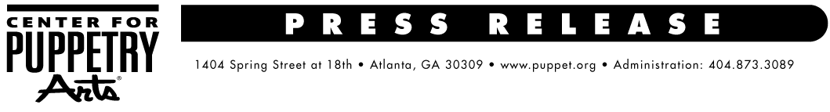
For more information, contact:
Becca Meyer / Jennifer Walker
BRAVE Public Relations, 404.233.3993
bmeyer@bravepublicrelations.com /
jwalker@bravepublicrelations.com

One night only: A Ghastly Ghathering at Center for Puppetry Arts, October 7
Atlanta’s Ghastly Dreadfuls are awakening from the afterlife for a haunting Halloween party!

ATLANTA (August 31, 2017) – The Center for Puppetry Arts’ resident ghouls, the Ghastly Dreadfuls, are throwing A Ghastly Ghathering to celebrate the Ghastlies’ annual return from the grave and to kick off the spooky Halloween season! On October 7, mortals are invited to mingle with the Ghastlies, dance and celebrate with supernatural musical numbers performed by the Ghastly Dreadfuls throughout the enchanted evening. During this special one-night-only event, guests are invited to dress up in their finest, gothic Halloween attire or create their own original Ghastly character to enter a costume contest. The grand prize winner of the costume contest will make a guest appearance on stage with the Ghastlies during opening night of this year’s production of The Ghastly Dreadfuls. In addition to the costume contest, there will be a variety of other activities during the evening, including a specially designed self-guided tour of the Worlds of Puppetry Museum featuring some of the most devilishly interesting puppets in the collection. The event will include FREE appetizers as well as and beer and wine for purchase. For fans and ghoulish friends of the Ghastly Dreadfuls, it will be a night to remember – and the ultimate way to usher in another spine-chilling season of The Ghastly Dreadfuls at the Center for Puppetry Arts, beginning October 11.

WHAT: A Ghastly Ghathering

WHEN: Saturday, October 7 from 7 – 10 p.m.
Ages 18+

WHERE: Center for Puppetry Arts
1404 Spring Street NW
Atlanta, GA 30309

HOW: Tickets are $25 (Members) and $30 (nonmembers) – plus sales tax. Tickets are available online at www.puppet.org or by calling 404.873.3391.

###
The Center for Puppetry Arts is supported in part by: Fulton County Arts Council • City of Atlanta Mayor’s Office of Cultural Affairs • Georgia Council for the Arts • The Zeist Foundation • The Jim Henson Company
For a complete list of the Center’s major supporters visit www.puppet.org/about/sponsors.
Center for Puppetry Arts® is a unique cultural treasure – a magical place where children and adults are educated, enlightened, and entertained. Since 1978, the Center has introduced millions of visitors to the wonder and art of puppetry and has touched the lives of many through enchanting performances, curriculum-based workshops, and the hands-on Museum as well as Distance Learning and Outreach programs. Center for Puppetry Arts is a non-profit, 501(c)(3) organization and is supported in part by contributions from corporations, foundations, government agencies, and individuals. Major funding is provided by the Fulton County Board of Commissioners and the City of Atlanta Mayor’s Office of Cultural Affairs. These programs are also supported in part by the Georgia Council for the Arts through the appropriations of the Georgia General Assembly. GCA is a partner agency of the National Endowment for the Arts. The Center is a member of Theatre for Young Audiences (TYA/USA/ASSITEJ).The Center also serves as headquarters of UNIMA-USA, the American branch of Union Internationale de la Marionnette, the international puppetry organization.

