Xytech Launches Podcast Focusing on Media Industry Trends
‘Xytech After Dark’ is available now on iTunes, Spotify and all podcast platforms

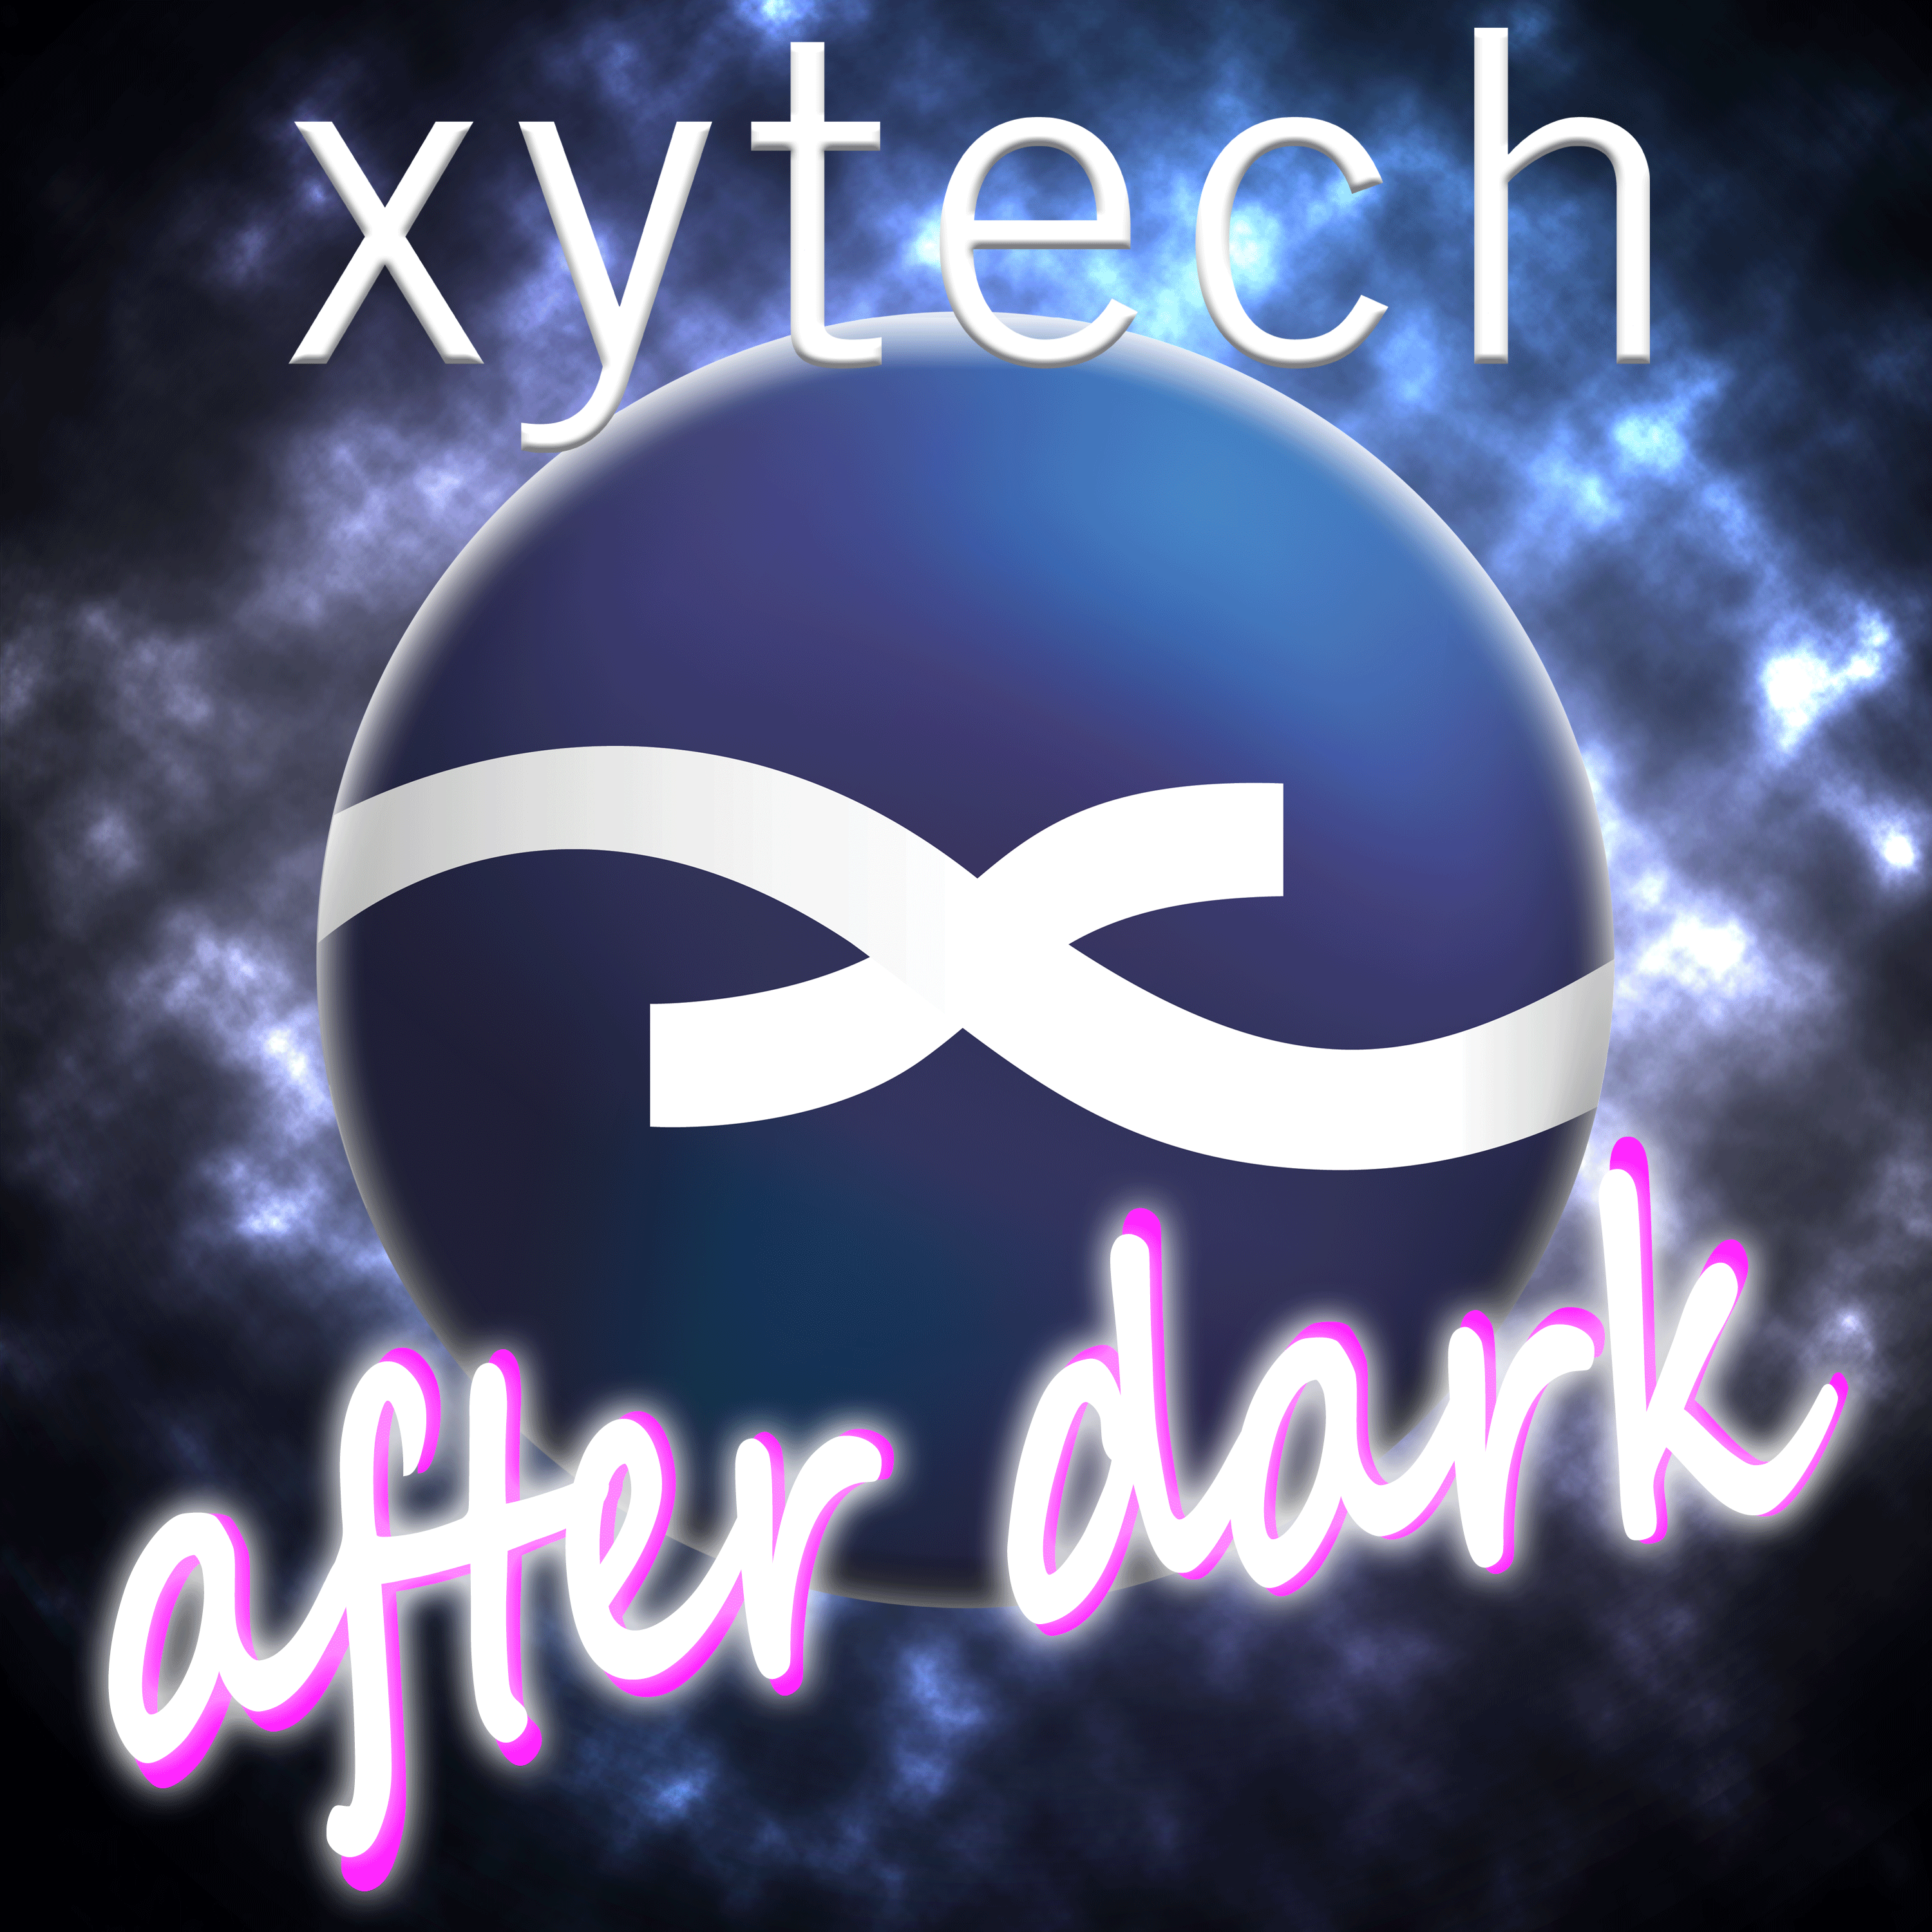
LOS ANGELES, CA, March 25, 2020 — Xytech, leader in facility management software for media and broadcast, has launched ‘Xytech After Dark,’ a podcast focusing on trends in the media and broadcasting industries. The first two episodes are now available on iTunes, Spotify and all podcasting platforms.

“Xytech has hundreds of clients around the world in the media and broadcast business,” said Xytech’s Greg Dolan. “We get this super unique view of the industry from our clients and maintain a comprehensive understanding of current trends. The podcast is not a forum to sell, but instead to talk about why create the functionality in MediaPulse, and the types of things happening in our industry. The podcast will focus on industry trends: what we are seeing and how we view the world of media. Finally, this is really fun work. There are a million easier ways to make a living, but there is nothing more exciting. I hope our sense of humor and passion come through.”

Hosted by Xytech’s Senior Account Manager, Gregg Sandheinrich, the podcast will feature a variety of Xytech staff, including Dolan, along with special guests. Available now, the first two episodes cover hot industry topics, including the recent HPA Tech Retreat, featuring special guest HPA President Seth Hallen, as well as the cancellation of the NAB Show, the value of trade shows and the effects of COVID-19 on the industry.

“The goal for the podcast is to take a not-too-serious look at the world of media and entertainment through the lens of software solutions,” Sandheinrich said. “We are looking forward to sharing what we see on the front lines with our listeners and evoke thoughtful conversations about our industry.”

To listen to ‘Xytech After Dark’ or to subscribe, visit: https://podcasts.apple.com/us/podcast/xytech-after-dark/id1502477089

About Xytech
For more than 30 years, the world’s premiere media companies have depended on Xytech to run their businesses. MediaPulse is the only end-to-end solution for the complete content lifecycle. MediaPulse provides scheduling, automation, asset management, billing and cost recovery for broadcasters, media services companies and transmission facilities in a scalable platform-independent solution. For more information, visit xytechsystems.com.

Media Contacts:

Katie Kailus
Public Relations
Hummingbird Media
+1 (630) 319-5226
katie@hummingbirdmedia.com

Jeff Touzeau
Public Relations
Hummingbird Media
+1 (914) 602 2913
jeff@hummingbirdmedia.com

