CONTACT: Kelly Harman For Immediate Release
SVP of Marketing
703-505-3133
kharman@yorktel.com
Yorktel Announces Newest Addition to Univago HE Telehealth Platform
The Acute Unit allows for expansion from the ICU into other areas for virtual care programs

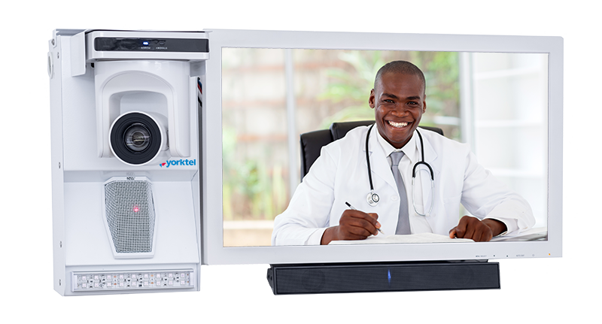
Eatontown, NJ (February 11, 2019) Yorktel today announced a new addition to its Univago HE™ healthcare communications solution suite – the Acute patient solution. With the same intuitive clinician interface as the Univago HE ICU, Acute has been purpose built to give hospitals a flexible solution for greater expansion into patient environments outside of the ICU such as medical-surgical units, step-down units, and emergency departments, providing remote clinical and monitoring workflows to the greater patient population.
Acute can also be used for inpatient telehealth programs such as on demand remote specialty consults, clinical assessment and intervention, patient education, and hospitalist/wound/proactive/sepsis/discharge planning rounding. Acute offers the same features and functionality users have come to rely on from Univago HE solutions, including night vision, advanced remote camera and audio controls, ad hoc expansion to multiple participants with a text or e-mail link, and a patient on hold feature for private sidebar discussions with remote participants.
Acute is fully interoperable with iObserver™, the company’s patient observation application. iObserver was developed to protect the safety of patients who are a fall risk, raise behavioral health concerns or those who are at-risk but do not require being placed in an ICU room. The Acute unit’s unique footprint creates a balance between space and enhanced visualization capabilities, both for the patient, the family and/or the remote healthcare provider, without sacrificing features or functionality.
“With the addition of Acute into our Univago HE platform, we are now able to support a greater range of clinical workflows within a healthcare environment,” said John Vitale SVP of Product Management for Yorktel. “Offering a single versatile platform for multiple workflows provides better patient care and outcomes, delivers ease of use and interoperability, saving time, money and frustration.”
Univago HE was created to help healthcare providers streamline and simplify collaboration and improve patient outcomes by enabling clinicians to focus on the delivery of quality care without having to worry about the complexity or reliability of telemedicine technology. With a flexible, standards-based design, the versatility of the Univago HE platform gives healthcare systems the ability to consolidate their various telehealth programs onto a single video platform, improving clinician efficiency and potential care response time and providing a strong positive return on investment.
Yorktel will be exhibiting the Acute unit at the upcoming HIMSS conference February 11-15 in Orlando, FL at booth #1973. Learn more about Univago HE, iObserver, Acute and Yorktel’s suite of virtual care solutions, visit www.yorktel.com/HIMSS19.
For more information about Yorktel’s Acute Wall Unit or Yorktel’s Univago HE Platform, please visit http://www.yorktel.com/healthcare

About Yorktel
Yorktel (www.yorktel.com) is a leading global provider of cloud and managed services for healthcare, large enterprise, and federal government customers. Founded in 1985 and with offices throughout the US and EMEA, Yorktel enables customers to successfully integrate secure and reliable communications into their operations – from telemedicine and organizational collaboration to consulting and managed services. Yorktel designs, integrates and manages system-wide communications solutions. For more information, visit Yorktel online at http://www.yorktel.com or email learnmore@yorktel.com. Follow Yorktel on Twitter: @yorktelcorp.

