PRESS FILE
EXHIBITION:

IMAGINING THE UNIVERSE
> from 22 October 2021 till 16 January 2022
> M Leuven

An initiative from:
> KU[N]ST Leuven, stad Leuven & KU Leuven

Partners:
> M Leuven & Illuminare KU Leuven

Explore the full programme at:
> www.bangfestivalleuven.be

In this file

Imagining the Universe 2
M Leuven 2
Everlasting awe 3
The universe in the hands of the Almighty: 4
The universe as the Pantheon’s playground: 4
An Incomparable Heritage: 5
The universe on a human scale 6
In a different light 7
AND THAT’S NOT ALL ... 8
Food for thought 8
PRACTICAL 9
CONTACT 10

Imagining the Universe

M Leuven

> 22.10.2021 – 16.01.2022

Little by little, we are ordering our knowledge of the universe based on centuries of experience, carefully passed down from generation to generation.
Leuven professor Georges Lemaître penned these words a century ago to the day. And just a few years later, he would go on to formulate his Big Bang theory. His quote is the spark of inspiration behind Imagining the Universe, the main exhibition of the BANG! Big Bang City Festival hosted by the university town of Leuven.
Tying it all together is humanity’s enduring sense of awe for the cosmos.
Leuven University Library’s To the Edge of Time exhibition is the next chapter of that story, revealing what all that wonder has produced until now. In addition to these exhibitions, M is also hosting a solo exhibition by Richard Long.

The exhibition is part of BANG! – Leuven’s city festival in celebration of the Big Bang theory’s discovery. BANG! is a city festival and KU[N]ST Leuven initiative in collaboration with diverse culture, science, and tourism sector players.

Everlasting awe

“For my part, I know nothing with any certainty,
but the sight of the stars makes me dream.”

Vincent van Gogh (Arles, 1888)

Who are we, and what is our place in the universe? These fundamental questions have moved people since the dawn of time. For thousands of years, we have projected those questions onto the starry sky. Mythology, religion, the arts, and science have come up with a host of answers so diverse it beggars the imagination. And every imagined universe invites us to connect with the great unknown. At the root of every attempt to get to the bottom of this mystery is a deep longing for security. What persistently wins out, however, is a profound sense of our insignificance amid the majesty of the cosmos. There is only one constant – our everlasting awe of the universe.
Curator Jan Van der Stock and his team of art historians (Illuminare - Centre for Medieval and Renaissance Art, KU Leuven) co-created a captivating look at the wide range of answers proposed to these seminal questions over the centuries.
One hundred genuine masterpieces reveal how the visual arts and sciences were the seedbed of answers in Europe and the Arab world. And the fertile intersection of observation and imagination is what empowered them to pose the right questions and formulate answers. The exhibition homes in on this close encounter, where astonishment and wonder are ever-present. The result is a long and winding ode to the arts and sciences.

The universe in the hands of the Almighty:
  - the Judeo-Christian tradition

“In the beginning, God created the heavens and the earth.”

Genesis 1:1: ‘on the first day’ (6th century BCE)

The universe depicted and understood by the Christian world is based on the Jewish tradition from which it came, starting with the Torah and the book of Genesis [Bereishit]. Genesis opens with a story that immediately draws the reader into an encounter with the universe: In the beginning, God created the heavens and the earth. This is not a historical narrative that naively explains how life and the universe came about. Today, we view it as literary and poetic imagery dealing with the orchestration of a boundless cosmos. This liturgical-sounding text was written six centuries before Christ (Common Era). It generated conflict with neighbouring Mesopotamian religions by depriving the heavenly bodies of their traditionally divine status. At the same time, the story positions humans as – ‘made in the image and after the likeness of God’ at the centre of the universe.

The universe as the Pantheon’s playground:
  - the Greco-Roman tradition

“When all the other animals, downcast looked upon the earth,
he [Prometheus] gave a face raised on high to man, and
commanded him to see the sky and raise his high eyes to the stars.”

Ovid (Metamorphoses, Rome, 1st century CE)

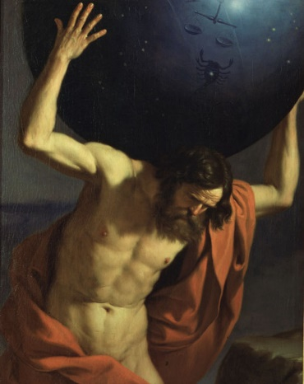
The Greek and Roman Ancients unfolded the tale of the universe’s creation and described its appearance through countless myths recounted all over the world. A pantheon of gods and goddesses, responsible for governing the moral order of life on Earth, populated the cosmos. These stories from antiquity served as an inexhaustible fount of inspiration for artists well into the seventeenth century.

Guercino (Giovanni Francesco Barbieri)
Atlas holding up the celestial globe
1646 © Musei Civici Fiorentini, Museo Stefano Bardini

An Incomparable Heritage:
  - the Euro-Arab vision of the universe

“Glance at the sun. See the moon and the stars.
Gaze at the beauty of the Earth’s greenings. Now, think.”

Paraphrase of Hildegard of Bingen (ca. 1170)

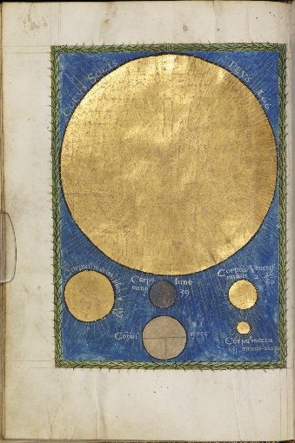
The Greek astronomer Ptolemy of Alexandria laid the scientific groundwork for the geocentric model of the universe around 150 CE, in part inspired by the prior work of predecessors such as Aristotle (400-300 BCE). The geocentric model claimed that Earth was the centre of the universe. In his treatise, The Almagest, Earth is a sphere at the centre of the cosmos; the moon, planets, sun, and stars revolved around it in a complex system of concentric circles. This was the underlying concept of the European and Arab portrayal of the universe that persisted for over 1,500 years, well into the sixteenth century. In the West, the geocentric model was reinforced by Christian beliefs about creation and was passed down through the generations. Muslim astronomers also enriched the world’s knowledge with their meticulous observations of the passage of the heavenly bodies. These observations allowed them to correct Greek astronomical errors. Byzantium, Spain, and southern Italy were gateways through which Islamic astronomy passed into Europe, made popular by a handful of texts translated into Latin. An impressive amount of classical Greek science was also translated from Arabic to Latin, allowing it to find an audience in Western Europe.
The Sun, Mars, Earth, Venus, the Moon, and Mercury
in: Christianus Prolianus, Astronomia Naples, 1478 © University of Manchester, Rylands Medieval Collection

The universe on a human scale

“A physician without a knowledge
of astrology has no right to call himself a physician.”

Hippocrates of Chios, ca. 400 BCE

The idea that macrocosm and microcosm are intimately connected was depicted as early as Mesopotamian, Egyptian, and Greek Antiquity, which assumed humans to be the centre of the universe. The individual is the ‘small world’ (microcosm) that reflects the ‘large world’ of the universe (macrocosm). ‘Cosm’ or cosmos means the harmonic order or interdependence of the parts in an organic system. For instance, phenomena and events observed in the macrocosm affect the microcosm. Astrologers saw omens in the position of the heavenly bodies that presaged events that would take place on Earth. Solar and lunar eclipses and the planetary alignment held sway over the fate of individuals and territorial domains alike.

In a different light

“Creating a new theory is not like destroying an old barn and erecting a skyscraper in its place. It is rather like climbing a mountain, gaining new and wider views, discovering unexpected connections between our starting points and its rich environment.”

Albert Einstein (Princeton – New Jersey, 1938)

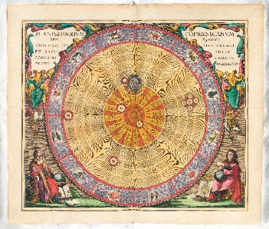
The eternal sense of awe at the splendour of the universe was and remains the most powerful incentive for continually assessing old beliefs against new notions and fine-tuning how we imagine the universe.
Copernican illustration of the universe in: Andreas Cellarius, Harmonia macrocosmica seu Atlas universalis et novus ... Amsterdam, 1660. © Amsterdam University Library
In 1543, Copernicus was the first to devise a mathematical model in which the Earth and other planets revolved around the sun. He believed that the sun, not the Earth, was the centre of the universe. Over half a century later, Johannes Kepler improved this heliocentric model to provide a highly accurate description of planetary movements. Galileo then confirmed Copernicus’ understanding with his first telescope observations in 1610. And in 1687, Newton’s theory of gravity eradicated the last vestiges of opposition to heliocentrism. Newton proved that the celestial bodies attract each other. Copernicus’ visionary imagination, Kepler’s meticulous calculations, Galileo’s telescopic observations, and Newton’s foundational theories radically altered how we look at the universe. And so, humanity invented a new place for itself in the universe.
The exhibition rounds off with the greatest scientific achievements of the sixteenth and seventeenth-century Western astronomers. They have been symbolically arranged around the lens of the telescope used by Christiaan Huygens in 1655 to discover Titan, Saturn’s first moon. On that lens, he had a verse by the Roman poet Ovid, engraved: Admovere Oculis Distantia Sidera Nostris - ‘They brought the distant stars closer to our eyes.’

AND THAT’S NOT ALL ...
M presents an array of lectures, debates, and gatherings related to the exhibitions. Two lectures will be hosted at M in tandem with the Imagining the Universe exhibition.

‘Everlasting Wonder’

Thursday 4 November: 7 p.m. – 8:30 p.m.
Speaker: Curator and Prof. Jan Van der Stock (KU Leuven)
Location: M (please note that capacity is limited)
Language: Dutch
Registration: mandatory, per bubble

Tickets and booking via https://www.mleuven.be/nl/denkvoer-eeuwige-verwondering

‘Imagining the Universe – The Marquise and the Philosopher – The Universe as Theatre’

Thursday 18 November: 7 p.m. – 8 p.m.
Speaker: Prof. Em. Geert Vanpaemel (KU Leuven history of science studies)
Location: M (please note that capacity is limited)
Language: Dutch
Registration: mandatory, per bubble

Tickets and booking via https://www.mleuven.be/nl/universum-als-theaterg

PRACTICAL
M LEUVEN
Vanderkelenstraat 28
3000 Leuven
+32 (16) 27 29 29
info@mleuven.be
www.mleuven.be

  - Plan your route to the museum

By bike
Cyclists are welcome! Parking is easy. Just use the secure underground bicycle parking at Rector de Somerplein. From there, it’s just a two-minute walk to the museum.

Via public transport
The museum is a ten-minute walk from Leuven Station. Rector de Somerplein is the closest stop if you’re coming by bus. Use Google Maps to plan your route.

By car
Leuven’s new circulation plan leads you into the city and car parks via a series of rings. Would you prefer to avoid the city’s traffic? Just park your car at one of the car parks on Leuven’s outskirts and catch a free bus to the centre. Prefer to park nearby? The Ladeuze car park is only a two-minute walk from the museum. There are also 18 spaces for disabled passengers (higher clearance: 1.90 m). Click here for more information on the circulation plan and parking options.

Webpage links:
https://www.mleuven.be/en/imagining-the-universe
https://www.mleuven.be/en/richard-long

Prezly link:
High-resolution images can be downloaded at the bottom of this press release:
https://mleuven.prezly.com/media

CONTACT

Hanne Grégoire
Head of Press & Communications
hanne.gregoire@mleuven.be
+32 (0)472 95 52 26

Samantha Fadahunsi
Press & Communications Officer
samantha.fadahunsi@mleuven.be
+32 (0) 491 35 02 95

