Sennheiser brings latest products to The Media Production & Technology Show
Audio specialist’s Evolution Wireless Digital microphone system and Neumann’s NDH 30 studio headphones will be on display for the first time at a UK show

Marlow, UK, May 2022 – Launched in 2016, in just six short years The Media Production & Technology Show has cemented its position as one of UK's largest events and a must-attend for the media and broadcast industries. This year, the show’s visitors will be able to experience Sennheiser’s Evolution Wireless Digital (EW-D), a wireless microphone system with a rich feature set and app-based workflow integration that makes it a unique solution at its price point. Neumann’s Miniature Clip Mic System (MCM) for close miking acoustic instruments in live applications raises the bar of electret capsules. It will be demoed at the show together with the recently announced NDH 30, a reference-class open-back studio headphones for editing, mixing, and mastering, and Neumann’s Automatic Monitor Alignment MA 1, ensuring the best possible sound quality in any room.

Evolution Wireless Digital (EW-D)
Providing the highest dynamic range of any wireless system currently on the market, EW-D utilises advanced features that simplify users’ setup and guarantee the most reliable connection. With EW-D, any speaker can maximize efficiency by taking full control with the Sennheiser Smart Assist app and automatically coordinate frequencies with ease. Increased bandwidth and the lowest latency of any digital wireless system currently available make Evolution Wireless Digital the most powerful tool for those who put quality and performance above all else.

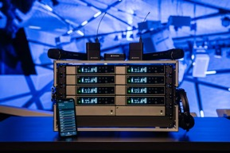 | Sennheiser Evolution Wireless Digital (EW-D) is a wireless microphone system with a rich feature set and an app-based workflow integration which makes this system a unique solution at its price point

Neumann NDH 30
The Neumann NDH 30 is a circumaural, open-back headphone with outstanding detail resolution and high-precision stereo imaging with razor-sharp localization. Its linear soundstage and superior transient response recommend it for the most demanding applications such as mixing and mastering. With its high linearity and detail resolution, the NDH 30 is perfectly compatible with a loudspeaker system that has been optimally calibrated using Neumann Automatic Monitor Alignment.

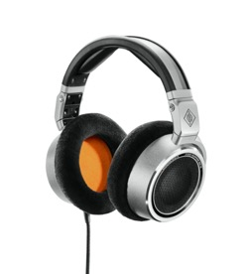 | Neumann NDH 30 is a reference-class studio headphone for the most demanding mixing and mastering applications in both stereo and immersive formats. The NDH 30 reproduces the linear sound image of a perfectly calibrated Neumann loudspeaker setup in a portable format.

Neumann Automatic Monitor Alignment MA 1
The MA 1 is an integrated hardware/software tool for acoustic calibration and room correction that is tailor-made for the company’s studio monitors. Calibration algorithms, jointly developed with Fraunhofer IIS, a leading institute for audio signal processing, are designed to help ensure monitoring quality in any environment, from acoustically untreated bedroom studios to professional control rooms. Neumann’s Automatic Monitor Alignment is available for all DSP-controlled stereo systems of the KH line, currently the KH 80 DSP as well as the analogue studio monitors KH 120, KH 310, and KH 420 in combination with the subwoofer KH 750 DSP.

Neumann Miniature Clip Mic System
To create the Miniature Clip Mic System, the Neumann engineers in Berlin elevated electret technology and its production process to a whole new level. The new KK 14 capsule is able to capture the details of sound better than anything that came before – without any of the production tolerances that have been associated with electret solutions to date. The system’s modular construction has been designed to ensure excellent stability and long service life for live and stage performances. The system includes nine mounting solutions that make it possible to find the optimum positioning for acoustics while simultaneously protecting the instrument. Typical users of this microphone system include orchestras, theatres, musical productions, concert halls, big bands, brass sections and drummers.

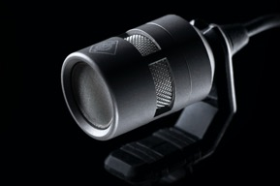 | Neumann’s Miniature Clip Mic System (MCM) for close miking acoustic instruments in live applications raises the bar of electret capsules

“MPTS provides us with a unique opportunity to be at the forefront of discussions affecting the media and broadcast industries, and it’s a great platform to learn and present the latest technological innovations,” says David Atkinson, Marketing Manager, Pro Audio at Sennheiser. “We’re thrilled to bring our roster of Sennheiser and Neumann solutions to the show and let visitors experience them first hand!”

Visit Sennheiser on Stand L526 at The Media Production & Technology Show at Olympia London from 11-12 May 2022.

(Ends)

About the Sennheiser brand
We live and breathe audio. We are driven by the passion to create audio solutions that make a difference. Building the future of audio and bringing remarkable sound experiences to our customers – this is what the Sennheiser brand has represented for more than 75 years. While professional audio solutions such as microphones, meeting solutions, streaming technologies and monitoring systems are part of the business of Sennheiser electronic GmbH & Co. KG, the business with consumer devices such as headphones, soundbars and speech-enhanced hearables is operated by Sonova Holding AG under the license of Sennheiser.

www.sennheiser.com
www.sennheiser-hearing.com

About Neumann
Georg Neumann GmbH, known as “Neumann.Berlin”, is one of the world’s leading manufacturer of studio-grade audio equipment and the creator of recording microphone legends including the U 47, M 49, U 67 and U 87. Founded in 1928, the company has been recognized with numerous international awards for its technological innovations. Since 2010, Neumann.Berlin has expanded its expertise in electro-acoustic transducer design to also include the studio monitor market, mainly targeting TV and radio broadcasting, recording, and audio production. The first Neumann studio headphone was introduced at the beginning of 2019. Georg Neumann GmbH has been part of the Sennheiser Group since 1991, and is represented worldwide by the Sennheiser network of subsidiaries and long-standing trading partners. www.neumann.com

Local Press Contacts

Sarah James Maik Robbe
sarahj@gasolinemedia.com maik.robbe@sennheiser.com
+44 (0) 1483 223333 +44 (0) 7393 462484

