For more information, please contact Marta de Paco
On +34 670 780 664 or email press@comunicahair.com

Important:
These images are only available for editorial content.
Credits must be included.

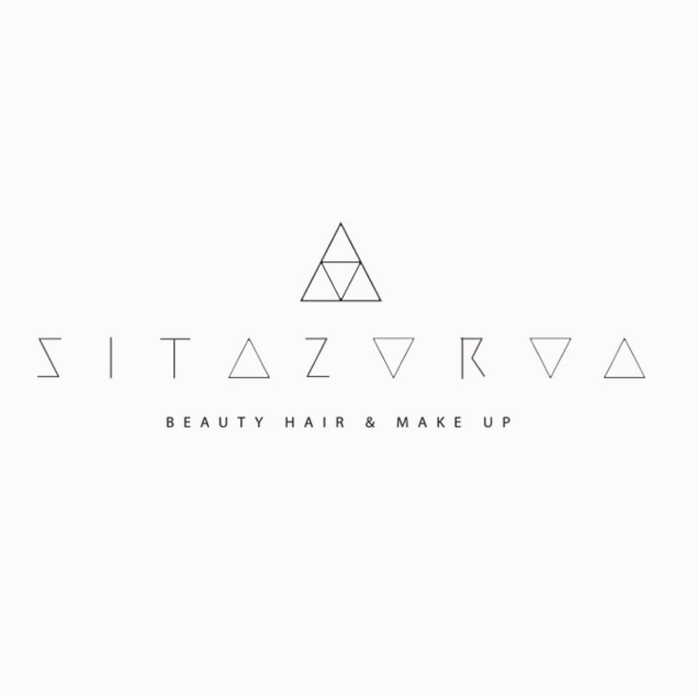
SITA ZOROA
CLARENDON Collection

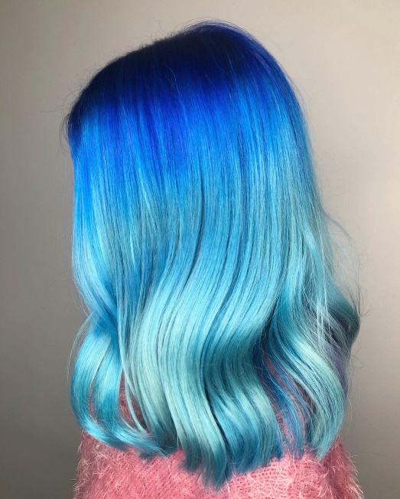
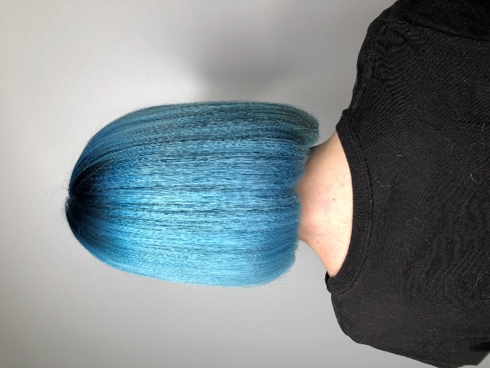
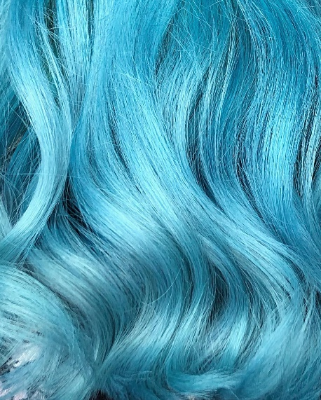

Hair: Sita Zoroa
Hair Instagram: @sita_zoroa
Products: Indola
Products Instagram: @indolaspain

SITA ZOROA
CLARENDON Collection

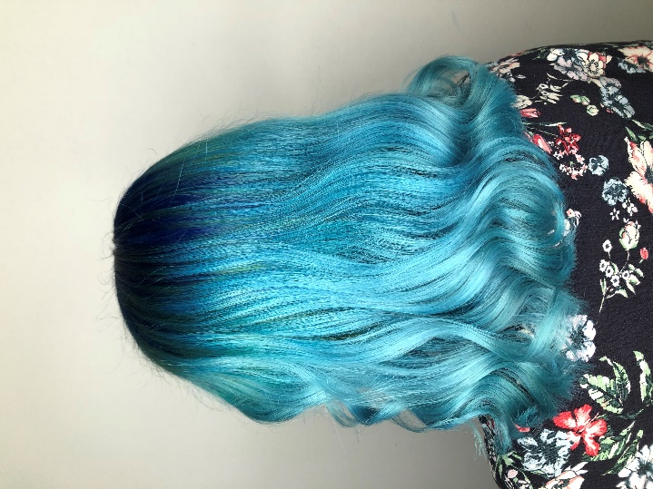

This work is inspired by the sea tones, and shows us vibrant hair that at the same time transmits peace and depth.

Blue tones are sometimes combined with subtle darker streaks or with the dimension of navy blue or klein blue. The result is a color very rich in nuances, never flat, reminiscent of aquamarine. The color on the wavy hair simulates the waves and on the smooth mane simulates the calm sea that hypnotizes us.

