July 21, 2017
Toyota Motor Corporation
GAZOO Racing Company

Rally Finland: Preview
TOYOTA GAZOO Racing’s trio of Finns ready to fly at home

The TOYOTA GAZOO Racing World Rally Team is ready to take on the fastest event of the season, Rally Finland (July 27-30), with its trio of home-grown drivers: Jari-Matti Latvala, Juho Hänninen and Esapekka Lappi.
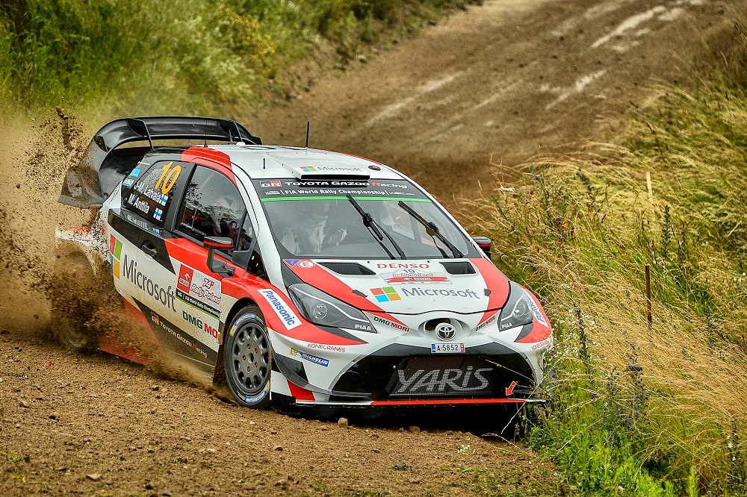

Car 10(Jari-Matti Latvala, Miikka Anttila)

Rally Finland is famous for its fast gravel stages through forests, featuring large jumps and numerous crests. Many of these are located on corners, making the positioning of the car for the perfect take-off crucial to carrying speed through the bend. The stages are mostly wide with a smooth and compact gravel surface that contributes to the rapid pace.

Jyväskylä hosts the service park and the opening Thursday-night Harju street stage, which is run again at the end of a very long day on Friday that consists of 12 stages. There are another eight stages on Saturday, including two runs over the most famous test of all, Ouninpohja. Four more stages round out the action on Sunday, with the Oittila Power Stage set to begin at 13:18 local time.

As well as the drivers, Rally Finland is a home event for team principal Tommi Mäkinen, and one that he won four times during his career behind the wheel. Latvala has the opportunity to match that achievement, having already claimed victory in 2010, 2014 and 2015. Hänninen finished in the top six on his last two attempts in 2014 and 2015, while Esapekka Lappi has come eighth overall in the past two years while also dominating the WRC2 category. With the team based very close to Jyväskylä, the Yaris WRC has completed plenty of development running on local roads as well as specific pre-event testing.

Quotes:

Tommi Mäkinen (Team Principal)
“Finland is a very special home rally for us, and as long as the drivers are feeling confident, then I am feeling confident too. I think we are well prepared as we have quite a lot of experience of Finnish stages. On the other hand, our car has been constantly evolving so we are always discovering new things. What’s certain is that this rally is going to be an incredible experience for all of us and we’ll see lots of fans on the stages. We have a great line-up of drivers: Jari-Matti knows how to win here, Juho is very experienced and fast, while Esapekka is young and hungry. I think they will all be very strong.”

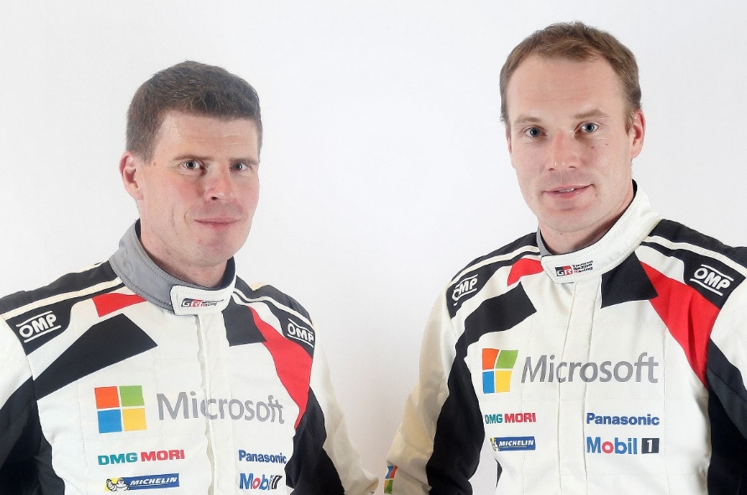
Jari-Matti Latvala (Driver car 10)
Miikka Anttila and Jari-Matti Latvala
“Along with Monte-Carlo, Finland is the rally that everyone wants to win; especially if you are Finnish. There’s pressure to do well, but it’s a positive pressure. No doubt about my target: victory. I’m feeling confident, but I don't think there’s such a thing as a big home advantage for Finnish drivers anymore. Now that so many of the stages are used every year, the other drivers have got a lot of experience as well. I’m expecting a big fight.”

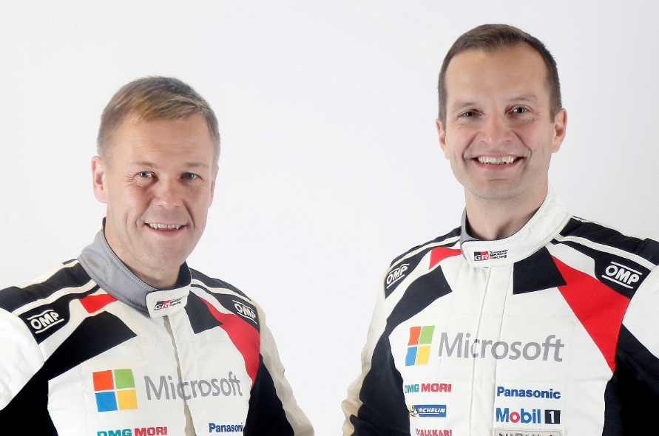
Juho Hänninen (Driver car 11)
Kaj Lindström and Juho Hänninen
“Finland is the rally I have done more than any other, so I’m feeling quite confident. I don't want to set any specific targets but I’m definitely going to push hard from the start and see how high we can finish. There’s no choice in Finland: the speeds are so fast that you don’t have time to build up to speed; you have to be awake from the first corner. The work we did on the test was mainly on the suspension and now it feels really good. I also had some rain at the start of my test but this is positive as it means that the roads should be really compact and in the right condition for the rally.”

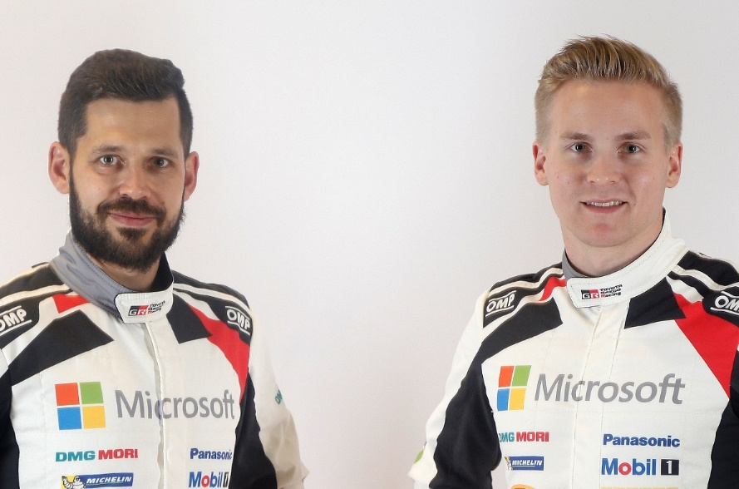
Esapekka Lappi (Driver car 12)
Janne Ferm and Esapekka Lappi
“It’s going to be really exciting to take part in my home event for the first time with a World Rally Car. I think there’s a chance that if we have a perfect rally we could be on the podium, but everything would have to go without a hitch because the gaps in Finland are normally so small. Our car should be very well suited to the roads in Finland: I think the aerodynamics and engine are really our strong points. This rally is a big job for my co-driver Janne too as he’ll be calling out the pace notes at speeds that are much faster than we have ever experienced in Finland before.

The statistics (Rally Finland):
Year | Jari-Matti Latvala | Juho Hänninen | Esapekka Lappi
2016 | 2 | - | 8
2015 | 1 | 6 | 8
2014 | 1 | 6 | -
2013 | 17 | 32 | 31
2012 | 3 | - | 25
2011 | 2 | 10 | 32

2017 FIA World Rally Championship for drivers after round eight:

1 Sebastien Ogier 160
2 Thierry Neuville 149

3 Jari-Matti Latvala 112

4 Ott Tanak 108
5 Dani Sordo 82
6 Elfyn Evans 57
7 Hayden Paddon 51
8 Craig Breen 43

9 Juho Hänninen 30

10 Kris Meeke 27

13 Esapekka Lappi 20

2017 FIA World Rally Championship for manufacturers after round eight:

1 M-Sport World Rally Team 259
2 Hyundai Motorsport 237

3 TOYOTA GAZOO Racing WRT 153

4 Citroen Total Abu Dhabi World Rally Team 117

Team Media Hour – Rally Finland

Wednesday 26 July at the TOYOTA GAZOO Racing World Rally Team hospitality in the Paviljonki service park, with drivers and management present, from 18:30-19:15. All media are welcome.

Press release

URL: http://toyotagazooracing.com/release/2017/wrc/rd09-preview.html

Pictures will be uploaded here during the event

URL: https://www.tgrwrt.com/ ( ID and Password needed)

Follow us!
Follow TOYOTA GAZOO Racing WRT:

∇Facebook: https://www.facebook.com/TOYOTAGAZOORacingWRC
∇Twitter: https://www.twitter.com/TGR_WRC (@TGR_WRC)
∇Instagram: https://www.instagram.com/tgr_wrc/ (@TGR_WRC)
∇YouTube: https://www.youtube.com/channel/UCCtALHup92q5xIFb7n9UXVg

<Contact>

TOYOTA GAZOO Racing PR Office
Email: tgr_pr @rights-apartment.com

TOYOTA GAZOO Racing Official website
http://toyotagazooracing.com/

TOYOTA GAZOO Racing World Rally Team is supported by following partners:
