Synthax Named U.S. Distributor of Digigram, Maker of Audio Solutions for
Broadcasters, Installers

The latest addition to Synthax’s portfolio offers a wide range of solutions for both broadcasters and audio installers
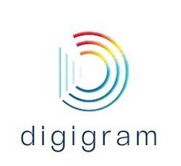
Fort Lauderdale, Florida, July 9, 2019 – Synthax, distributor of premium interface manufacturer RME, converter manufacturer Ferrofish and personal monitor mixer myMix, has announced that it is now the exclusive U.S. distributor of French audio over IP manufacturer Digigram.
For the last 30 years, Digigram has designed and developed innovative digital systems that help broadcasters easily deliver their content. At the forefront of IP audio system development, Digigram manufacturers a range of products, from professional sound cards and advanced audio coding systems to powerful cloud-based codec management services. These solutions are also an easy way for museums, retail stores, schools, theme parks, transportation centers and more to broadcast public address announcements throughout their space over the internet.
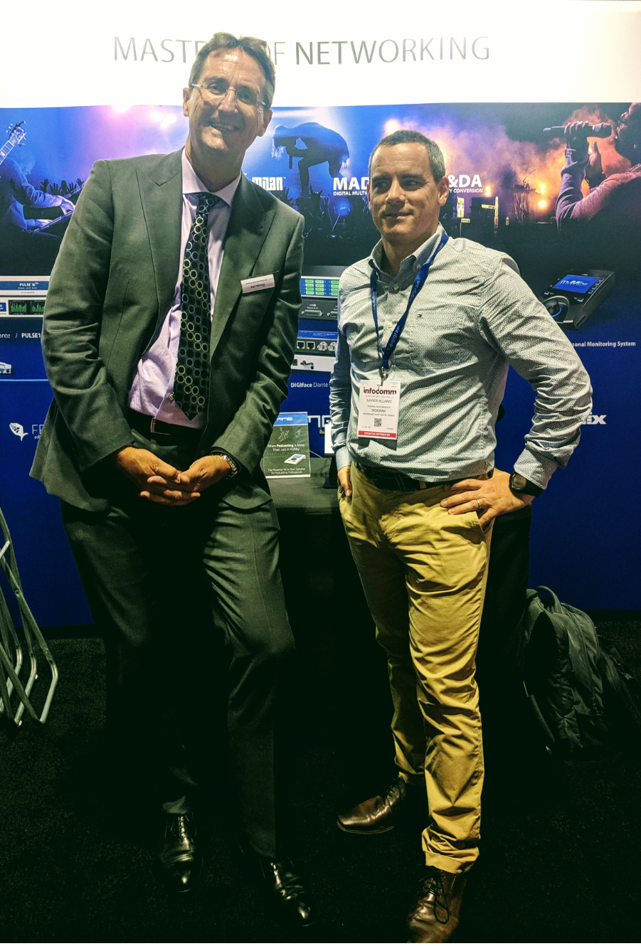
Both Synthax and Digigram share similar business strategies and are both leaders in the audio over IP space, making the new distribution deal a perfect fit.
“We are thrilled to team up with Synthax USA,” said Xavier Allanic, Sales Director at Digigram. “This new partnership provides us with the perfect boost we needed to deploy Digigram’s commercial strategy throughout North America.”
“Acting as Digigram’s exclusive distributor in the US, Synthax USA has the experience to broaden Digigram’s spectrum as our range of solutions are key to making customers’ day-to-day operations simpler,” Allanic continued. “We are excited about this new chapter and working hand-in-hand with Synthax.”

“Digigram is on the cutting edge of audio over IP, offering end-users solutions that not only fill their current audio needs but also keep them ready for the future,” said Mathias von Heydekampf, Managing Director of Synthax. “Digigram’s solutions provide both radio and TV broadcasters as well as audio installers solutions that help simplify every-day operations while streamlining the delivery of their content.”
The distribution deal is effective immediately.
For more information on Synthax, visit: https://www.synthax.com/
For more information on Digigram, visit: https://www.digigram.com/
About Synthax, Incorporated
Synthax Inc. is the exclusive USA distributor for RME digital audio solutions, Ferrofish advanced audio applications, myMix audio products, and ALVA cableware. We supply a nationwide network of dealers with these products for professional audio, broadcast, music industry, commercial audio, theater, military and government applications. For additional information, visit the company online at http://www.synthax.com.
About Digigram
For over 30 years, Digigram has developed innovative digital systems that make modern broadcasters rapidly evolving operations more efficient, more reliable and more effective. Used by thousands of journalists, broadcasters and industrial users all over the world, Digigram’s sound cards, audio processing software and pioneering IP audio technologies are designed with a consistent attention to quality and reliability. Digigram (DIG) is publicly listed on the NYSE Euronext Paris stock exchange. More information is available at http://www.digigram.com/.

Media Contacts:
Katie Kailus
Public Relations
Hummingbird Media
+1 (630) 319-5226
katie@hummingbirdmedia.com

Jeff Touzeau
Public Relations
Hummingbird Media
+1 (914) 602 2913
jeff@hummingbirdmedia.com

