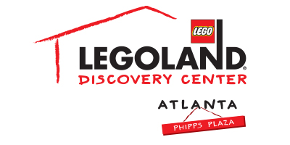
For more information:
Katie Clark
BRAVE Public Relations
kclark@bravepublicrelations.com

**MEDIA ADVISORY**

LEGOLAND® Discovery Center Atlanta to close temporarily for
routine cleaning, January 29 – January 31
Phipps Plaza attraction to jump start spring cleaning with annual cleaning and maintenance to enhance overall guest experience

ATLANTA (January 10, 2017) – LEGOLAND® Discovery Center Atlanta will briefly close from January 29 – January 31 for routine cleaning and maintenance to ensure the safest and most enjoyable guest experience.

“We want to thank our fans for their patience and understanding as we take this short break,” said Whitney Kemmerick, marketing manager of the popular attraction. “LEGOLAND Discovery Center Atlanta is dedicated to offering a clean and safe play environment for its guests, which is why routine cleaning and maintenance is necessary. We look forward to seeing our guests return when we reopen on February 1!”

For more information, follow along on Twitter, Instagram and Facebook or online at atlanta.legolanddiscoverycenter.com.

About Merlin Entertainments
MERLIN ENTERTAINMENTS plc is the leading name in location-based, family entertainment. Europe’s Number 1 and the world’s second-largest visitor attraction operator, Merlin now operates 111 attractions, 12 hotels/4 holiday villages in 23 countries and across 4 continents. The company aims to deliver memorable and rewarding experiences to its almost 63 million visitors worldwide, through its iconic global and local brands, and the commitment and passion of its managers and estimated 26,000 employees (peak season).

Among Merlin’s attractions are - SEA LIFE, Madame Tussauds, LEGOLAND, DreamWorks Tours SHREK’s Adventure, The London Eye, Dungeons, Gardaland, LEGOLAND Discovery Centres, Alton Towers Resort, Warwick Castle, THORPE PARK Resort, Blackpool Tower, Heide Park Resort, Sydney Tower Eye and SKYWALK. All brands which are distinctive, challenging and innovative – and which have great potential for growth in the future. Visit www.merlinentertainments.biz for more information.

###

