The sound for their vision
Sennheiser’s outstanding audio solutions for filmmakers, content creators and vloggers are the ideal gift for creatives looking to add exceptional sound to their video

Wedemark, October 12, 2021 – When you’re buying for anyone with a passion for video or filmmaking, it can be hard to know where to start. However, many creatives focused on honing their visual artistry – and camera and lens collections! – can often overlook how great sound can bring their work to life and take their content to the next level. From mobile kits for vlogging, shotgun mics for the most demanding environments, to an ultra-convenient digital wireless lavalier for crystal-clear dialogue, audio specialist Sennheiser has the perfect solution for giving the gift of great sound this festive season.

MKE 200 Mobile Kit – The ideal go-anywhere kit for vlogging and content creation
If you’re buying for a keen vlogger or content creator that’s often on the move, Sennheiser’s MKE 200 Mobile Kit is the ideal choice and a great option for those seeking to step up their smartphone content. Compact enough to even fit in a pocket for go anywhere convenience, the kit includes Sennheiser’s MKE 200 directional on-camera microphone and Smartphone Clamp, as well as a Manfrotto PIXI Mini Tripod. The MKE 200, which is suitable for DSLRs, mirrorless cameras and smartphones, features a built-in windscreen and shock mount to help reduce handling noise while the durable solid aluminium Smartphone Clamp with soft runner grips allows for both portrait and landscape orientation. The Manfrotto PIXI features a locking ball head which can be adjusted with the push of a button, making composing shots a breeze.

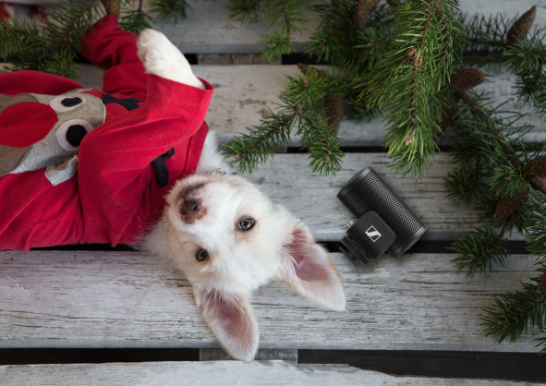 | Sennheiser’s first step to upgrading your sound, the MKE 200 is a directional on-camera microphone with built-in wind protection and shock absorption for enhanced in-camera audio

- MKE 200 Mobile Kit is ideal for vloggers and content creators that use a smartphone as part of their creative toolkit
- Microphone features integrated windscreen and shock mount
- Complete with Smartphone Clamp, cold shoe mount, Manfrotto PIXI Mini Tripod, two locking cables for smartphone or DSLR use and furry windshield for outdoor use
- Durably constructed components built to withstand daily use
- No batteries required, the microphone is powered by the smartphone
- MSRP (incl. VAT): EUR 129. The MKE 200 is also available without tripod and smartphone clamp at EUR 99.

Get the shot, get the sound – MKE 400
Perhaps you’re buying for someone that needs just a bit more control? Sennheiser’s MKE 400 is a compact, highly directional on-camera shotgun microphone that is designed to isolate and enhance audio for video. Just like the MKE 200, the MKE 400 includes built-in wind protection and integrated shock absorption, but this model offers even more features to ensure the best possible recordings. The MKE 400 is fitted with a low-cut filter and three-step sensitivity switch to give you full control over the sound and features a headphone monitoring output with integrated digital volume control. Two AAA batteries are all that is needed to power the microphone for up to 100 hours of continuous audio capture.

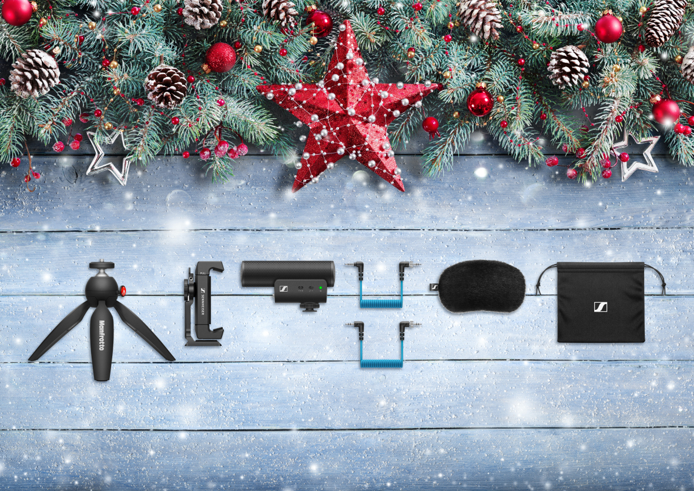 | Offering distortion-free sound in any environment, the MKE 400 is a compact, highly directional on-camera shotgun microphone designed to isolate and enhance the audio for your video. Pictured is the MKE 400 Mobile Kit

- Highly directional, compact, on-camera shotgun microphone to enhance the audio for your video
- Integrated wind protection and internal shock mount to eliminate handling noise
- Switchable low-cut filter to eliminate wind noise
- Three-step sensitivity switch
- Convenient headphone output allows you to monitor your levels while recording
- Manual or automatic power on/off
- Complete with two locking cables for smartphones or DSLR/Ms and furry windshield for outdoor use
- MSRP (incl. VAT): EUR 199. Also available as MKE 400 Mobile Kit with Sennheiser Smartphone Clamp and Manfrotto PIXI Mini Tripod (EUR 229)

Great mobile and computer audio is just a clip away with the XS Lav USB-C
This brilliant value mic is a great choice to give the gift of better audio with mobile devices and computers – and it’s especially great for enhancing dialogue. The XS Lav USB-C is an omni-directional clip-on lavalier mic that delivers a clear, natural sound for interviews, vlogs, podcasts and more. Also available is the XS Lav Mobile with 3.5mm TRRS connector and the XS Lav USB-C Mobile Kit, which adds the Smartphone Clamp and Manfrotto PIXI to the USB-C lavalier microphone to create an ideal vlogging and podcasting bundle.

Designed for vloggers and content creators on the move, the XS Lav is an omni-directional clip-on lavalier mic that delivers a clear, natural sound for interviews, vlogs, podcasts and more

- Omni-directional lavalier microphone provides clear, natural sound
- Ideal for podcast, video and voice-over recordings that require a simple, high-quality set-up
- Accessories include mic clip, windshield and storage pouch; the XS Lav USB-C additionally comes with a Sennheiser Smartphone Clamp and Manfrotto PIXI
- USB-C connector for use with mobile devices and computers
- Cable length of 2m (6.6’) gives you enough room to move
- MSRP (incl. VAT): XS Lav USB-C: EUR 59, XS Lav USB-C Mobile Kit: EUR 99. Also available as XS Lav Mobile with 3.5mm TRRS plug (EUR 49).

XSW-D Portable Lav Mobile Kit: Effortless and seamless wireless digital audio
Giving a gift to a really demanding vlogger or content creator? This wireless digital audio solution could be the ultimate way to take their sound to new heights. The XSW-D Portable Lav Mobile Kit is a wireless audio system offering one-touch ease-of-use and digital transmission to seamlessly link the audio source to the smartphone or camera. Equipped with an ME 2-II omni-directional lavalier microphone, this elegant solution makes it so much easier to capture dialogue on a smartphone – or a DSLR/M – all while maintaining a reliable connection. The Mobile Kit includes a Smartphone Clamp, as well as the Manfrotto PIXI Mini Tripod.

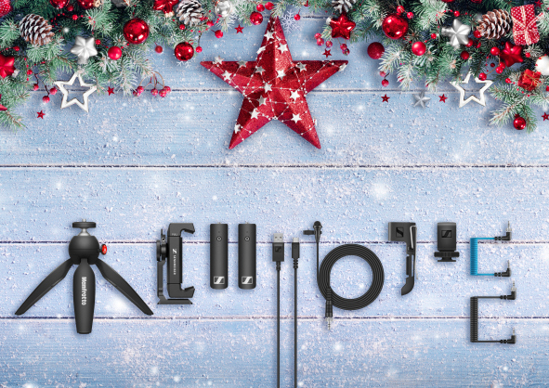 | The XSW-D Portable Lavalier Mobile Kit features a complete 2.4 GHz wireless lavalier system combining functionality with efficiency for the ultimate vlogging experience

- Easy-to-use wireless lavalier solution for demanding vloggers and content creators
- Mobile Kit comes complete with transmitter, ME 2-II clip-on microphone, camera receiver, Smartphone Clamp, Manfrotto PIXI Mini Tripod, TRS and TRRS locking cables, camera cold shoe mount, transmitter clip and charging cable
- Durably constructed components built to withstand daily use
- MSRP (incl. VAT): EUR 329

Get closer to the sound – with the MKE 600
For filmmakers seeking to take on the most demanding filmic challenges, a shotgun mic is a gift that will be really appreciated. Due to its high directivity, Sennheiser’s MKE 600 is the ideal video camera/camcorder microphone for challenging situations, picking up sounds coming from the direction in which the camera is pointing and effectively attenuating noise coming from the sides and rear.

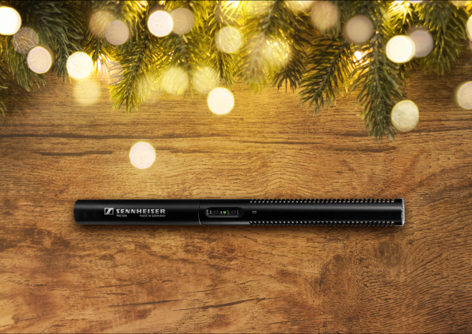 | The MKE 600 is the ideal video camera/camcorder microphone able to handle even the most demanding filmic challenges thanks to its high directivity and rugged all-metal housing

- Shotgun mic offers pronounced directivity with maximum rejection of side noise
- Switchable low-cut filter minimizes wind noise
- Phantom or battery powering; battery on/off switch with low-batt indicator
- Rugged all-metal housing
- Very good suppression of structure-borne noise
- Supplied with foam windshield, camera shock-mount, battery and XLR3F to TRS cable
- MSRP (incl. VAT): EUR 299

A truly legendary gift: the Sennheiser HD 25
For a truly timeless gift, how about a set of monitoring headphones with a legendary status? Revered across the broadcast and music industries due to their toughness, low weight and optional one-ear listening, HD 25 headphones are indispensable for monitoring. Capable of handling very high sound pressure levels and of extremely robust construction, the closed-back HD 25s perform exceptionally well in loud environments where they offer high attenuation of background noise.

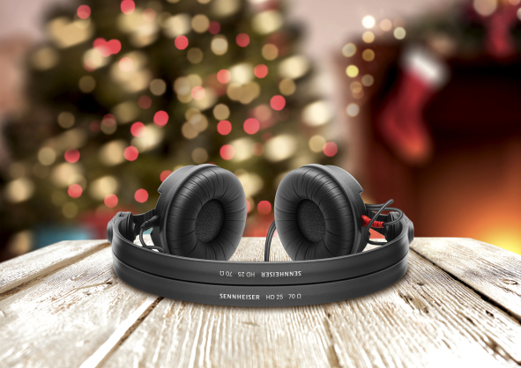 | The HD 25s are a pair of true sound professionals’ working headphones, lightweight and of extremely robust construction

- Closed, supra-aural monitoring headphones
- Professional split headband and rotatable ear-piece for one-ear listening
- High sensitivity due to lightweight aluminium voice coils
- Capable of handling very high sound pressure levels
- Rugged design
- Very lightweight and comfortable, even if used for long periods of time
- MSRP (incl. VAT): EUR 149

(Ends)

The images accompanying this press release can be downloaded here.
Standard product shots can be downloaded here.

About Sennheiser
Shaping the future of audio and creating unique sound experiences for customers – this aim unites Sennheiser employees and partners worldwide. The independent family company, which is managed in the third generation by Dr. Andreas Sennheiser and Daniel Sennheiser, is today one of the world’s leading manufacturers of headphones, loudspeakers, microphones and wireless transmission systems. In 2020, the Sennheiser Group generated turnover totaling €573.5 million. www.sennheiser.com

Global Press Contact

Stephanie Schmidt
Stephanie.schmidt@sennheiser.com
+49 (5130) 600 – 1275

