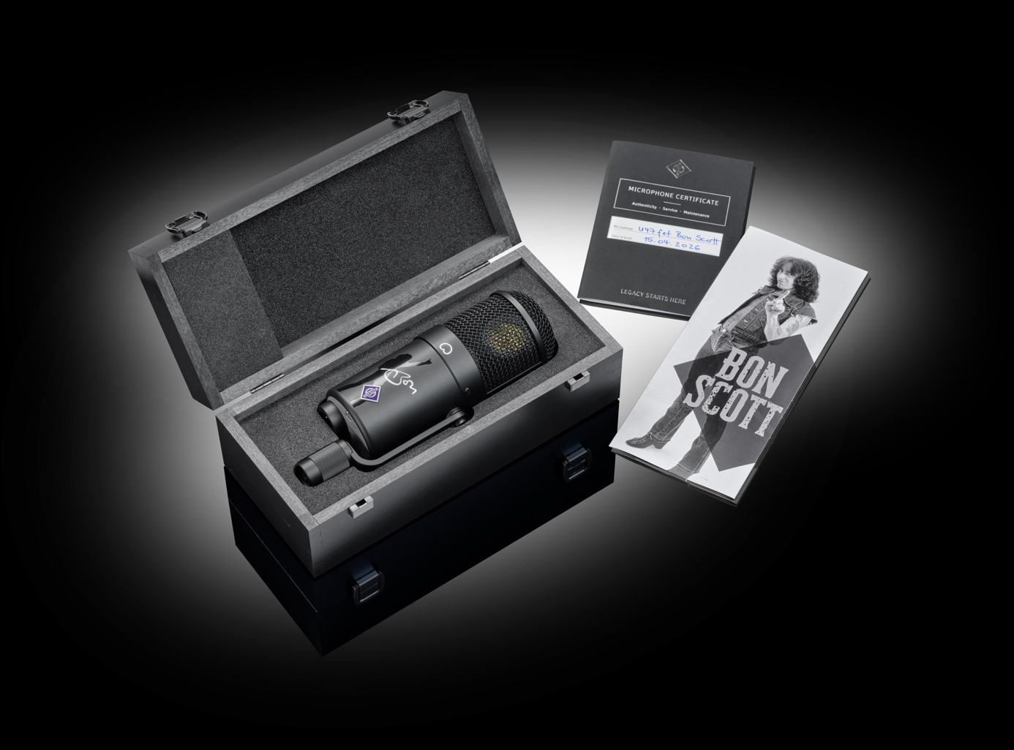

Neumann Celebrates a Rock Icon – The U 47 fet Bon Scott Edition

The Voice of High-Voltage Rock, Captured for Eternity
Berlin, Germany, July 1, 2026 – Neumann proudly unveils the U 47 fet Bon Scott Edition, a strictly limited special edition of one of the most iconic studio microphones in recording history. In partnership the Bon Scott Estate, this exclusive release honors Bon Scott, the electrifying frontman of AC/DC, and the microphone that captured the raw energy and unmistakable character of his voice on some of rock’s most influential recordings.
Based on the current production U 47 fet reissue, the Bon Scott Edition pairs the unmistakable sound of a true studio classic with bold visual elements and a premium collector’s presentation. Limited to just 300 units worldwide, it stands as both a world-class recording tool and a tribute to a defining era of rock.

Where Rock History Found Its Voice
In the 1970s, producers Harry Vanda and George Young needed a microphone that could keep up with Bon Scott’s explosive vocal style – powerful, gritty, and full of attitude. Their choice was the Neumann U 47 fet.
With its extraordinary headroom and signature midrange presence, the U 47 fet became the driving force behind Scott’s vocals on early AC/DC albums, including Let There Be Rock. It captured not just the power, but the personality – ensuring his voice cut through thunderous guitars without losing its edge.
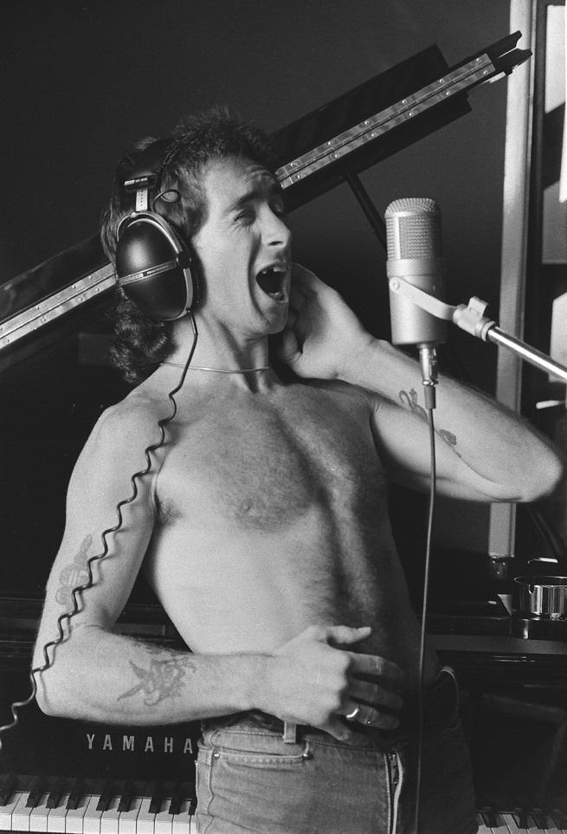
As Harry Vanda recalls, the microphone allowed Bon’s voice to “sit best with the guitars,” delivering exactly the sound that would help define a genre.

A Studio Legend, Turned Modern Classic
Introduced in 1972 as the solid state successor to the original tube-based U 47, the U 47 fet quickly earned its reputation as a go-to microphone for loud, demanding sources. Its FET design offered remarkable headroom while retaining the unmistakable tonal authority of the U 47 family.
Since its return to production in 2014, the U 47 fet has remained a trusted choice for engineers worldwide – equally at home on vocals, amplifiers, and drums.
The Bon Scott Edition preserves this legacy in full: identical in sound and performance to the current U 47 fet reissue, delivering the same punch, clarity, and character that have made it a studio essential.

A Collector’s Piece with Attitude
The Bon Scott Edition brings a distinctive visual identity to this legendary microphone, celebrating its connection to rock history:
- Matte black finish with bold Bon Scott graphics
- Bon Scott’s name and signature on the microphone body
- Exclusive black wooden presentation box
- Collector’s booklet featuring an interview with producer Harry Vanda
Each unit is individually numbered, underscoring its rarity and collectability.

Built for Power and Presence
Engineered for the most demanding recording environments, the U 47 fet Bon Scott Edition handles up to 137 dB SPL (147 dB with pad engaged), making it perfect for:
- Powerful, high-energy vocals
- Guitar and bass amplifiers
- Kick drums and high-impact sources
Its unmistakable midrange authority and massive headroom make it the ideal choice whenever sound needs to hit hard – and cut through.

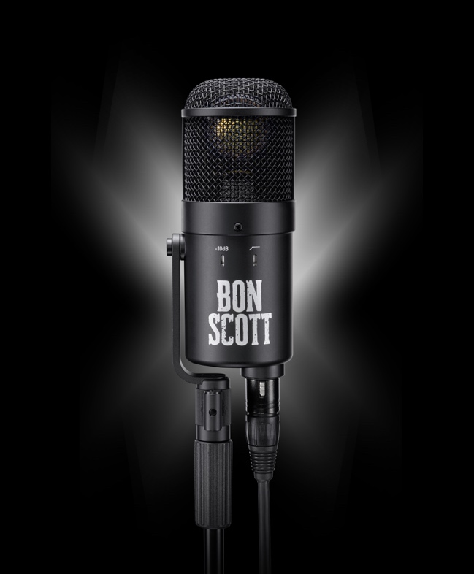
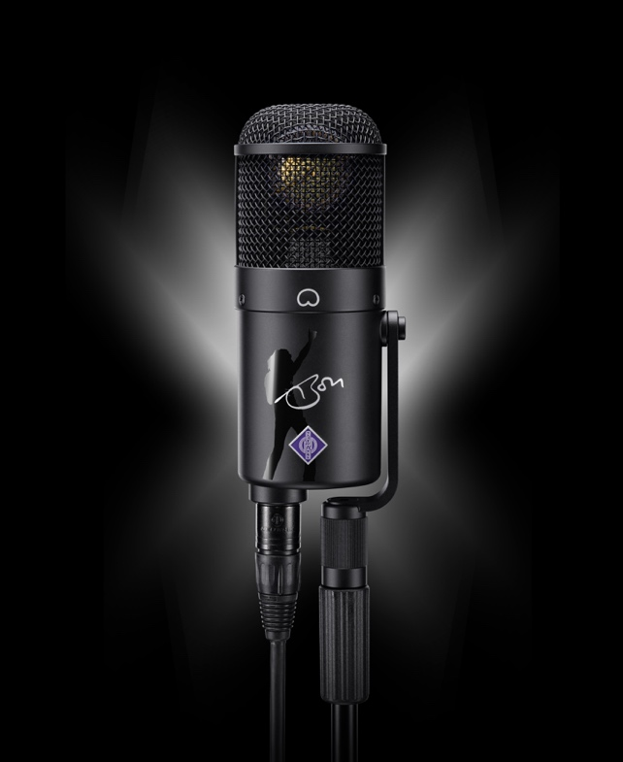
Giving Back
In the spirit of supporting the music community Neumann and Bon Scott's family will donate a portion of proceeds from this edition to Support Act Australia, helping artists and industry professionals in need.

Availability
The U 47 fet Bon Scott Edition will launch on July 9, 2026, marking what would have been Bon Scott’s 80th birthday.
In Europe and Asia, the U 47 fet Bon Scott Edition will be available from select dealers.
In North and South America, it will be sold exclusively through Sweetwater and Guitar Center.
Product page Sweetwater: https://www.sweetwater.com/store/detail/U47FETbonsc
Product page Center: https://www.guitarcenter.com/Neumann/U47-fet-Bon-Scott-Edition-Condenser-Microphone-1500000484261.gc
With only 300 units available worldwide, this special edition is set to become an instant classic.
For more information, visit www.neumann.com and Bon Scott official



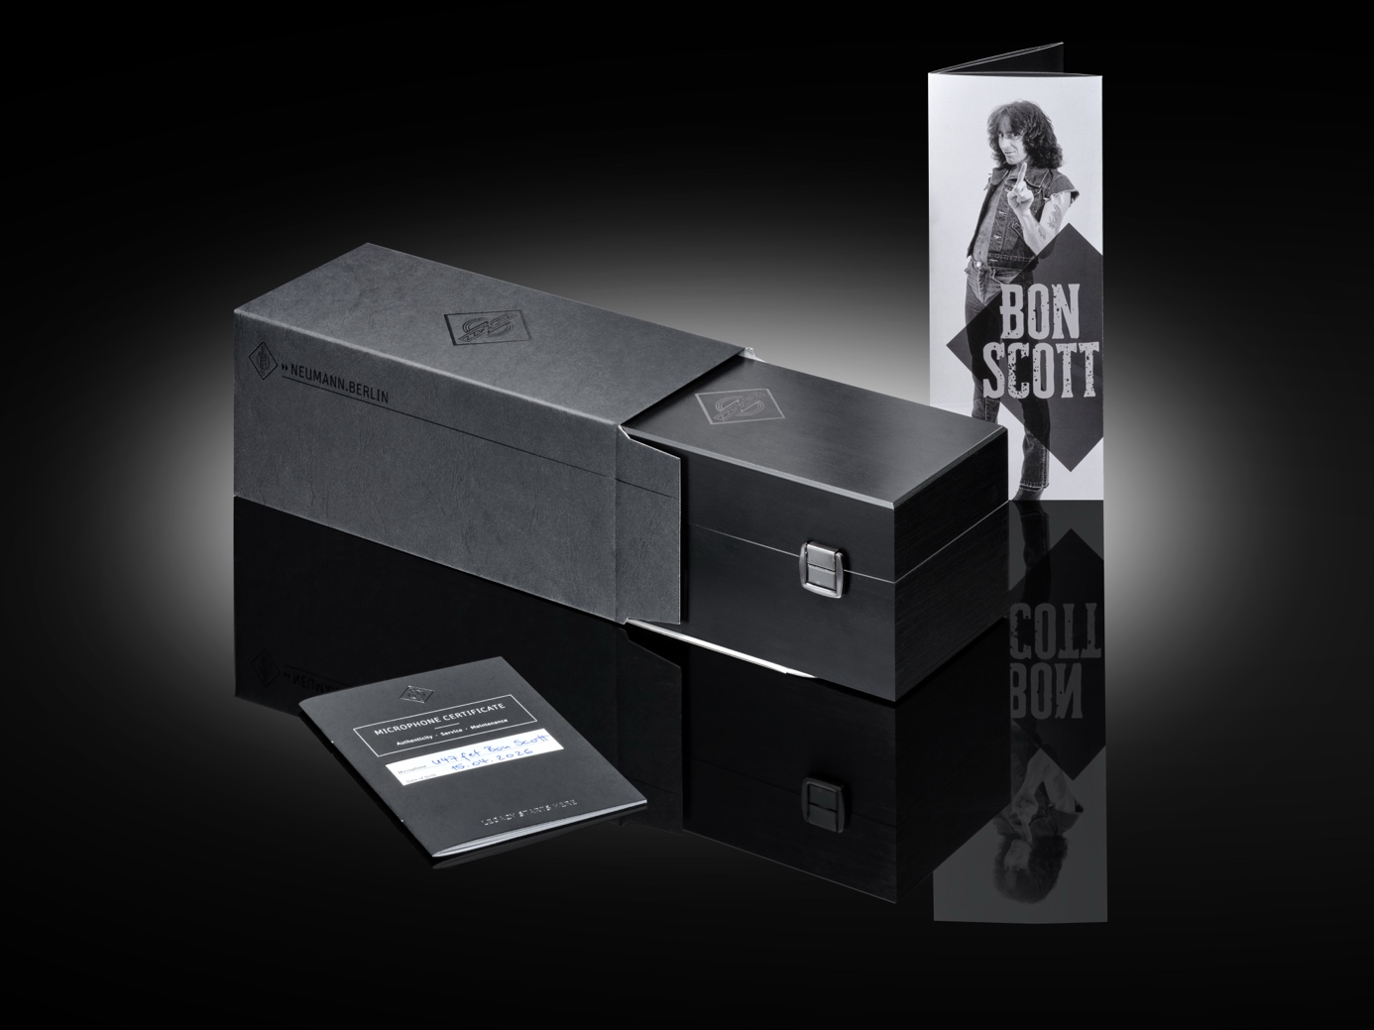

About Neumann
Georg Neumann GmbH, known as “Neumann.Berlin”, is one of the world’s leading manufacturers of studio-grade audio equipment and the creator of recording microphone legends such as the U 47, M 49, U 67, and U 87. Founded in 1928, the company has been recognized with numerous international awards for its technological innovations. Since 2010, Neumann.Berlin has expanded its expertise in electro-acoustic transducer design to also include the studio monitor market, building upon the legacy of the legendary loudspeaker innovator Klein + Hummel. The first Neumann studio headphones were introduced in 2019, and since 2022, the company has increased its focus on reference solutions for live audio. With the introduction of the first audio interface MT 48, and its revolutionary converter technology, Neumann now offers all the necessary technologies needed to capture and deliver sound at the highest level. Georg Neumann GmbH has been part of the Sennheiser Group since 1991 and is represented worldwide by the Sennheiser network of subsidiaries and long-standing trading partners. www.neumann.com
Stay up to date and follow us on: FACEBOOK I INSTAGRAM I YOUTUBE

Press Contact Neumann:
Neumann Newsroom
newsroom@neumann.com
+49 30417724-0

