IMS Productions Chooses Xytech’s MediaPulse

The multimedia production company turns to the facility management software
for its adaptability, flexibility

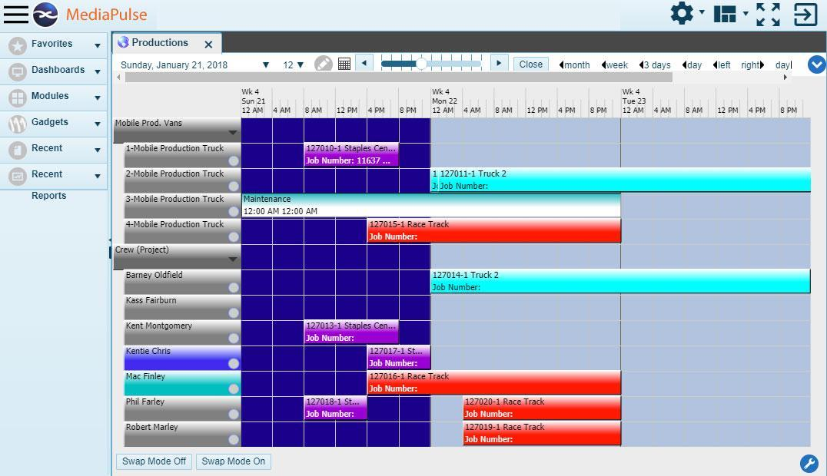
Indianapolis, January XX, 2018 — Located across the street from the iconic Indianapolis Motor Speedway, IMS Productions is a premier multimedia production company, maintaining mobile television and content divisions nationwide, as well as the IMS Radio Network providing live coverage of Indianapolis Motor Speedway events.

The mobile television department is the biggest facility at IMS Productions with a fleet of 15 trucks capable of handling six productions simultaneously. IMS Productions’ trucks work coast to coast covering the NBA’s Indiana Pacers and Los Angeles Lakers, IndyCar races, auto auctions and the Red Bull Global RallyCross, among other events. The company deployed Xytech’s MediaPulse facility management software to achieve operational and financial control over their diverse service offerings.

“Our mobile television division has a lot of moving parts,” said Robby Greene, president of IMS Productions. “Each show we do is different; we manage and move people and equipment all over the country. This is live TV so we absolutely must get things right the first time. We need to be able to access our assets and have confidence in tracking where they are at any given time. MediaPulse does this for us.”

Adaptability & Flexibility
While the company initially began using MediaPulse two years ago to schedule engineers and drivers for productions nationwide, IMS Productions recently expanded MediaPulse for invoicing, cost tracking and financial forecasting.

A team of a half-dozen IMS Productions’ employees chose MediaPulse after examining products offered by three software developers. MediaPulse offered IMS Productions the adaptability and flexibility it needed to manage the complexity of its mobile television facility.

“We really needed a product we could customize to our needs,” Greene said. “MediaPulse gave us the flexibility to do just this. Our IT team works with Xytech to implement options to give us a solution tailored to what we want to do. We’re at close to 100-percent utilization now for tracking our mobile division’s people and assets.”

IMS Productions also implemented MediaPulse for its content division. MediaPulse efficiently schedules employees’ time to make the best use of the company’s edit bays and creative talent.

“We expect to see the same level of momentum and positive progress from our content division as we did when our mobile television division began using MediaPulse,” Greene said.

Now, IMS Productions is ready to step up to the Divisions Module to securely manage information access. The new module allows easy access to specific types of information by different user groups to further streamline operations.

“Our team at Xytech has been a real partner in helping us maximize MediaPulse to reap the benefits of the product,” Greene said. “We’ve been so impressed by what MediaPulse has delivered, we’re now embracing the software in additional ways and exploring what Divisions has to offer us next.”

About Xytech Systems: For 30 years, the world’s premiere media companies have depended on Xytech to run their businesses. MediaPulse is the only end-to-end solution for the complete content lifecycle. MediaPulse provides scheduling, automation, asset management, billing and cost recovery for broadcasters, media services companies and transmission facilities in a scalable platform-independent solution.

For more information, visit xytechsystems.com.

Media Contacts:

Jeff Touzeau
Public Relations
Hummingbird Media
+1 (914) 602 2913
jeff@hummingbirdmedia.com

Katie Kailus
Public Relations
Hummingbird Media
+1 (630) 319-5226
katie@hummingbirdmedia.com

