For more information, please contact Marta de Paco
On +34 670 780 664 or email press@comunicahair.com

Important:
These images are only available for editorial content.
Credits must be included.
Notification of their publication is expected.

GEMA MORENO
Antonio Eloy Escuela Profesional
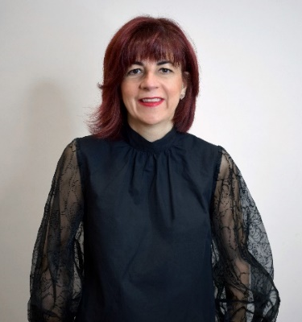
INVICTA Collection
Picasso Awards – Andalusian Hairdressing Awards
- Finalist Best Men's Collection (2021)
- Finalist Best Video (2021)

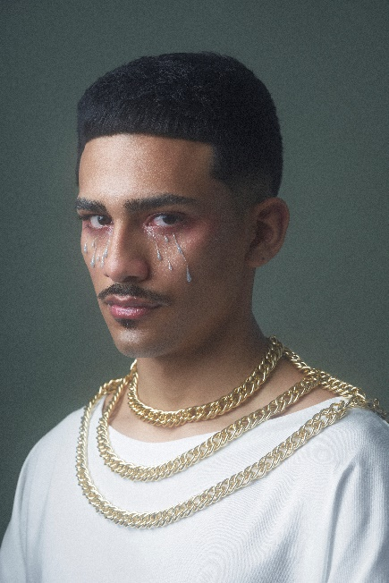
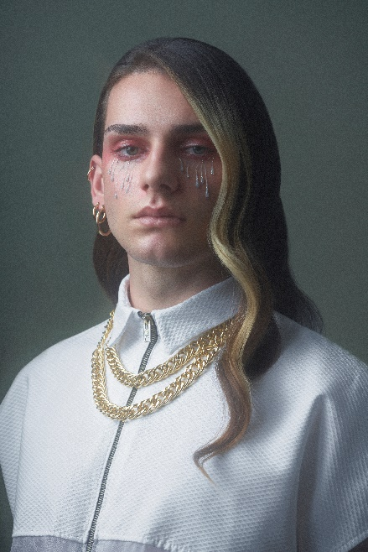
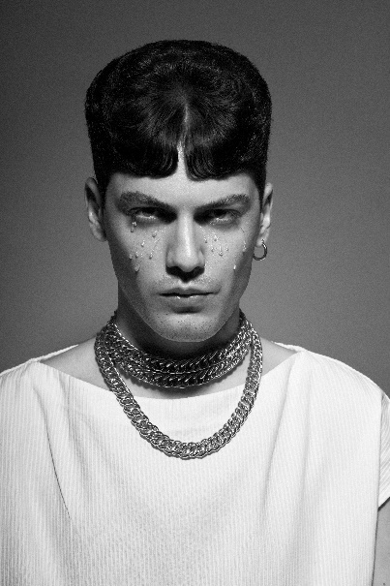
Hairdressing: Antonio Eloy Escuela Profesional | @antonioeloyescuela
Hairdresser: Gema Moreno | @gema_moren
Hair Assistant: Fran Sobrino | @fran_sobrino_
Photography: Edu Gómez | @edugomez
Retouche: Edu Gómez | @edugomez
MUA: Lulú Pérez | @_luluperez_
Styling: Álvaro De Olmedo | @alvarodolmedo
Designer Álvaro De Olmedo | @alvarodolmedo
Models: Cristopher Ishikawa | @cris_bong
Sergio Espinar | @chochex
Alejandro Fernández | @alexfernandezweb
José Herrera | @luckyrahrah
Products: Revlon | @revlonprofesional_es
American Crew | @americancrew_spain
Video Author: Infodelmedia
GEMA MORENO
Antonio Eloy Escuela Profesional
INVICTA Collection

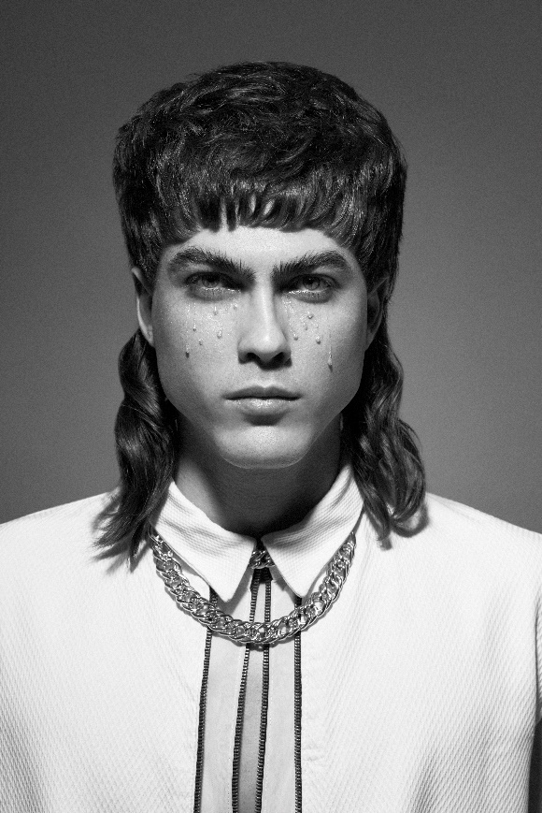

This collection is inspired by the poem "Invictus", written by the English poet William Ernest Henley and is a great motivation to face life in the face of difficulties. In all the looks there is a positive, resilient look from those who in the face of adversity have grown up, despite suffering, re-emerging victorious. Quite a phoenix attitude that translates into simple, yet luxurious haircuts and textures. This strength is reflected in mullets and short hairstyles with fringes that highlight the eyes, with a shine that fills the image with light, as well as long manes that explore their strength with waves.

