iSE 2020
Bose Professional and Sennheiser deliver collaboration solution

Wedemark/Amsterdam, 11 February 2020 – Sennheiser and Bose Professional today announced the Bose ES1 Ceiling Audio Solution, a powerful in-ceiling conferencing solution optimized for unified communication platforms. The bundle consists of the Sennheiser TeamConnect Ceiling 2 microphone and three Bose products: the ControlSpace EX-440C conferencing digital signal processor, the EdgeMax EM180 in-ceiling loudspeaker and the PowerSpace P2600A amplifier. The solution ensures a transparent and reliable technology experience with no audio devices on the walls or tabletops, creating a modern-looking meeting room.

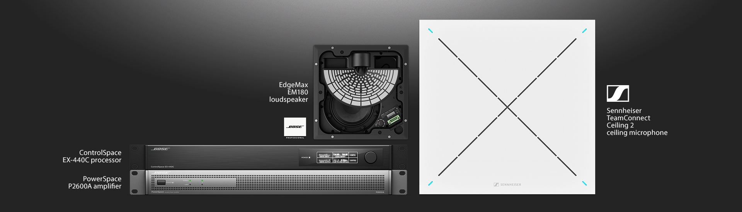

Conferencing is about collaboration, and better conferencing is more than just technology. It’s about enabling people to seamlessly connect and collaborate without having to focus on the technology or being concerned if the equipment is working. Bose Professional and Sennheiser – two leading brands who are passionate about audio – have teamed up to provide an in-ceiling unified communications solution that delivers the quality audio, ease of use and performance needed for productive meetings every single day.

“We are proud to deliver a conferencing solution together with Bose Professional that has been designed to provide a perfect conferencing experience, no matter whether you are on site or attending remotely,” said Charlie Jones, global business development manager for Sennheiser’s Business Communication segment.

“Collaboration is about being empowered to work together through technology, not hindered by it,” shared Martin Bodley, director of emerging business at Bose Professional. “The Bose ES1 ceiling audio solution combines premium performance and refined aesthetics for when ‘good enough’ won’t suffice and delivers a fully integrated meeting room solution that will shape the future of unified communications experiences.”

Sennheiser’s TeamConnect Ceiling 2 microphone uses adaptive beamforming to automatically and reliably pick up the person speaking in a conference room, no matter where he or she is located within the space. The microphone allows for freedom of movement, flexible use of conference rooms and outstanding audio quality.

Visit Sennheiser at ISE, Hall 2, Stand B 50.

The images to this press release can be accessed here: https://sennheiser-brandzone.com/c/181/YWc1yMUA.

About Sennheiser
Shaping the future of audio and creating unique sound experiences for customers – this aim unites Sennheiser employees and partners worldwide. Founded in 1945, Sennheiser is one of the world’s leading manufacturers of headphones, loudspeakers, microphones and wireless transmission systems. Since 2013, Sennheiser has been managed by Daniel Sennheiser and Dr. Andreas Sennheiser, the third generation of the family to run the company. In 2018, the Sennheiser Group generated sales revenues totalling €710.7 million. www.sennheiser.com

Global Press Contact

Stephanie Schmidt
stephanie.schmidt@sennheiser.com
+49 0(5130) 600 – 1275

