RIME 1.5 Update - True Immersion, Now Even Sharper
The free update of Neumann’s RIME plug-in redefines immersive audio monitoring on headphones.
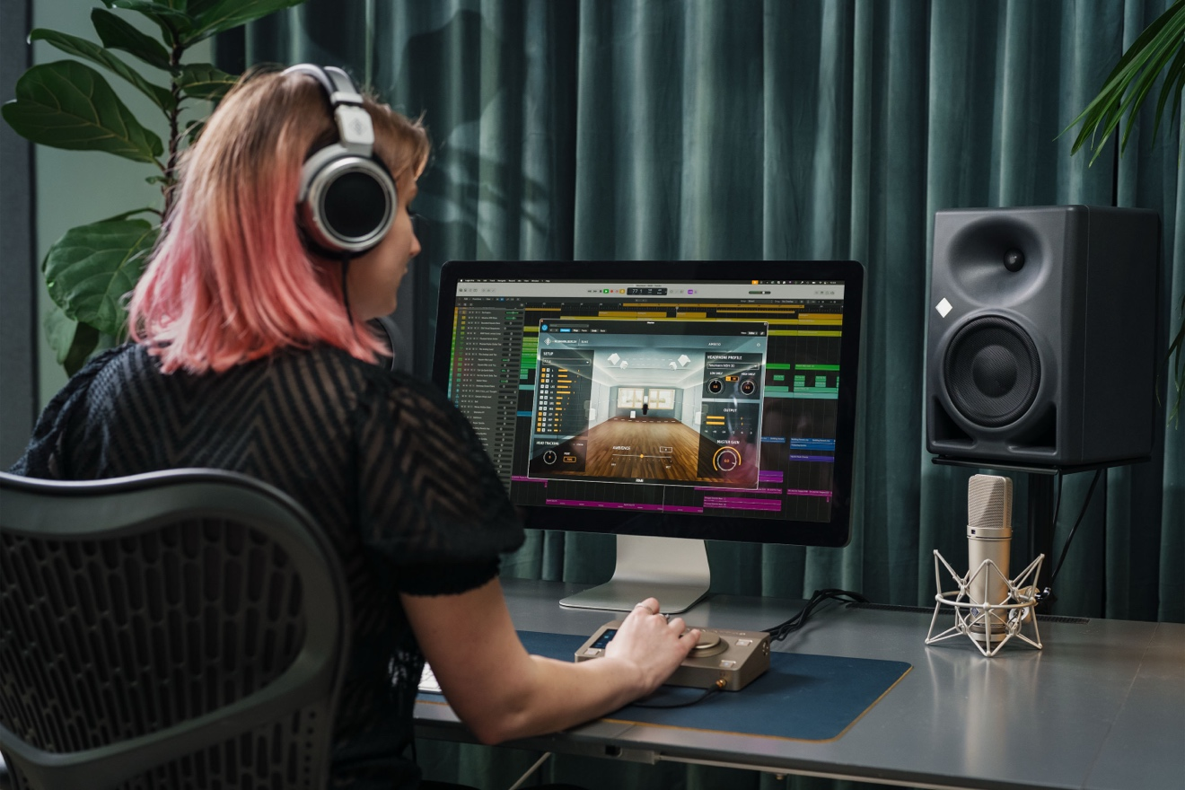

Neumann proudly announces the release of RIME Version 1.5, the latest update to its Reference Immersive Monitoring Environment plug-in. Designed tailor-made for Neumann headphones, RIME enables music producers and audio engineers to monitor immersive formats like Dolby Atmos with reference-grade precision—now with even more powerful features.

New in RIME 1.5:
- Deeper Bass – Extended low frequency response for all non-sub speakers.
- Improved Transient Accuracy – Sharper dynamics for better mix decisions.
- 3DOF Headtracking – Tracks vertical and horizontal head movements.
- More Format Options – Adds support for 5.1 and 7.1.2.
- Ambience Parameter Range Extended – More control over room feel and spatial depth.
- Peak-Aligned Output – Prevents levels above 0 dBFS for cleaner signal integrity.
- Loudness-Matched Bypass – Seamlessly compare binaural and downmixed signals.
- Quick Solo/Mute Buttons – Instantly isolate horizontal or height channels.
- Standalone Version for macOS – Use RIME independently of your DAW.

Another leap forward
“As RIME is tailor-made for Neumann headphones, this perfect signal chain extends all the way to the user,” explains Jorma Marquardt, Product Manager at Neumann. “Our NDH 20 and NDH 30 headphones are manufactured to extremely tight tolerances. And of course, we know all their acoustic parameters. Using groundbreaking AMBEO algorithms, we are able to realize true immersion with unmatched sonic consistency and razor-sharp 3D localization.”
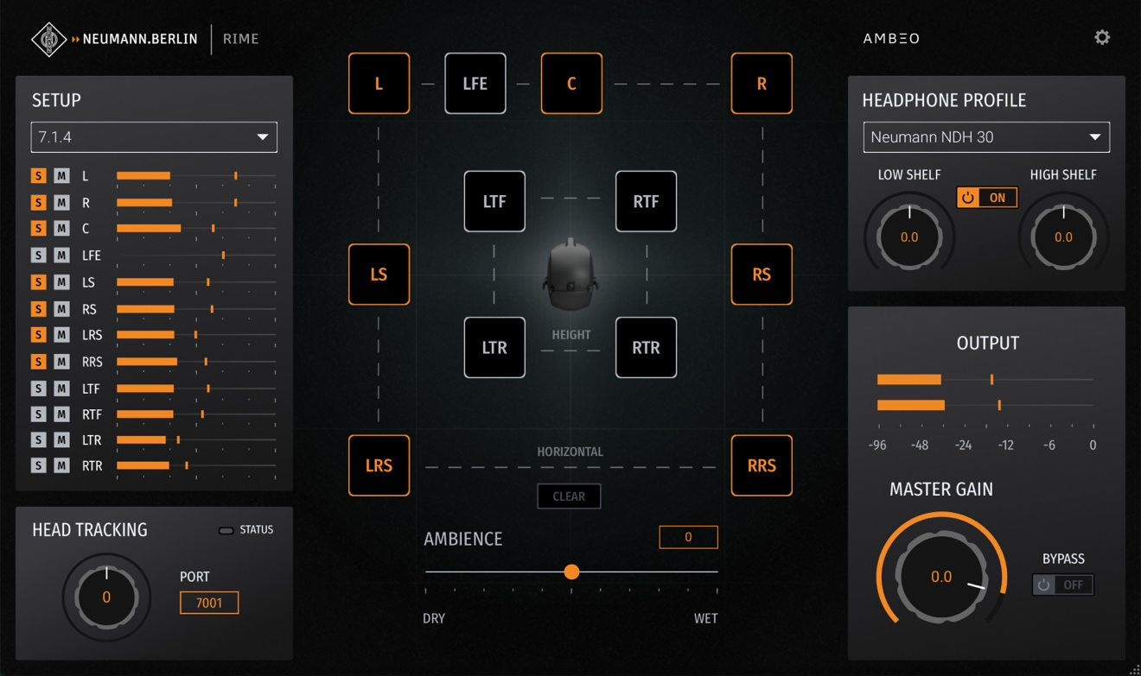

“RIME is not a simulation,” Marquardt adds. “It captures an optimal control room in ultimate quality. With version 1.5, we’ve pushed realism and usability even further—making immersive monitoring more accessible and accurate than ever before.”

Why RIME?
RIME offers a reference-quality immersive monitoring experience tailored specifically for Neumann headphones. Powered by AMBEO virtual acoustics algorithms and captured using Neumann’s legendary KU 100 binaural microphone, RIME delivers stunningly realistic 3D soundscapes. Whether you're mixing in Dolby Atmos or checking stereo compatibility, RIME ensures your work translates perfectly across playback systems.

System Requirements:
- Mac: macOS 10.15+, Intel & Apple Silicon native
- PC: Windows 10+
- Formats: VST3, AU, AAX
- Compatible DAWs: Pro Tools, Pyramix, Logic, Reaper, Cubase, Nuendo

Availability
RIME 1.5 is available now via electronic delivery through authorized retailers as well as on the Neumann Website for $99.95. Customers receive their license code within minutes of purchase. Existing RIME users will receive the update at no extra cost.
Link: RIME - Neumann Software

About Neumann
Georg Neumann GmbH, known as “Neumann.Berlin”, is one of the world’s leading manufacturers of studio-grade audio equipment and the creator of recording microphone legends such as the U 47, M 49, U 67, and U 87. Founded in 1928, the company has been recognized with numerous international awards for its technological innovations. Since 2010, Neumann.Berlin has expanded its expertise in electro-acoustic transducer design to also include the studio monitor market, building upon the legacy of the legendary loudspeaker innovator Klein + Hummel. The first Neumann studio headphones were introduced in 2019, and since 2022, the company has increased its focus on reference solutions for live audio. With the introduction of the first audio interface MT 48, and its revolutionary converter technology, Neumann now offers all the necessary technologies needed to capture and deliver sound at the highest level. Georg Neumann GmbH has been part of the Sennheiser Group since 1991 and is represented worldwide by the Sennheiser network of subsidiaries and long-standing trading partners. www.neumann.com
Stay up to date and follow us on: FACEBOOK I INSTAGRAM I YOUTUBE

Press Contact Neumann:
Raphael Tschernuth
raphael.tschernuth@neumann.com
+49 (030) 41772467

