RME to Showcase Latest Networking Solutions During Parsons Audio Expo 2018
The company will highlight its latest Dante-, MADI- and AVB-compatible gear while hosting a session focused on “unraveling audio networking”

Dedham, Massachusetts, October 31, 2018 – Premium German interface manufacturer RME is excited to announce it will be exhibiting its latest networking solutions as well as hosting a session on audio networking during Parsons Audio Expo 2018 on November 7, 2018, at the Hilton Boston/Dedham in Dedham, Massachusetts.
Considered New England’s premier professional audio trade show, the one-day event features dozens of audio exhibitors, professional development sessions and guest speakers, including RME’s Derek Badala who will present a session on “Unraveling Audio Networking: An In-Depth Look at Dante, AVB and MADI.” Badala, who serves as Director of Sales for Synthax, RME’s distributor, will discuss the new go-to systems and delve into the advantages each system has to offer, explaining how to best employ them in your setup.
“RME continues to be on the forefront of audio networking,” Badala said. “While these systems might be new to some users, they offer a plethora of benefits, including minimizing setup times and working with less cables, not to mention they are easy to operate. This session will focus what each system has to offer, helping attendees find which system best suits their needs.”
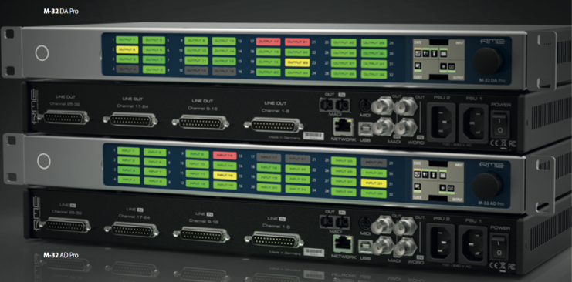
A Vast Array of Networking Solutions
In addition to Badala’s session, RME will exhibit a wide variety of its latest technology, including the new M-32 Pro Series. This series includes the M-32 AD Pro and M-32 DA Pro, two high-end, 32-channel 192 kHz converters that meet the requirements of today’s productions and installations that require high analog channel counts.
With two fully-equipped MADI I/Os including separate signal routing, the M-Series converters boast an AVB interface based on the open network standard IEEE 802.1 and 1722.1, enabling transmission of the 32 analog channels at maximum 192 kHz sampling rate via a single Ethernet cable. Combined with external AVB switches, the new converters can be quickly, easily and reliably integrated into more complex network structures thanks to the comprehensive time-synchronous signal processing of the AVB protocol.
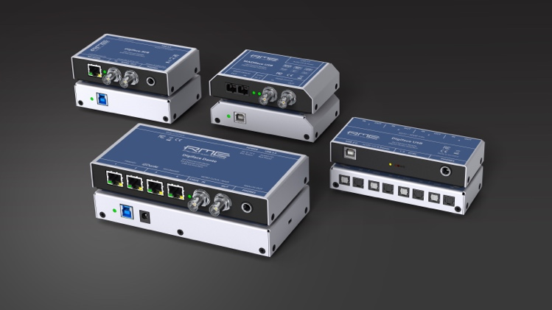
RME will also showcase the two latest additions to its popular Digiface Series of mobile audio interfaces — the Digiface Dante and Digiface AVB.
The new Digiface Dante is a 256-channel, 192 kHz USB audio interface that combines a lightweight design with Dante network connectivity, while supporting AES67. The BNC connections provide Word Clock I/O and can be switched to work with MADI, allowing for MADI and Dante to be used simultaneously, and enabling the unit to work as a simple bidirectional format converter in standalone mode.
The Digiface AVB meets the growing need in the AV industry to distribute audio over a local area network. The Digiface AVB USB audio interface uses AVB to transfer up to 256 channels of audio between PC and audio networks. The integrated USB 3.0 connection allows up to 128 audio channels to be streamed back to the AVB network and another 128 channels to the computer — with sampling rates of up to 192 kHz. Users can adjust the channel sizes of streams between 2 and 32 channels as needed to ensure maximum compatibility with AVB audio devices available on the market.
For more information on RME, visit http://www.rme-usa.com/
About Synthax, Incorporated
Synthax Inc. is the exclusive USA distributor for RME digital audio solutions, Ferrofish advanced audio applications, myMix audio products, and ALVA cableware. We supply a nationwide network of dealers with these products for professional audio, broadcast, music industry, commercial audio, theater, military and government applications. For additional information, visit the company online at http://www.synthax.com.

Media Contacts:
Katie Kailus
Public Relations
Hummingbird Media
+1 (630) 319-5226
katie@hummingbirdmedia.com

Jeff Touzeau
Public Relations
Hummingbird Media
+1 (914) 602 2913
jeff@hummingbirdmedia.com

