Middle East Photograph Preservation Initiative
Call for Applications Fall/Winter 2019/2020

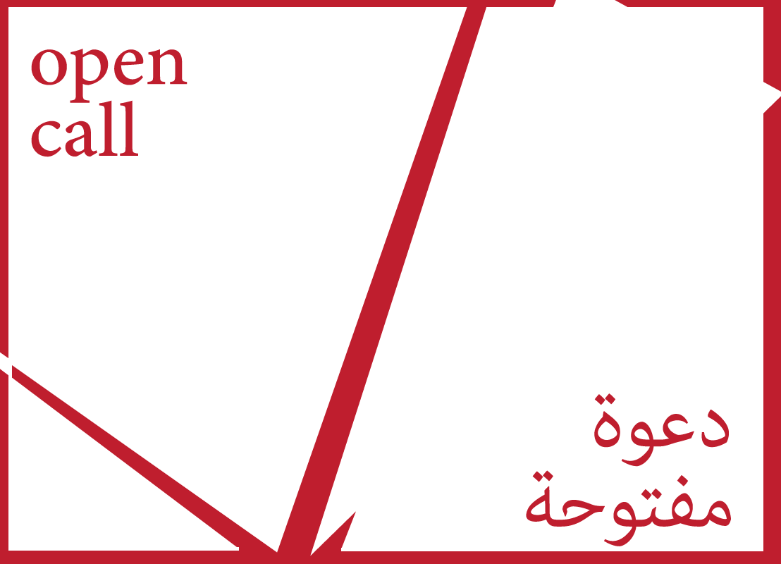

The Middle Photograph Preservation Initiative is seeking grant applications from its Alumni to address photograph preservation in the Middle East, Turkey and Iran. Submitted projects proposals to focus on studying and/or improving the preservation of photographic collections, digitization of photographs, accessibility, and care of photographs.
With a unique focus on photographic preservation, this open call encourages applications with engaging formats ranging from workshops, podcasts, research papers, talks, and video tutorials.
A sum of USD2000/- will be awarded per winning project. A total of 3 projects will be selected by a panel of MEPPI Partners.
Click here to know more about the Middle East Photograph Preservation Initiative.

Key Dates
- Anticipated date for announcing the recipients and awarded projects is December 10, 2019.
- Application deadline is November 10, 2019 at 23:59 Beirut time (GMT +3).

Eligibility Criteria
- Grant applicant to be a MEPPI Alumni, observers included.
- Application to be endorsed by the applicant’s institution.
- Project to be produced in the Middle East, Turkey, & Iran.

Jury Panel
- Kathleen Dardes, Head, Collections, The Getty Conservation Institute
- Debra Hess Norris, Chair and Professor of Photograph Conservation, Department of Art Conservation, University of Delaware
- Nora Kennedy, Sherman Fairchild Conservator in Charge, Metropolitan Museum of Art
- Marc Mouarkech, Director, Arab Image Foundation
- Rawad Isaiah J. Bou Malhab, Project Manager, Middle East Photograph Preservation Initiative

Applicant Information
Full name of applicant (First Name, Last Name)
-
Address (City, Country)
-
Phone number (with international dialing code)
-
Email address
-
Name of institution (please specify if you’re currently unemployed or working as a freelancer)
-
Current role at your institution (please specify if you’re currently unemployed)
-

Which MEPPI workshop(s) you participated in? (please tick mark)

Phase 1 // Pilot Project, Beirut, 2009
Phase 2 // Beirut 2011, Rabat 2012
Phase 2 // Abu Dhabi 2012, Istanbul 2013
Phase 2 // Amman 2014
Phase 3 // Beirut 2015
Phase 3 // Rabat 2016
Phase 3 // Beirut 2016
Phase 3 // Beirut 2017
MEPPI Extended // Beirut 2018
None

Project Information
Project title
-
Project type (text, audio, video, image)
-

Project format (research, survey, workshop, presentation, publication, video tutorial, podcast, exhibition, etc.)
-
Project abstract (please explain your project idea and submit any material that could support your proposal)
-

Please address any questions to:
Rawad Isaiah J. Bou Malhab
MEPPI Project Manager
Rawad.boumalhab@fai.org.lb
T +961 81 801 558

