Sennheiser Announces TeamConnect Bar Solutions

for Small and Mid-Sized Collaboration Spaces

Global audio leader unveils its first scalable, all-in-one conferencing devices featuring a built-in-camera

Wedemark, Germany June 13, 2023 – Sennheiser, the first choice for advanced audio technology that makes collaboration and learning easier, has entered the unified communications A/V bar market with the most flexible all-in-one devices for small and mid-sized meeting rooms and collaboration spaces. Part of the Sennheiser TeamConnect Family, the TeamConnect (TC) Bar Solutions were unveiled publicly during an exclusive virtual launch event earlier today and will be showcased this week in-person to the attendees of the InterOp Tokyo and the InfoComm Orlando.

With options for small (TeamConnect Bar S) or mid-sized (TeamConnect Bar M) meeting and collaboration spaces, the TC Bar Solutions are true problem solvers with benefits like easy setup, brand agnostic integration, easy management & control, high video quality, security and sustainability. The TC Bar S features 4 microphones and 2 speakers, while TC Bar M has 6 microphones and 4 speakers. Both easily integrate with any meeting platform and can be further enhanced with other compatible products, including those from Sennheiser.

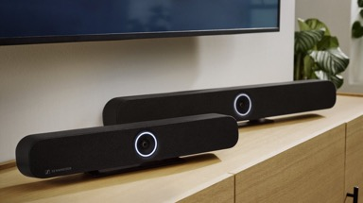

“At Sennheiser, we've specialized in superior audio quality for years, but found a strong video partner in the independent test laboratory "Image Engineering" to ensure that the video quality stood up to the audio quality that is synonymous with our brand,” said Ronja Harste, Product Manager, UC Solutions, Sennheiser. “That led to the development of our first all-in-one device, the TeamConnect Bar Solutions, which are the most feature-rich all-in-one conferencing devices in their class.”

The TC Bar Solutions provide unparalleled freedom and flexibility, allowing customer to choose the right video conferencing device for their meeting room size. Easily integrate the TC Bar into a room design with multiple mounting options like wall mount, VESA mount, tabletop or freestanding. The option of using Dante for adding extension mics and/or a 2nd external USB camera make the device even more scalable.

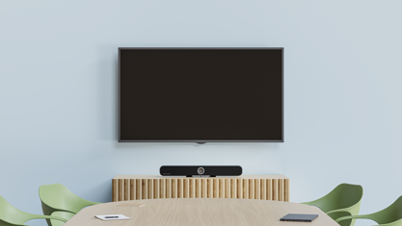

The powerful full-range stereo speakers with their improved directivity pattern and optimized passive radiators ensure natural speech and outstanding intelligibility. Integrated beamforming technology enables seamless transition between presenters and offers freedom of movement and configuration within the space.

The built-in DSP, as well as the option to adjust your audio settings via Sennheiser Control Cockpit, gives users the opportunity to further optimize room acoustics. The TC Bars also come with an automatic conference & music mode switch to provide the best audio to match the content.

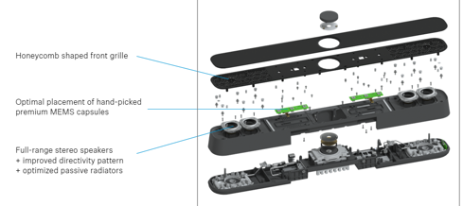

The TeamConnect Bar Solutions feature some of the latest advances in meeting technology to further enhance modern hybrid meetings and lectures – taking video to the next level. The 4K Ultra HD camera is further enhanced by AI features like "Autoframing" and "Person Tiling", enabling all remote participants to clearly see everyone in the room. With advanced AI, even the smallest gestures and facial expressions are conveyed to ensure increased meeting inclusion and engagement.

Thanks to Sennheiser’s open and agnostic ecosystem philosophy, the TC Bars are also compatible with many major Media Control Systems from our Alliance Partners, with certifications currently in process. For basic adjustments, several features, like zoom, person tiling and more, can be found on the included remote control.

When it comes to security, the TC Bar Solutions follow industry best security practices, and their configuration is password protected. The communication to the Sennheiser Control Cockpit, as well as 3rd party media control systems, is encrypted using industry standard Transport Layer Security 1.2 and safe from misuse. The TC Bars also support IEEE 802.1x network authentication and, of course, for additional privacy, a lens cap is included.

The TC Bar Solutions received a distinction with the Red Dot Award: Product Design 2023. Companies and design studios from all over the world faced the professional
judgement of the Red Dot Jury, international experts who examined a remarkable
number of products during the competition. In an evaluation process lasting
several days, the submissions were thoroughly reviewed and assessed according to their design quality and degree of innovation. Following the assessment, the jury unanimously said: "The high-quality fabric covering elegantly conceals the powerful speakers and microphone array. The central camera module with surrounding LED ring serves as a user interface and is the striking design element of the otherwise unobtrusive device that integrates well into any environment.”

With the addition of the TC Bar Solutions to the TeamConnect Family, Sennheiser now offers another option to customers to compliment the family’s trusted ceiling microphone solutions to support large and midsized rooms as well as an intelligent speaker for smaller meetings. Each product is designed to function as a standalone solution. Additional coverage or features can be achieved by scaling with other compatible Sennheiser or third-party products and by leveraging the power of the Sennheiser Control Cockpit for ease of configuration and monitoring.

Register at the following site to view a replay of the virtual unveiling event:
https://media.marketscale.com/Sennheiser-Product-Announcement-2023/

Visit InfoComm 2023 this week to experience the TC Bar Solutions in live demo rooms. More information about the Sennheiser TeamConnect Family, including the new TC Bar and can be found here. TC Bar is expected to begin shipping later this year.

About the Sennheiser brand
We live and breathe audio. We are driven by the passion to create audio solutions that make a difference. Building the future of audio and bringing remarkable sound experiences to our customers – this is what the Sennheiser brand has represented for more than 75 years. While professional audio solutions such as microphones, meeting solutions, streaming technologies and monitoring systems are part of the business of Sennheiser electronic GmbH & Co. KG, the business with consumer devices such as headphones, soundbars and speech-enhanced hearables is operated by Sonova Holding AG under the license of Sennheiser.

www.sennheiser.com
www.sennheiser-hearing.com

Global Press Contact

Jeff Horan
+1 860-598-7539
jeffrey.horan@sennheiser.com

