Synthax to Showcase Next Generation Ferrofish A32 Pro Dante Series and Advanced RME Dante Solutions at the 2022 NAMM Show
The exclusive US- distributor of RME celebrates the return to NAMM by teasing a new product launch

Anaheim, CA, May 23, 2022 — Synthax, US distributor of RME, Ferrofish, Digigram, Appsys and myMix, has announced it will showcase products from RME and Ferrofish, [Booth 14704, ACC North Hall] at the 2022 NAMM Show. The latest RME and Ferrofish solutions, including the A32 Pro Dante and A32 Pro, will be on display at the booth.

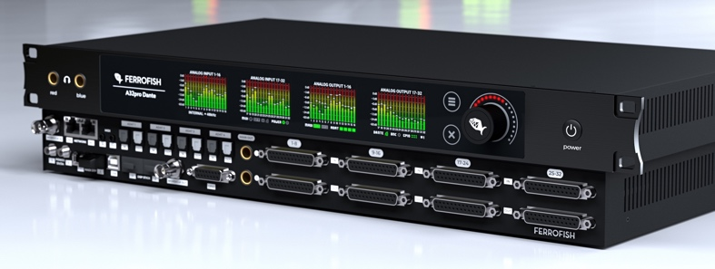
The new A32pro Series combines high analog channel-counts with extensive digital I/O and powerful signal routing with DANTE capabilities with the A32 Pro Dante, which provides 64x64 Dante I/O channels on dual Ethernet ports with redundant functionality. The new additions to the A32 Series set a new standard in high-quality with reliable signal conversation and distribution for modern recording studios, live audio playback systems and broadcast audio facilities.

“We are looking forward to showcasing the A32 Pro Series at this year’s NAMM show,” said Derek Badala, Director of Sales for Synthax, Americas. “In every new generation, the technology becomes more dynamic to better future-proof solutions for integrators as well as adapt in various applications according to their needs. The Ferrofish A32 Pro Dante supports this vision by solving technological boundaries between audio formats and interoperability. New enhancements include user touch screen, 2 independent headphone outputs, SFP MADI implementation, Studio analog outputs, and GPIO triggers. The RemoteFish remote makes it even more powerful in installations where remote control and metering are needed.”

RME, a German manufacturer of premium digital audio solutions, will announce a new product on the first day of the NAMM show. “It will be nice to be back on the show floor where we will also unveil RME’s latest product. I can’t say much more than that. People will have to come see for themselves,” mentioned Mathias von Heydekampf, managing director of Synthax.
To learn more please visit the Synthax booth 14704 in the North Hall of the Anaheim Convention Center.
For more information on the Ferrofish A32 Pro Dante, visit ferrofish.com.
For more on RME, visit: rme-usa.com.
About Synthax, Incorporated
Synthax Inc. is the exclusive USA distributor for RME digital audio solutions, Digigram broadcast audio systems, Appsys digital audio tools, Ferrofish advanced audio applications, myMix personal monitoring systems and ALVA cableware. We supply a nationwide network of dealers with these products for professional audio, broadcast, music industry, commercial audio, theater, military and government applications. For additional information, visit the company online at http://www.synthax.com.

Media Contacts:
Shelby Coppola
Public Relations
Hummingbird Media
+1 (203) 598-8167
shelby@hummingbirdmedia.com

Jeff Touzeau
Public Relations
Hummingbird Media
+1 (914) 602 2913
jeff@hummingbirdmedia.com

