Press Information

EVOC COMMUTING 2023 – COMMUTE A.I.R. PRO 18
EVOC launches revolutionary airbag technology for bike backpacks

For the first time, EVOC has integrated an airbag system into a protector backpack for commuters with the goal of minimizing the risk of injuries while cycling in the city. In collaboration with Minerva Airbag Systems GmbH, EVOC developed a sensor-controlled, inflatable airbag protector aimed at reducing impact forces in bicycle crashes. From now on, the abbreviation “A.I.R.” will mark all EVOC products with the integrated airbag protection system: the Airbag Integrated Rescue System.

The TÜV-certified COMMUTE A.I.R. PRO 18 backpack with the groundbreaking integrated airbag function will represent the core element of the new EVOC-COMMUTING range. In a bicycle crash, the integrated airbag inflates in a mere 0.2 seconds and provides protection of the neck, shoulder and chest areas of the rider. In combination with the back protector which is also integrated in the backpack (EN 1621-2; level 2) and a helmet, the system constitutes an innovative approach to injury prevention in bicycle traffic.
Close the buckle and be fully protected within milliseconds
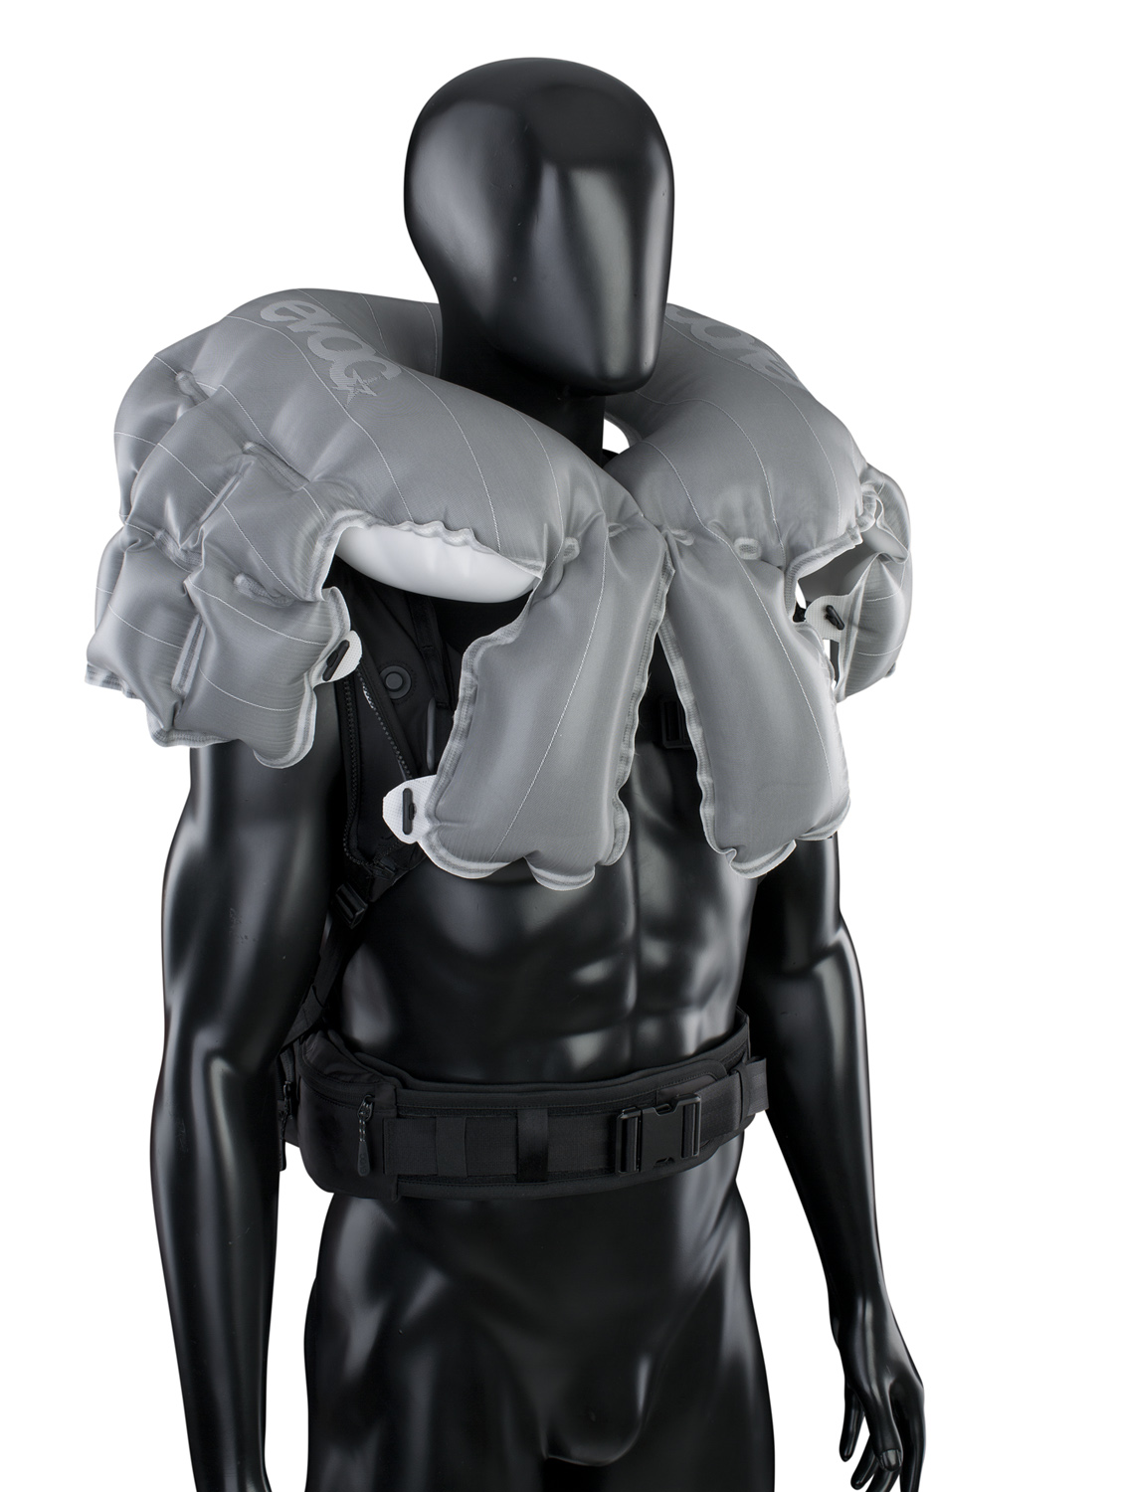
The integrated airbag system (AIRBAG INTEGRATED RESCUE SYSTEM - A.I.R) was developed specifically for the application in bike backpacks – for daily commutes to work, school or leisure activities. For this purpose, EVOC teamed up with Minerva-AS GmbH, a Bavaria-based company specializing in work-safety airbags. The heart of the system is a sensor-controlled, 18-liter inflatable airbag protector which drastically reduces impact forces in the case of a crash.
The airbag itself, similarly to car airbags, consists of a two-layer Polyester fabric design with silicone coating sown in one piece. It can withstand an excess pressure of 7 bar – the equivalent of a 100 kg steel plate falling from 5 meters. When the airbag is deployed, the impact force and (braking) acceleration (HIC – Head Injury Criterion) acting upon the cyclist are reduced by up to 80%.

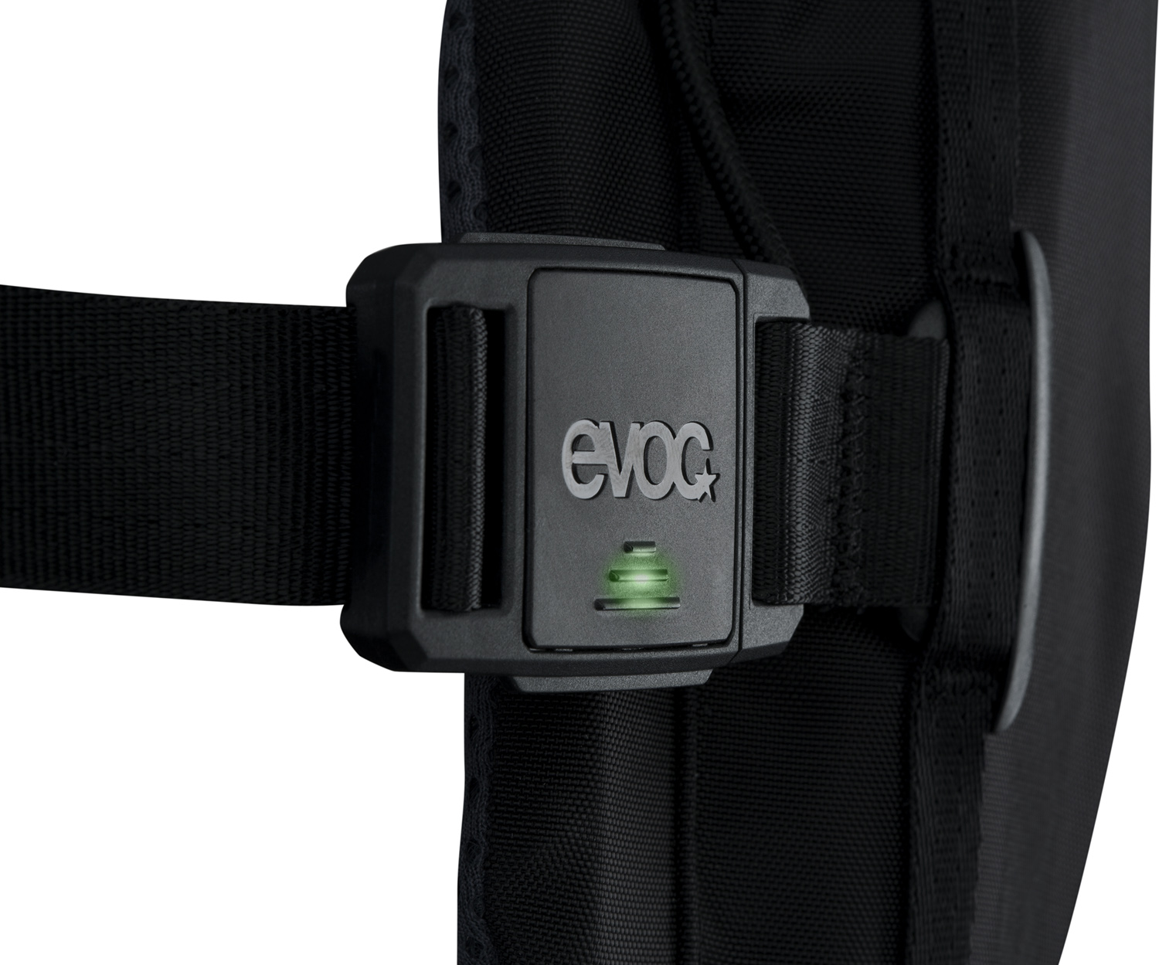
The magnetic buckle on the chest strap is responsible for activating and deactivating the airbag. The sensory unit, which is USB-chargeable, is equipped with six sensors enabling it to analyze the position of the backpack, i.e. the rider up to 1,100 times per second. Once the deployment criteria are met, the airbag inflates within just 0.2 seconds, hereby unfolding its full protective effects for the cervical spine, shoulders, collar bones and chest.
The triggering unit, which is fixed permanently to the airbag, includes a battery, memory chips and interfaces (USB/Bluetooth). Its overall weight, including the airbag is approximately 800 g. The mechanical deployment is implemented via the activation of an e-igniter. This builds up stagnation pressure that drives a needle through the sealing cap of the compressed-gas cylinder. Under atmospheric pressure, the liquid CO2 expands and fills the airbag within milliseconds.

In order to avoid unnecessary deployment, a special algorithm developed by Minerva monitors data collection frequency, filters out spikes, eliminates faulty data or allows for angular velocity. Only secured values from the laboratory or from customers are memorized and analyzed in the database. In addition, the mechanisms and triggering parameters of the algorithm are constantly controlled and optimized.
After the airbag has been deployed and checked for damage, the system can simply be reused with a new cartridge. The recyclable and reusable inflator can be easily replaced as a whole. In this case, the gas container is replaced with the connector as a unit. The system controls automatically monitor whether the inflator is connected properly and displays this information via an LED which switches from red to green.
Technical Parameters:
- Airbag volume: 18 liters
- 200 milliseconds to full inflation of the airbag
- 1.4 bar maximum internal pressure in the inflated airbag
- Pressure loss 5 seconds after deployment
- 32 hours battery life
- Range of application and temperature 0 °C to + 40 °C

Premiere on the IAA Mobility 2021
On the IAA Mobility from September 7th to 12th 2021 in Munich, EVOC will present their new concept for the COMMUTING range, as well as the COMMUTE A.I.R. PRO 18 – backpack with innovatively integrated airbag technology - for the first time. The range will be available for sale from 2023.

Protection as a business model

EVOC Sports GmbH is an owner-operated company based in Munich specializing in the development and production of functional sports backpacks with protective features and sports travel gear. Since the company’s founding, Bernd Stucke and Holger Feist have been managing directors. The team at the headquarters currently includes 20 employees in the areas of sales, marketing and product design.

Today, EVOC is the global market leader for backpacks with back protectors, which are mainly focused on ambitious mountainbiking and wintersports, as well as bags for travelling with bikes. The well over 100 product models available in the segments BIKE, SNOW, TRAVEL and PHOTO are sold through a network of distributors in 32 countries around the globe. In future, COMMUTING products will compliment this portfolio.

DESIGN | COMPONENTS

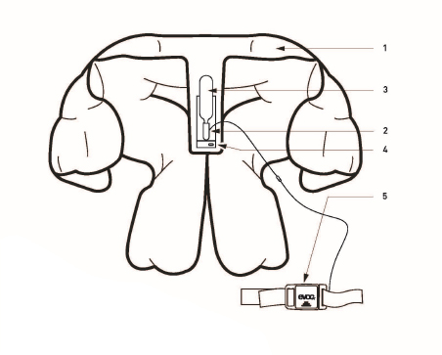
1 | Airbag
2 | Triggering unit
3 | Gas cartidge
4 | USB charger
5 | Chest strap with FIDLOCK triggering buckle

Date: September 2021
Subject to changes.

Media Contact: Alexandra Hlawitschka | EVOC Sports GmbH | press@evocsports.com

