Bright Lights of Vegas Set to Shine on Sennheiser’s Latest Audio Innovations at InfoComm 2022
This year, what happens in Vegas definitely won’t stay there, as Sennheiser introduces game-changing solutions to optimize learning and achieve effortless collaboration

Wedemark, June 2, 2022 – Sennheiser, the first choice for advanced audio technology that makes collaboration and learning easier, will be back at InfoComm 2022 June 8-10 in Las Vegas, Nevada to unveil a new solution that allows customers to focus less on the wireless and more on the audio. The Sennheiser booth (W957) in the West Hall of the Las Vegas Convention Center will have the company’s new products front and center, while also showcasing the remainder of its comprehensive business communications portfolio.

Sennheiser: All-in on Making Collaboration and Learning Easier
Leading off the first day of InfoComm (June 8th), Sennheiser will unveil a soon-to-be available wireless solution. The offering is designed for the most demanding business and professional applications and will include a feature set that allows it to easily be scaled from the smallest meeting space or classroom to the largest business and educational installations. First samples of this new solution will be on display at the Sennheiser booth at InfoComm.

Double Down: the TCC2 and the TC ISP
The TeamConnect Ceiling 2 (TCC2) offers the innovation and reliability synonymous with the Sennheiser brand. With its patented automatic dynamic beamforming technology and open system architecture, the TCC2 has set a new standard in the industry by enabling meeting participants to be heard clearly as they move freely around a room. Visitors to the Sennheiser booth will have the opportunity to experience the TCC2 in a fully recreate meeting environment. The live demonstration will showcase the ceiling microphone’s TruVoicelift and advanced zone control, resulting in targeted voice amplification. Additionally, the TCC2’s tracking capability will be featured when Sennheiser and partner QSC team up to show how QSC’s cameras use this innovative technology to create the complete meeting experience.

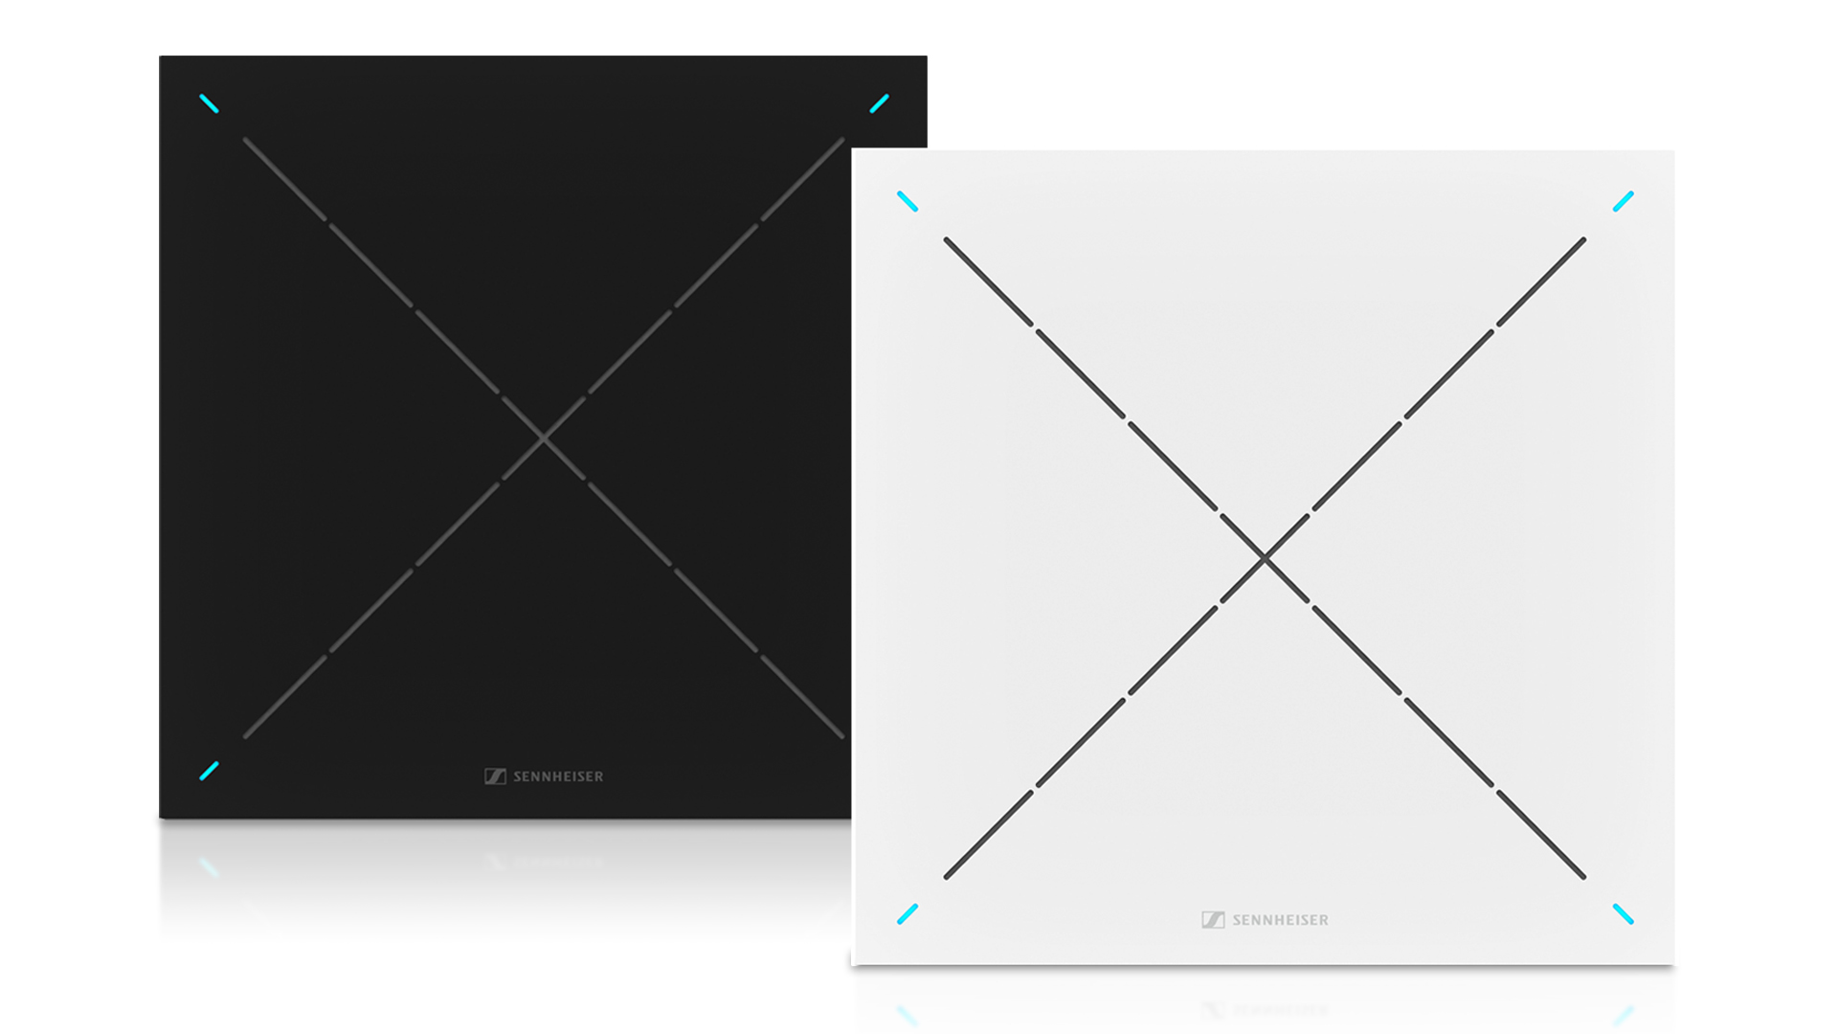 | TeamConnect Ceiling 2 with TruVoicelift offers automatic, adaptive beamforming technology, providing superior speech intelligibility for remote and in-room participants
Coming off the heels of a strong showing at Integrated Systems Europe in Barcelona, the Sennheiser TeamConnect Intelligent Speaker (TC ISP) will once again be on display, this time at InfoComm. Launched earlier this year, this new addition to the TeamConnect family is certified and optimized for the Microsoft Teams Rooms. Attendees will see the first intelligent speaker from Sennheiser on display at booth W957.

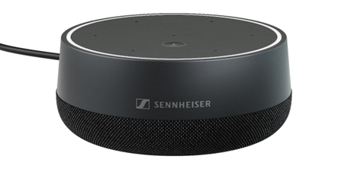 | With TeamConnect Intelligent Speaker (TC ISP), Sennheiser is delivering a solution to support smart, focused and inclusive meetings for up to 10 people, whether participants are in the room or joining remotely

A Jackpot of Solutions to Optimize Audio for Working and Learning
In addition to the TC ISP and TCC2, the Sennheiser booth will feature experience areas highlighting the following industry-leading audio solutions:
- SpeechLine Digital Wireless (SL DW) - a versatile microphone system, which can be easily adapted to your individual professional needs. The series’ multi-channel receiver will be on display to show how the SL DW can be integrated smoothly into an existing IT infrastructure for effortless lectures, meetings and presentations.
- MobileConnect - a Wi-Fi based assistive listening system that helps to break listening barriers and make learning more inclusive. With MobileConnect, high sound quality audio content can be streamed live via Wi-Fi directly to your personal smartphone using a free app that allows individual sound settings (app available in English, German and French). MobileConnect will be demonstrated throughout InfoComm at the Sennheiser booth.
- Sennheiser Control Cockpit - a powerful, yet simple browser-based remote management software tool for network-enabled Sennheiser microphones. The centralized control capability that Sennheiser Control Cockpit provides is helping universities and companies worldwide to digitize their workflows by offering easy control and monitoring of all devices in their network with email/SMS alerts support. Experience Sennheiser Control Cockpit live in every corner of the Sennheiser InfoComm booth.
More information about Sennheiser at InfoComm can be found here. To book an appointment during the show, please get in touch with the press contact listed below.

The images accompanying this press release and additional photos can be downloaded here.

About the Sennheiser brand
We live and breathe audio. We are driven by the passion to create audio solutions that make a difference. Building the future of audio and bringing remarkable sound experiences to our customers – this is what the Sennheiser brand has represented for more than 75 years. While professional audio solutions such as microphones, meeting solutions, streaming technologies and monitoring systems are part of the business of Sennheiser electronic GmbH & Co. KG, the business with consumer devices such as headphones, soundbars and speech-enhanced hearables is operated by Sonova Holding AG under the license of Sennheiser.

www.sennheiser.com
www.sennheiser-hearing.com

Global Press Contact

Jeff Horan
+1 860-598-7539
jeffrey.horan@sennheiser.com

