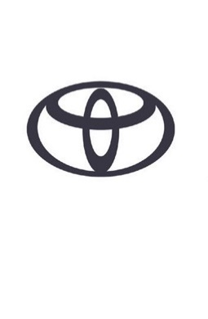
LAND CRUISER 250 – SPECIFICATIONS
Tentative values - all data subject to homologation

POWERTRAIN*
TYPE | 4-CYLINDER, IN-LINE
VALVE MECHANISM | DOHC 16-VALVE
FUEL SYSTEM | COMMON RAIL
DISPLACEMENT (CM³) | 2,755
BORE x STROKE (MM) | 92.0 x 103.6
POWER OUTPUT (PS / KW) @ RPM | 204 / 150 @ 3,000-3,400
MAX TORQUE (NM) | 500 @ 1,600 - 2,800
TYPE | 4-CYLINDER, IN-LINE

TRANSMISSION | A/T
TYPE | 8-SPEED AUTOMATIC (AL80F)
FINAL GEAR RATIO (:1) | 3.583
1ST | 4.413
2ND | 2.808
3RD | 1.950
4TH | 1.511
5TH | 1.274
6TH | 0.100
7TH | 0.793
8TH | 0.651
REVERSE | 3.645

PERFORMANCE* | 18” | 20”
MAX. SPEED (KM/H) | 165 | 170
ACC. 0-100 KM/H (SEC) | Pending homologation

FUEL CONSUMPTION (L/100KM)*
WLTP COMBINED CYCLE | Pending homologation
FUEL TANK CAPACITY (L) | 80

CO₂ EMISSIONS (G/KM)*
EURO CLASS | EURO6E
WLTP COMBINED CYCLE | Pending homologation

CHASSIS
FRONT SUSPENSION | DOUBLE WISHBONE
FRONT SUSPENSION STABILISER | CONVENTIONAL / SDM
REAR SUSPENSION | 4-LINK RIGID (WITH LATERAL CONTROL ARM)
REAR SUSPENSION STABILISER BAR DIAMETER (MM) | CONVENTIONAL
STEERING  LOCK TO LOCK  MIN. TURNING RADIUS TYRE (M)  MIN. TURNING RADIUS BODY (M) | RACK&PINION  3.24  6.0  6.4
BRAKES  FRONT  REAR | VENTILATED DISC (18”)  VENTILATED DISC (17”)

EXTERIOR DIMENSIONS (MM)*
OVERALL LENGTH | 4,925
OVERALL WIDTH | 1,980
OVERALL HEIGHT | 1,935
TREAD FRONT | 1,664
TREAD REAR | 1,668
WHEELBASE | 2,850
FRONT OVERHANG | 935
REAR OVERHANG | 1140
APPROACH ANGLE | 32
DEPARTURE ANGLE | 17
MIN. RUNNING GROUND CLEARANCE | 215.3

CARGO (M³ VDA)*
CAPACITY | 1.063

WEIGHT (KG)*
KERB WEIGHT MIN | 2,330
MAX | 2,550
GROSS WEIGHT | 3,150
TOWING CAPACITY (KG) | 3,500

*All data is tentative and subject to homologation.

