The gateway to audiophile excellence.
The new HD 505 catapults the burgeoning audio enthusiast into a world of pure, audiophile listening.


Wedemark, Germany – February 10, 2025 – The Sennheiser brand today announces the HD 505, a headphone crafted for listeners looking to elevate their love for audio to the next level of performance. With its blend of analytical tuning, precise detail, and enduring comfort, the HD 505 brings the essential Sennheiser experience to listening setups and gaming rigs of all kinds.
“The HD 505 is for anyone ready to experience the audio awakening a great set of Sennheiser headphones is known for,” said Klaus Hanselmann, Sennheiser Audiophile Product Manager. “There is something truly special in here that puts serious listening within arm’s reach of the emerging audiophile or gamer.”
Your Introduction to True Sound
At the heart of the Sennheiser HD 505 is a custom 120-ohm transducer situated in an open earcup, produced at their cutting-edge audiophile factory in Tullamore, Ireland. With a frequency response stretching from 12 to 38,500 Hz and total harmonic distortion measurement of less than 0.2%, listeners can ensure that their music is reproduced with surprisingly rich detail and integrity. This combination delivers a politely balanced sound signature, with the punchy bass, effortless mids, and non-fatiguing treble the audiophile brand is lauded for. The angled transducers replicate the triangular positioning of a set of nearfield loudspeakers, resulting in an expansive soundstage that enables listeners to sit in the front row of their favorite music, movies, and games.
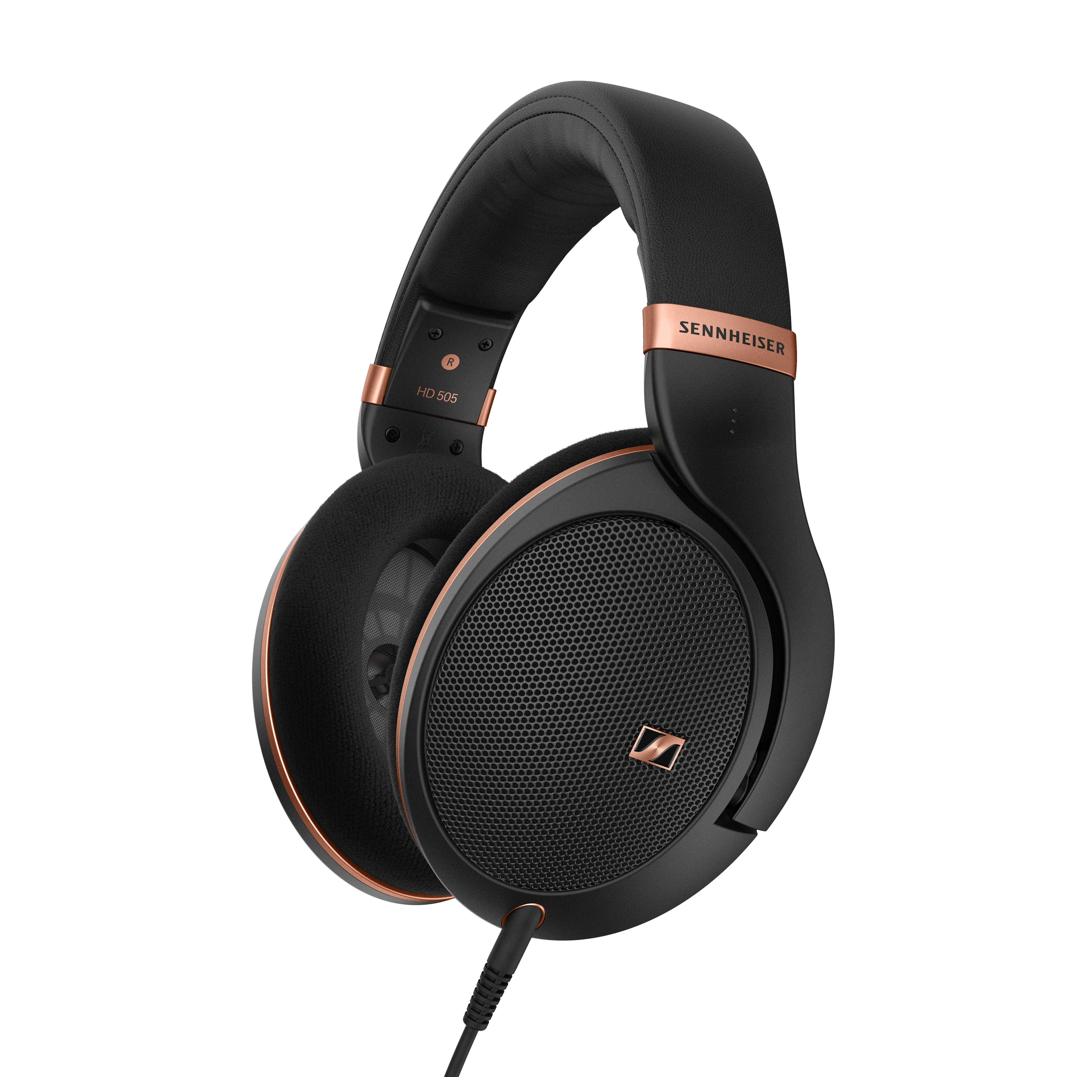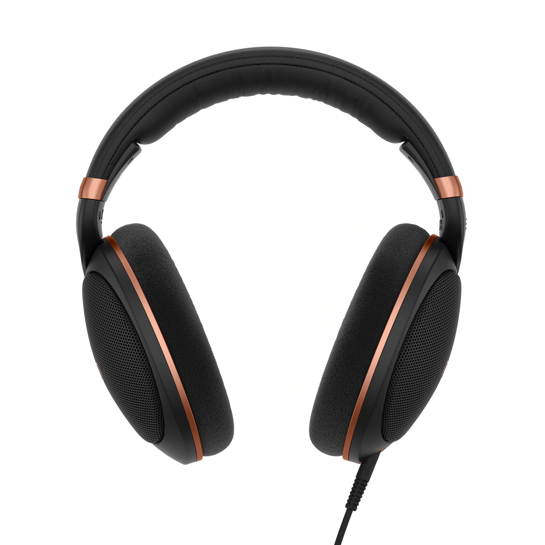
Pictured: The HD 505 is a compelling option to get into audiophile listening
Timeless Design, Built to Last
The HD 505 is built upon the trusted HD 500 series chassis, celebrated for its long-term comfort and lightweight fit. From the synthetic leather headband to the metal mesh earcup covers, every component is designed to last while exuding an understated sophistication. At just 237 grams, the HD 505 offers a level of comfort that makes extended listening a pleasure. It comes with a detachable 1.8m (6 foot) cable, with a 3.5mm (1/8-inch) plug and 6.3mm adapter for connection to the widest range of audio sources like amplifiers, sound cards, audio interfaces, and A/V receivers. Like virtually all 500 series headphones, a wide range of cables and earpads—ranging in length, application, and plug type—can be swapped by the user without tools. This modular design lets the HD 505 adapt to the wearer’s evolving setup over time such as incorporating a balanced audio source or adding an in-line microphone.
Availability
The HD 505 will be available starting today from Amazon.com with an MSRP of $279.95.

About the Sennheiser brand
We live and breathe audio. We are driven by the passion to create audio solutions that make a difference. Building the future of audio and bringing remarkable sound experiences to our customers – this is what the Sennheiser brand has represented for more than 75 years. While professional audio solutions such as microphones, meeting solutions, streaming technologies and monitoring systems are part of the business of Sennheiser electronic GmbH & Co. KG, the business with consumer devices such as headphones, soundbars and speech-enhanced hearables became part of the Sonova Holding AG group of companies in 2022, who have licensed the Sennheiser trademark for this purpose.

www.sennheiser.com
www.sennheiser-hearing.com

About Sonova Consumer Hearing
Sonova Consumer Hearing offers premium headphones and hearables – primarily in the true wireless segment – as well as audiophile headphones, hearing solutions and soundbars under the Sennheiser brand. The business is part of the Sonova Group, a global leader in innovative hearing care solutions with headquarters in Switzerland and more than 17,000 employees worldwide.

Press contact
Sonova Consumer Hearing
Eric Palonen
Head of PR and Influencers | Americas
Headphone and Soundbars
T +1 (860) 908 1210
eric.palonen@sonova.com

