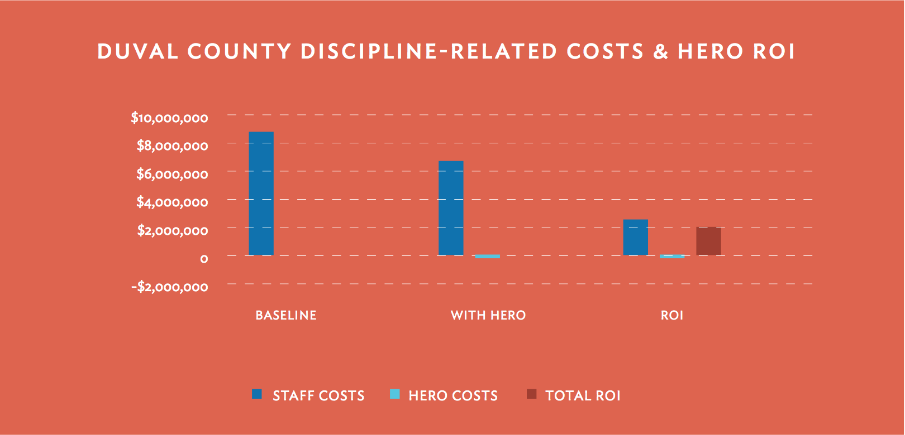
TIP SHEET: Duval County Public Schools
(Jacksonville, FL)

General Story Arc

After a successful pilot in April of 2015, Duval County Public Schools expanded their Hero program to 54 schools for the 2015-2016 school year. They continue to see success and results at both the individual school level and district level today. They have had excellent usage with their Hero program this school year. Over 1.5 million student behaviors were recognized through the end of December leading to the following gains:

• Over $2M in instructional dollars
• 27% reduction in referrals
• 15% reduction in suspensions across middle and high schools
• Increased FSA scores

District contacts can talk about how Duval has gained over $2M for instruction, reduced referrals by 27%, reduced suspensions across middle and high schools by 15% and increased FSA scores.

Additional Background

• Duval Summary of Value (available upon request)
• Huffington Post Article: Can this man (former Superintendent of Duval County Public Schools) save Detroit Public Schools? http://www.huffingtonpost.com/entry/can-this-man-save-detroit-public-schools_us_5919aca7e4b0bd90f8e6a737

Tech Elements

- Hero K12
- iPads and other mobile devices
- Mobile Scanning

Contact

Jennifer Harrison, cell: 916-716-0636 or email: jennifer@jharrisonpr.com

