Yo-Yo Ma to release new Warner Classics album, Azul, with The Knights on March 31

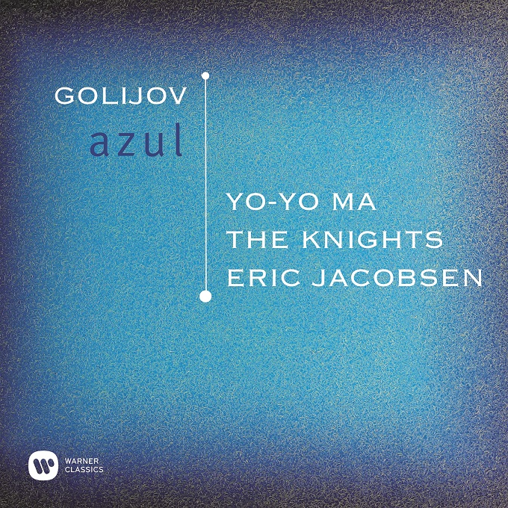

New York, NY – Yo-Yo Ma will release a new Warner Classics album, Azul, with Brooklyn-based orchestral collective The Knights on March 31,2017. The title refers to the Spanish word for “blue” and forms the album’s centerpiece with Argentine composer Osvaldo Golijov’s contemplative cello concerto, Azul. The work was commissioned for Yo-Yo Ma by the Boston Symphony Orchestra, with which he gave its premiere in 2006; this album marks its first studio recording. With influences including Western classical, tango, klezmer, gypsy and Middle Eastern music, and inspirations that range from the poetry of Pablo Neruda to the blue sky above Tanglewood, the piece was described by The Washington Post as “long, thoughtful, different, and real: anything but an easy star showpiece.”

Four other works on Azul support the album’s contemplative theme. Ascending Bird was written by The Knights’ co-Artistic Director and violinist Colin Jacobsen with Iranian composer Siamak Aghaei. Another of their collaborative pieces, the Concerto for Santur (Persian dulcimer), Violin, & Orchestra, was recorded with Aghaei as a soloist on The Knights’ first Warner Classics album, the ground beneath our feet. A piece that emerges from European myths and Romanticism is the poignant, soaring ‘Song to the Moon’ from Dvořák’s opera Rusalka, in which Yo-Yo Ma’s cello replaces the customary soprano. Pulitzer prize-winning composer Caroline Shaw arranges ‘Leo’ from Tierkreis (Zodiac) by the visionary avant-gardiste Karlheinz Stockhausen, a brief, whimsical and haunting movement. The album ends with a work that takes its lead from the Chinese zodiac, the Suite from Run Rabbit Run, which The Knights’ horn- player, Michael P. Atkinson, has extracted and adapted from Sufjan Stevens’ ambitious 2001 album Enjoy Your Rabbit. Stevens’ original music was described by the BBC News as “a jagged, electronic miasma of bleeps and loops”, and Atkinson’s arrangement makes unusual demands on its ensemble of string players, who are called upon to imitate computerized effects with both their instruments and their voices.

Colin Jacobsen sums up the entire album’s vision and philosophy as: “The music engages with the question of perspective – of looking at the cold beauty of the stars from below, juxtaposed with a birds-eye view of the tumultuous pulsation of life in all its warm messiness down here on the surface … Yo-Yo often talks about how the arts can encourage the capacity for imagination, and that imaginative aptitude is an essential quality, whether one is pursuing the arts, business, politics or any other endeavour. If we collectively and individually don’t have the capacity to imagine a better world, how can we even begin to address the challenges that we face?”

The Knights: Azul with Yo-Yo Ma

Tracklist:

SIAMAK AGHAEI (1974- ) & COLIN JACOBSEN (1978- )
Ascending Bird

ANTONÍN DVOŘÁK (1841-1904)
Rusalka: “Song to the Moon” (arr. Jesse Diener-Bennett)
Yo-Yo Ma, cello

OSVALDO GOLIJOV (1960- )
Azul – Cello Concerto
I. Paz Sulfúrica
II. Silencio
III. Transit
IV. Yrushalem
Yo-Yo Ma, cello
Michael Ward-Bergeman, hyper-accordion
Jamey Haddad, percussion
Cyro Baptista, percussion

KARLHEINZ STOCKHAUSEN (1928-2007)
Tierkreis: “Leo” (arr. Caroline Shaw)

SUFJAN STEVENS (1975- )
Suite from Run Rabbit Run (arr. Michael P. Atkinson)
I. Year of the Ox
II. Enjoy Your Rabbit
III. Year of Our Lord
IV. Year of the Boar

