XARO FERRI

Xaro Ferri Estilistas

Xaro Ferri Sanchís began her career in the world of hairdressing at only 13 years old, when she started work in a salon in her neighbourhood. There she soon discovered that this job would become her passion. When she was sixteen, she decided to pursue her relationship with the profession by undertaking a course at an academy in Valencia. Since then, Xaro has lived for hairdressing, her great passion.
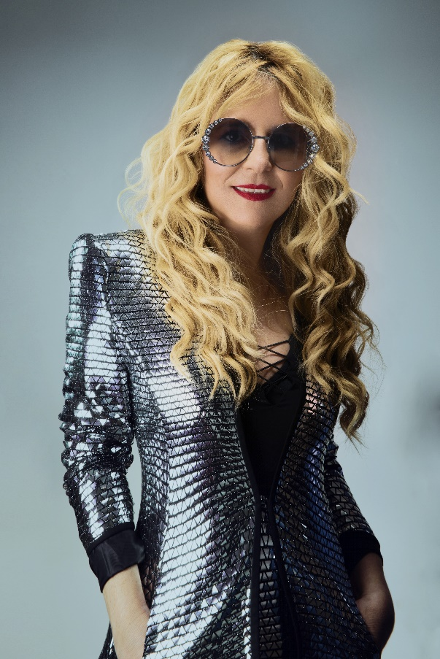
In 1987, Xaro inaugurated Xaro Ferri Estilistas, a cosy design salon where customers feel at home, and Xaro along with her team, give themselves completely to the well-being of those who trust in their hands.
Today, Xaro combines her work in the salon with the development of her artistic side, creating avant-garde hairdressing collections.
Gradually, Xaro has been making her mark in the world of Valencian hairdressing. She is part of the select artistic team (chosen from several thousand professionals) for the Cooperativa de Peluquería de Valencia, an event lasting two weeks that has more than ten thousand attendees. In addition, through this Cooperative, Xaro imparts avant-garde hairdressing training with commercial techniques throughout Valencia, and is periodically invited by the Hairdressing Association of Albacete to pass on this training and take part in a parade they hold each year.
The designs of Xaro Ferri have achieved recognition as shown by her winning the second Periche Prize (2014) and coming second place (2019) and winner (2020) in the contest for best poster at the fair Beauty Valencia.

