Embargoed until May 3, 2021, 9:00 a.m. CEST

New headmic for broadcasting, theatres and musicals
Sennheiser HM 200 uses popular MKE 1 capsule

Wedemark, May 3, 2021 – Sennheiser has launched the HM 200 today, a sturdy yet lightweight headmic that brings the esteemed sound of the MKE 1 lavalier microphone into a headset configuration.

“The HM 200 has had an immense success as a custom-made product in our home broadcast market,” explains Tom Vollmers, Manager Professional Portfolio at Sennheiser. “It was about time that we turned this top-of-the-range headmic into a series product and brought it to broadcasters as well as theatre and musical sound designers everywhere.”

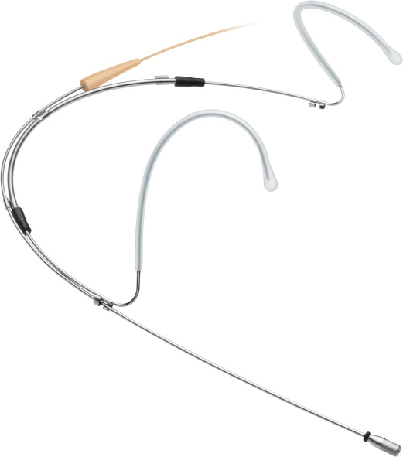 | The HM 200 has witnessed an immense success on the German broadcast market – now Sennheiser is turning the custom headmic into a series product

The HM 200 uses the capsule of Sennheiser’s smallest lavalier mic, the MKE 1, which is known for providing all the advantages of an omni-directional design – such as lower susceptibility to wind noise – while still putting an audible focus on the speaker’s voice. The headmic is virtually invisible from a distance while offering powerful sound – this makes the HM 200 an ideal choice for musical productions.

The metal frame of this headset microphone is lightweight, robust and flexible; its fixed cable is fitted with a professional 3-pin connector. The boom arm is shorter than with other models which adds to the inconspicuous nature of the design.

The HME 200 is silver-colored with transparent ear-bows and a beige cable. It comes with a beige foam windshield, one large and one small protection cap for the make-up artist, six attachment clips and a transport case. The headmic will retail at EUR 549 (MSRP) / USD 549 (MAP).

Technical Data
Frequency response: 20 to 20,000 Hz ± 3 dB
Max. sound pressure level: 143 dB
Pick-up pattern: omni-directional
Sensitivity in free field, no load (1kHz): 5 mV/Pa ± 2.5 dB
Nominal impedance: 1 kΩ
Equivalent noise level: 27 dB
Weight including cable: approx. 13 g
Weight without cable: 7 g

The high-res images accompanying this press release can be downloaded here.

About Sennheiser
Shaping the future of audio and creating unique sound experiences for customers – this aim unites Sennheiser employees and partners worldwide. Founded in 1945, Sennheiser is one of the world’s leading manufacturers of headphones, loudspeakers, microphones and wireless transmission systems. Since 2013, Sennheiser has been managed by Daniel Sennheiser and Dr. Andreas Sennheiser, the third generation of the family to run the company. In 2019, the Sennheiser Group generated turnover totaling €756.7 million. www.sennheiser.com

Global Press Contact

Stephanie Schmidt
Stephanie.schmidt@sennheiser.com
+49 (5130) 600 – 1275

