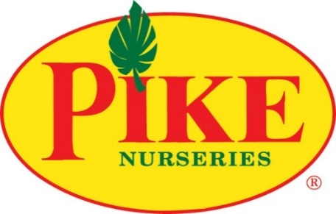

For more information:
Laurel Haislip/Becca Meyer
BRAVE Public Relations
404.233.3993
lhaislip@emailbrave.com/
bmeyer@emailbrave.com

**MEDIA ADVISORY**

Pike Nurseries to host Job Fairs for new Milton location, July 31 and August 1

Largest independent garden retailer welcomes all candidates who love to play in the dirt

ATLANTA (July 23, 2018) – In preparation for the new location in the Milton area, Pike Nurseries will host Job Fairs on Tuesday, July 31 at the Cumming store and Wednesday, August 1 at the Roswell store from 11 a.m. –3 p.m. The nation’s largest independent garden retailer plans to add associates in a variety of positions – including sales, maintenance and loading – to its new Milton store set to open in September 2018. The garden center will also be taking applications for manager trainees for all store locations. Applicants who enjoy connecting with others and playing in the dirt are encouraged to apply.

Pike Nurseries is employee-owned with opportunities for growth and development. Pike Nurseries offers a comprehensive benefits package including medical, dental, 401K and as an employee-owned company, provides employee stock-ownership.

Pike Nurseries is a full-service garden company that offers trees, shrubs, perennials, vegetables and more – as well as a collection of lifestyle products such as pottery, fountains, patio furniture and birding supplies. Known for their knowledgeable local garden experts at all locations, the garden centers also provide landscape design, installation and planting services to help homeowners as much or as little as they would like in their gardens.

WHAT: Pike Nurseries Job Fairs
Local garden center hiring for all positions, including sales, maintenance and loading

WHEN/
WHERE: Tuesday, July 31 from 11 a.m.-3 p.m.
Cumming store
6050 Bethelview Road
Cumming, Georgia 30040

Wednesday, August 1 from 11 a.m.-3 p.m.
Roswell store
615 West Crossville Road
Roswell, Georgia 30075

How: For information on Pike Nurseries careers or to see a full list of positions available, visit pikenursery.com/careers.

###

