PRESS CONTACT
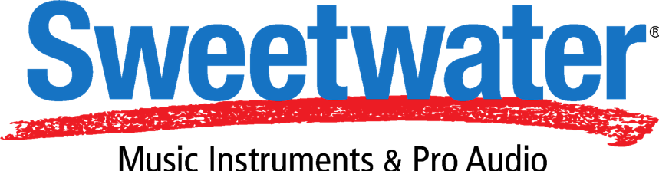
Heather Herron
V.P. of Corporate Communications
Sweetwater Sound, Inc.
heather_herron@sweetwater.com
5501 US HWY 30 W
Fort Wayne, IN 46818
Tel: (260) 432-8176, ext. 1030

North 6th Agency for Sweetwater
sweetwater@n6a.com

FOR IMMEDIATE RELEASE

Sweetwater Announces Grand Opening of Mega Music Store on Fort Wayne Campus
The new must-see destination for music enthusiasts features interactive experiences, exclusive musical instruments, studio recording gear and more

FORT WAYNE, Ind., June 22, 2021 – Sweetwater, the world's leading music technology and instrument retailer, today announced the grand opening of its new megastore. The captivating retail space, which boasts over 44,000 square feet, offers the ultimate experience for music fans and artists alike. Featuring Sweetwater-exclusive items, a state-of-the-art recording studio, piano room and live sound rooms, musicians and music makers of all types can now come together to experience and celebrate a one-of-a-kind environment with the people who know and love it better than anyone.
“We are honored to be able to present this experience to continue to enrich our music communities, both near and far,” said Chuck Surack, CEO and Founder of Sweetwater. “We have always been a business dedicated to building community. Our goal is to bridge stronger connections between musicians and offer our customers a new central destination where they can experience exactly what Sweetwater is.”
Featuring the world’s largest pedal display with more than 1,100 pedals and over 50 working headphones for guests to explore, music fans can interact with and shop for limited edition pieces, catch exclusive live events and surprises, and experience workshops with world-class musicians and industry leaders. The store also houses the industry’s first and only Roland VAD706 on display and playable in the showroom. Whether you’re into producing, recording, mixing, or just a music fan, this experience is for everyone.
Over 10,000 different items representing more than 1,000 manufacturers are featured in the new space, with thousands of the latest items across all product categories available in spacious showrooms, from audio technology to pro equipment and instruments. The store also features a section dedicated to customizing, selling, and trading gear, enabling customers to get a great deal and partake in the experience of building their own instrument or modifying their current one. Offering the most extensive, time-tested piano showroom in Northeast Indiana, music makers can find everything from modest digital home pianos to full-sized concert-worthy instruments. The digital piano room features fine and portable instruments by Roland, Yamaha, Casio, Korg and many other makers with over 40 instruments available on the floor.
As part of the launch, Sweetwater’s band and orchestra retailer, Mynett Music, will rebrand to Sweetwater Band & Orchestra and move from its independent location into the new store, featuring two state-of-the-art demo rooms that are equipped with acoustic enhancement technology that you'll only find at Sweetwater, and instruments within the shop from the last significant unexplored frontier of musical instruments.
“This was one of the best retail experiences I’ve ever had. The new store is epic... reminds me of the Apple store, but bigger, better and not aggravating.” Matt – Wildwood, MO.
“New store area is awesome. The pedal display/demo spot is particularly sick.” Kyle – Coopersburg, PA.
Since 1979, Sweetwater has championed musicians, creators and the arts. With a historical commitment to music makers, Sweetwater is dedicated to bringing world-class musical experiences and opportunities to Fort Wayne, and giving ambitious creators-- established or beginners-- possibilities to come together to create and immerse themselves in musical history on a grand scale.
“The music industry is all about connecting, and while we will always be an e-commerce business, we want to ensure our experiences online, and offline in our store, are unmatched. This for our customers,” continued Surack.
The store is officially open to the public in the iconic Sweetwater campus located at 5501 US-30 West, Fort Wayne Monday through Thursday, 9 a.m. to 9 p.m., Friday 9 a.m. to 8 p.m., Saturday 9 a.m. to 7pm and Sunday 11 a.m. to 5 pm.
About Sweetwater Sound
Founded in 1979, Sweetwater is the No. 1 online retailer of music instruments and audio gear in the U. S. The company is respected as the nation's leading retailer serving musicians, recording studios, broadcast, education, and houses of worship. Sweetwater's customers can be found everywhere music is heard and audio is played, broadcast, or recorded, including recording, film, and broadcast studios in New York, Nashville, Los Angeles, Chicago, and Miami; in hundreds of thousands of home recording studios; and in schools and churches nationwide. Sweetwater's founding and meteoric growth are built on a knowledgeable and experienced staff, outstanding selection and pricing, and, above all, an unwavering commitment to customer service excellence in every situation. For further information, visit Sweetwater.com.

