IMANOL OLIVER

OLIVER ESTILISMO BELLEZA HAIR SPA

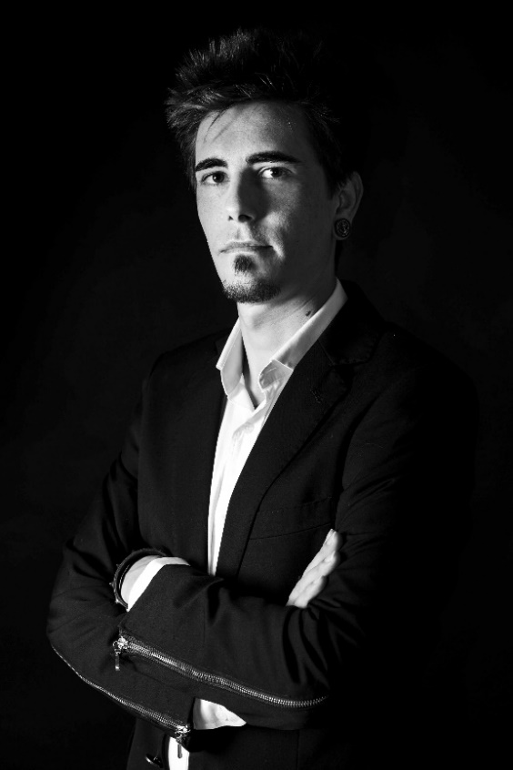
Imanol Oliver is part of a family with a deep-rooted tradition in hairdressing. He spent his childhood and adolescence surrounded by dryers, brushes, combs, scissors and Floïd's fragrance, which steered him towards his future career as a fourth-generation hairdresser. His road to success began at age seventeen with his first training position in female hairdressing using the Pivot Point method, which was followed by courses at prestigious schools such as Toni & Guy and Sassoon.

Aware of the value of in-depth training, he attended several seminars with leading professionals in the sector such as Gonzalo Zarauza, Robert Masciave, X-press, Anne Veck, Manuel Mon, Carlos Valiente and Antonio Calvo.

In 2007, he opened his own salon, Oliver Estilismo, and in 2013 he took a further step with the inauguration of the company's new facilities. The salon is a clear reflection of the way Imanol works, and is configured in a way to allow for a constantly evolving space. It is dominated by open areas, spacious and neutral zones, designed according to each service and covering all possible customer needs: thirteen styling chairs; barber corner; Make up Zone; Hair Spa where you can enjoy the best treatments; Nail Zone, and four cabins intended exclusively for aesthetic services.

The Oliver Estilismo brand is also known for offering its own training aimed at professionals, especially in the field of cut and colour, techniques for which the firm is renowned. In these sessions, Imanol describes the tools, tricks and techniques used in his creations. His passion for the profession is also shared in the training sessions he does for Intercoiffure Spain, Barbers 3.0 and Salon Look. The firm is currently part of the Revlon Professional Salon Adviser project.

The company strengthened its reputation in 2012, when Oliver committed to creating commercial hairdressing collections. That same year the stylist began to participate in national and international events such as the Intercoiffure World Congress 2012 held in Rome, which provided him with a springboard to participate in the creation of the collection that Intercoiffure Spain presented in Murcia and Valencia in 2013.

IMANOL OLIVER

OLIVER ESTILISMO BELLEZA HAIR SPA

Imanol combines his work in the salon and his training by additionally collaborating on projects with the model agency Monroe Models, photographer Juan Sánchez Castillo and designers Fernando Aliaga, Titis Clothing, and Núria Sanmartín.

His collections have been published in various national and international media and, in 2016, he received the Estrella Monroe Models distinction as well as his first recognition from the hairdressing sector: the prize for the Best Female Commercial Collection at the Modalité Contest held in Buenos Aires (Argentina).

In 2019, Imanol Oliver was a finalist at the International Visionary Awards in the Cut & Colour category, which was held at the ExCeL London's ICC Auditorium on October 6th.
