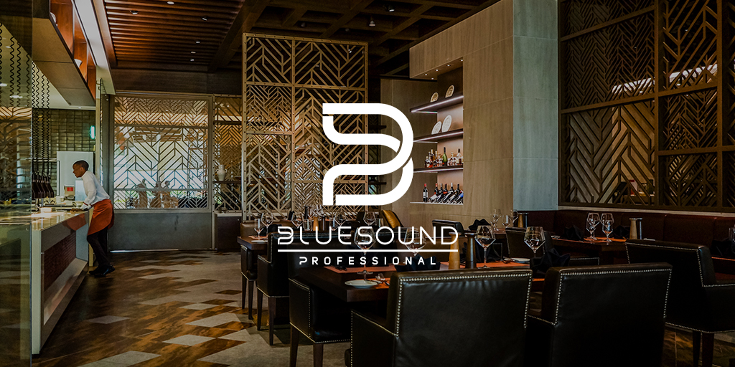

Bluesound Professional Announces New Southern California/Southern Nevada Rep
  - Premium commercial audio brand adds CA/NV rep to its existing network
Toronto, Ontario, canada April 12, 2022 – Bluesound Professional, the premium distributed commercial audio brand is excited to announce the addition of its latest rep firm in Southern California and Southern Nevada – Quantum Sales & Technology, Inc. – a California Corporation.

Craig Cooper, Bluesound Professional’s North American Sales Manager commented:

“By partnering with Quantum Sales & Technology, Bluesound Professional will grow its sales in the crucially important Southern California/Southern Nevada regions. This moves strengthens our representation in the territory and will allow us to continue our strong sales growth throughout USA, as people come back into public spaces and the retail and hospitality markets rebound after the pandemic. Omar and his team quickly understood the unique value that Bluesound Professional brings to the space and we in turn were highly impressed with the team’s enthusiasm, technical ability and connections in the market.”

Quantum Sales and Technology Inc.
Quantum Sales and Technology Inc represents manufacturers as a sales and marketing corporation. Founded on traditional values, they strive for long term, mutually beneficial business relationships with their manufacturers and customers with the goal of increasing awareness of how high-quality audio systems should sound. While headquartered in Santa Ana, California, they have been able to represent premium, world-class audio brands through the collective talents of their team. More information can be found at: https://www.quantumst.com/

Sales Inquiries:
Omar Arnold – Principal, Omar@quantumst.com

About Bluesound professional
Bluesound Professional is a fusion of hardware and software that is purpose-built for high performance networked audio for retail shops, bars, restaurants, hotels, gyms, and other commercial applications. End users can connect and control nearly any audio source, including streaming services, internet radio, or networked hard drives, while installers can confidently specify rack-mounted hardware that integrates seamlessly with smart controllers. Powered by BluOS, an award-winning multi-zone audio management software platform, made native in a comprehensive range of controllers, streamers, amplifiers, and speakers, Bluesound Professional makes commercial audio installation projects easy to configure, deliver, and use. Bluesound Professional is a division of Lenbrook International, renowned manufacturers of premium audio technologies for residential and commercial applications.

Contacts

Corporate & Media Contact
June Ip
Marketing, Lenbrook International
media@lenbrook.com

Links
Website: https://bluesoundprofessional.com
LinkedIn: https://www.linkedin.com/company/bluesoundpro

# # #

