The Search for Ultimate Sound: Sonarworks Launches user-driven research project for sonic personalization
Latvian company relies on user feedback to improve award winning headphone correction app
Riga, Latvia – March 21, 2019 – Sonarworks, the European sound calibration software developers, have just announced the launch of a public research project designed to fine-tune the calibration of their award winning apps for individual listener preference. The Sound Preference Research Project, which is currently underway globally, allows users to audition music samples with different sound settings in a simple A/B assessment to choose the sound they prefer most. Based on the user input AI algorithm predicts the best possible sound settings for that user. The Research Project is currently open to all, with integration into Sonarworks’ True-Fi mobile app planned for the end of Q2, 2019.

“By deploying this project, we are able to gain a better understanding of sound preference trends that are happening across our vast user base, with the goal of delivering the ultimate sound for each individual on any device,” explains Helmuts Bems, Sonarworks CEO and Co-Founder. “Everyone’s listening experience is inherently personal. So by feeding AI the results from this project we are able to ascertain objective insight into how people perceive sound. This means we can arrive at a user’s preference more quickly based on how they respond.” Once the project is complete and its results are fully integrated into True-Fi, it will be possible for users to then tailor sound to their own listening preferences.

The Sound Preference Research Project is the latest in a series of outreach efforts that Sonarworks has made to its growing user community, a dialogue that has allowed the company to integrate user feedback into upcoming projects. “We have established a solid foundation for delivering Studio Reference sound across many different audio devices,” Bems says. “The next step in this process is to create a seamless platform for users to discover and define their own ‘Ultimate Sound’.
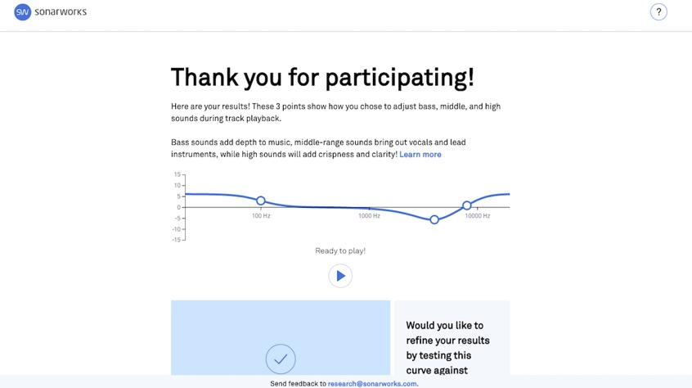
Furthering its mission to provide ‘Ultimate Sound’ for consumers, Sonarworks will soon be extending its Studio Reference technology into a range of new applications, including the residential and automobile markets. In January during CES 2019, the company unveiled a prototype automobile which integrated True-Fi technology. The company will be announcing new OEM integration as well as a new software offering aimed at wider consumer market towards the end of 2019.

To take the Sonarworks preference test, please visit: https://preference-research.sonarworks.com
For more information about Sonarworks True-Fi, please visit: https://www.sonarworks.com/truefi

About Sonarworks
Sonarworks is the leading sound calibration company in the sound recording industry. Our products are relied-upon by more than 30,000 recording studios worldwide, including 25 Grammy winners who enjoy and endorse Sonarworks. Now we are on a mission to take this even further - deliver the ultimate sound experience to all music listeners, regardless of the device used, be it headphones, speakers, or car stereo.

Media Contact:
Steve Bailey
Hummingbird Media
+1 (508) 596-9321
steve@hummingbirdmedia.com

Jeff Touzeau
Hummingbird Media
+1 (914) 602-2913
jeff@hummingbirdmedia.com

