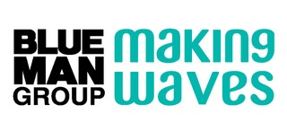
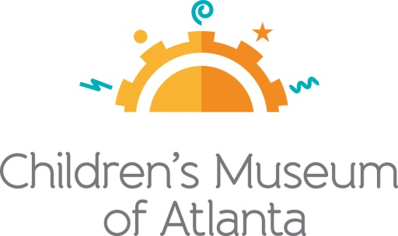

FOR MORE INFORMATION:

Becca Meyer/Jennifer Walker
BRAVE Public Relations
404.233.3993
bmeyer@bravepublicrelations.com/
jwalker@bravepublicrelations.com

Blue Man Group Contact:
Nancy Hirsch
212.967.3805
nancy@hirschgroup.com
*MEDIA ADVISORY*

Children’s Museum of Atlanta presents final weeks of Blue Man Group - Making Waves

National touring exhibit featuring renowned performing group closes September 4!

ATLANTA (August 7, 2017) – Blue Man Group – Making Waves, the national touring exhibit supported by Harman/Becker Automotive Systems and created by the Boston Children’s Museum and Blue Man Group and powered by JBL®, will be at Children’s Museum of Atlanta until September 4. The 1,500 square foot exhibit - designed to bring together science and art - takes the whole family through a multi-sensory exploration of sound and creates the opportunity to play together while discovering the fun of music. Throughout the exhibit, little ones can navigate the science behind sound through tube phones, a sand drum, PVC pipe instruments, a surround sound theater and more!

WHAT: Final weeks to visit Blue Man Group – Making Waves
Only a few weeks remaining for families to explore the elements of sound inspired by the well-known performing group

WHEN: Available through Monday, September 4
Monday, Tuesday, Thursday and Friday: 10 a.m. – 4 p.m.
Weekends: 10 a.m. – 5 p.m.
**The Children’s Museum of Atlanta is closed on Wednesdays

WHERE: Children’s Museum of Atlanta
275 Centennial Olympic Park Drive, NW
Atlanta, GA 30313

HOW: Entrance to the exhibit is included in each regular admission to Children’s Museum of Atlanta. Admission for ages 1-100 is $15.95 (+tax). Children under 1 are FREE.

Connect with the Children’s Museum of Atlanta on Facebook, Twitter, Pinterest and Instagram. For more information or to support the Museum, visit childrensmuseumatlanta.org or call 404.659.KIDS [5437].

###

