NEUMANN KH 750 DSP SUBWOOFER
DEEP BASS IN A SMALL SPACE
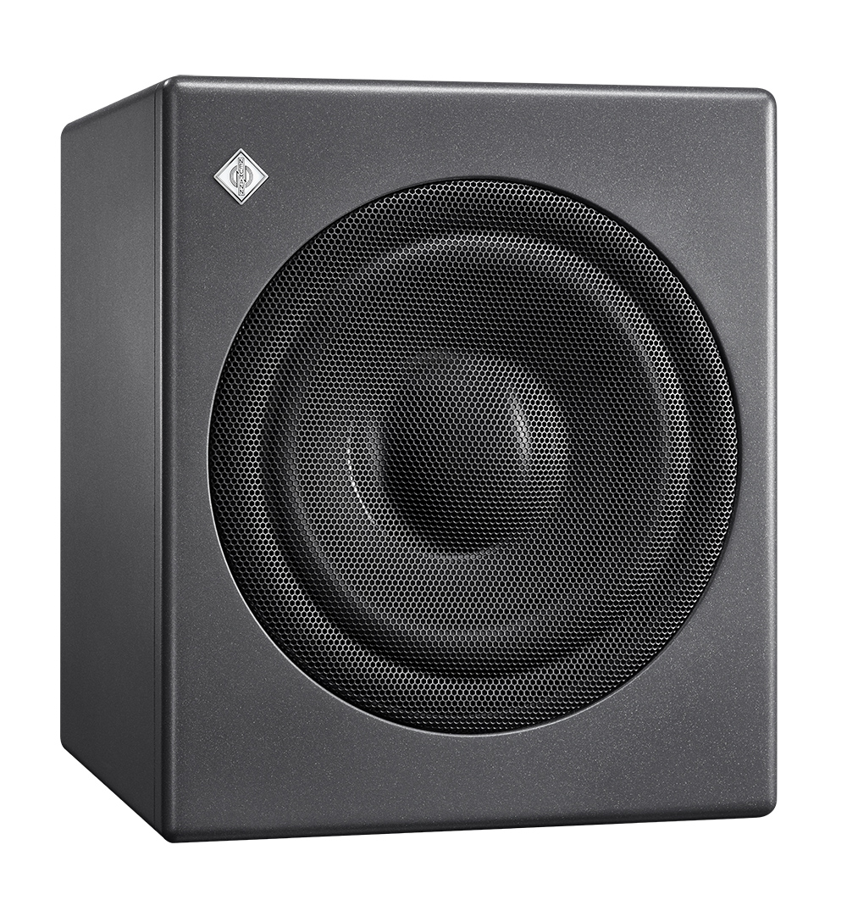

Berlin, January 24, 2019 – With the KH 750 DSP Neumann presents a new – particularly compact – subwoofer. It is the ideal choice for smaller rooms and the perfect complement to the Neumann KH 80 DSP studio monitors.

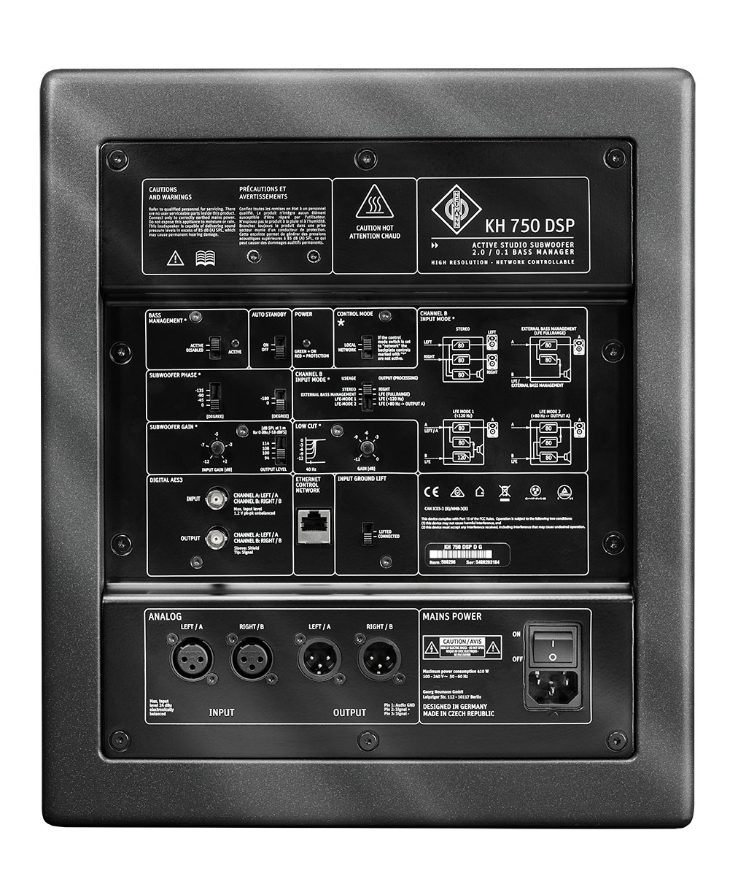
The KH 750 DSP has a unique and flexible 2.0/0.1 Bass Manager allowing the subwoofer to be used in many different system configurations. On the back panel there are analog and digital inputs and outputs, four routing modes and adaptable acoustical controls to allow for seamless system integration. The Neumann.Control App for iPad® gives access to many additional functions inside the subwoofer.

The newly designed 10” long-throw driver has a large magnet, linear motor design and a very stiff pressed steel basket. As subwoofers are usually placed on the floor, a robust grille protects the driver from accidental damage. The well-braced cabinet is a sealed design which brings the fastest possible transient response. The two analog XLR inputs are balanced as are the two analog XLR outputs. The 192 kHz / 24-bit digital input can accept AES3 and S/P-DIF signals.

The KH 750 DSP can be used in music, broadcast, and post production studios for tracking, mixing, and mastering. Wolfgang Fraissinet, President of Neumann.Berlin, adds: "Thanks to the significantly reduced housing depth, the KH 750 DSP is 'compatible' with the often confined space available in home recording and broadcast studios."

Features:
- Easily installed compact cabinet with a very deep bass response
- DSP engine optimizes output to achieve reference class sound
- Neumann.Control App for iPad® to set up, align and operate in a system

All further product information can be found at www.neumann.com.

Link for photo and text material:
https://www.neumann.com/exchange/Neumann-KH750DSP.zip

iPad® is a trademark of Apple Inc., registered in the U.S. and other countries.

About Neumann
Georg Neumann GmbH, known as “Neumann.Berlin”, is the world’s leading manufacturer of studio microphones and the creator of recording legends including the U 47, M 49, U 67 and U 87. Founded in 1928, the company has been recognized with numerous international awards for its technological innovations. Since 2010, Neumann.Berlin has expanded its expertise in electro-acoustic transducer design to also include the studio monitor market, mainly targeting TV and radio broadcasting, recording, and audio productions. Georg Neumann GmbH has been part of the Sennheiser Group since 1991, and is represented worldwide by the Sennheiser network of subsidiaries and long-standing trading partners. Website: www.neumann.com.

Neumann Press contact:

Andreas Sablotny
andreas.sablotny@neumann.com
T +49 (030) 417724-19

Local press contacts
Sarah James Victoria Chernih
sarahj@gasolinemedia.com.com victoria.chernih@sennheiser.com
+44 1483 223333 +44 7881 091687

