eneloop supports green organisations with 2 large-scale European projects

Zellik, 16 March 2017 – While the registrations for the eneloop expedition 2100 continue to flood in, the final edition of the eneloop European Photo Challenge is now taking place. Both competitions give participants the opportunity to win prize money for organisations that share a vision for a sustainable future.

Backpack through Europe, and support a good environmental cause
In the eneloop expedition 2100 three two-person teams will compete against one another in a 2,100 kilometre walk across Europe in 120 days. Their aim? To reach the finish line in Milan with as many points as possible through earning them by completing fun tasks along the way.

Each team chooses an environmentally-friendly organisation to raise money for and at the end of the adventure, eneloop will donate 21,000 Euros to the winning team’s organisation and 2100 Euros to the runner ups organisations. In addition to adventure and raising money for a good cause, each team member will win his/her complete expedition equipment plus a number of fabulous prizes from Panasonic.

Register before 17 April 2017. Anyone who is 18 years old, lives in Europe and has no obligations between 23 June and 20 October 2017 can participate. For more information go to www.eneloopexpedition.com or see the eneloop expedition 2100 Facebook page.

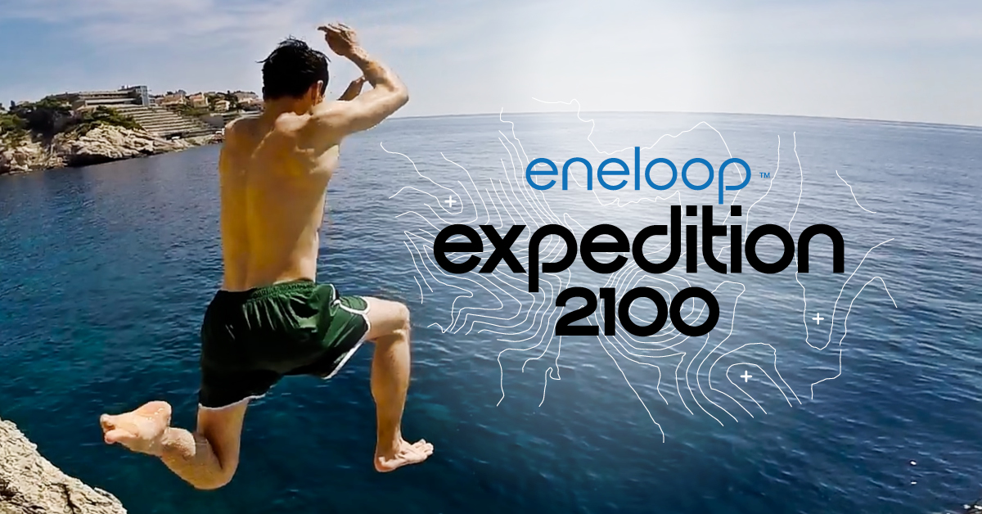

Take part in the final eneloop European Photo Challenge
The final edition of the eneloop European Photo Challenge is currently being held. Until 31 March, 10.00 hours (amateur) photographers from across Europe can send in their best nature photograph that best depicts the theme ‘communication’. The photo with the most likes wins.

The photo challenge was developed by Panasonic Energy Europe in December 2015 to raise public awareness of their environmentally friendly eneloop batteries. In this final edition the emphasis moves to their eneloop lite batteries (specially for devices with low energy consumption, such as DECT phones) that can be charged up to 3000 times.

Each edition of the European Photo Challenge eneloop supports two environmental organisations. Both the organisation linked to the photo with the most votes and the organisation chosen most often by the participants will receive a donation of 5000 Euros. In addition, participants have the opportunity to win a Panasonic DMC-G80MEF-K camera worth 1000 Euros and eneloop batteries and chargers.

Winners Ocean edition
The Dutch organisations Bite Back and Sea First won the prize money in the previous ‘Ocean’ themed edition.

Bite Back will use the 5000 Euros to raise awareness of the impact of consuming meat and dairy on animals and nature in general. In addition, they are calling on people to eat a more plant-based diet and to combat animal abuse in dolphinaria.

Educational organisation Sea First Foundation teaches pupils and students at school how important a healthy ocean is, and what the threats and solutions are. They are also committed to the welfare of marine animals. With the 5000 Euros from Panasonic, Sea First is making a film about dolphins in the wild versus captivity. It will use the remaining money to visit additional schools.

About Panasonic Energy Europe
Panasonic Energy Europe is headquartered in Zellik, near Brussels, Belgium. The company is part of the Panasonic Corporation, a leading global manufacturer of electronic and electrical goods. Panasonic’s vast and lengthy experience in the consumer electronics field has helped make Panasonic the largest battery manufacturer in Europe today. The European production facilities are located in Tessenderlo, Belgium, and Gniezno, Poland. Panasonic Energy Europe supplies ‘mobile’ energy solutions to more than 30 European countries. The company’s diverse product range includes rechargeable, chargers, zinc carbon, alkaline and specialty batteries (such as zinc air, photo lithium, lithium coin, micro alkaline, silver oxide).
For more information, visit: www.panasonic-batteries.com.

About Panasonic
The Panasonic Corporation is a leading company worldwide in the development and manufacture of electronic goods for a wide range of private, trade and industrial uses. Panasonic, based in Osaka, Japan, in financial year ended 31 March 2015 posted consolidated net sales of around 57.28 billion EUR. Panasonic is committed to creating a better life and a better world, continuously contributing to the evolution of society and to the happiness of people around the globe.
More information about the company and the Panasonic brand name at www.panasonic.net.

PRESS CONTACT

ARK Communication
Ann-Sophie Cardoen
Content & PR Consultant
T +32 3 780 96 96
ann-sophie@ark.be
www.ark.be

Panasonic Energy Europe NV
Vicky Raman
Brand Marketing Manager
T +32 2 467 84 35
vicky.raman@eu.panasonic.com
www.panasonic-batteries.com
www.panasonic-eneloop.com

