OMNIMAGO Selects Xytech’s MediaPulse to Streamline Project Management Needs
The German post-production house chooses MediaPulse to put targeted functionality in the hands of all users

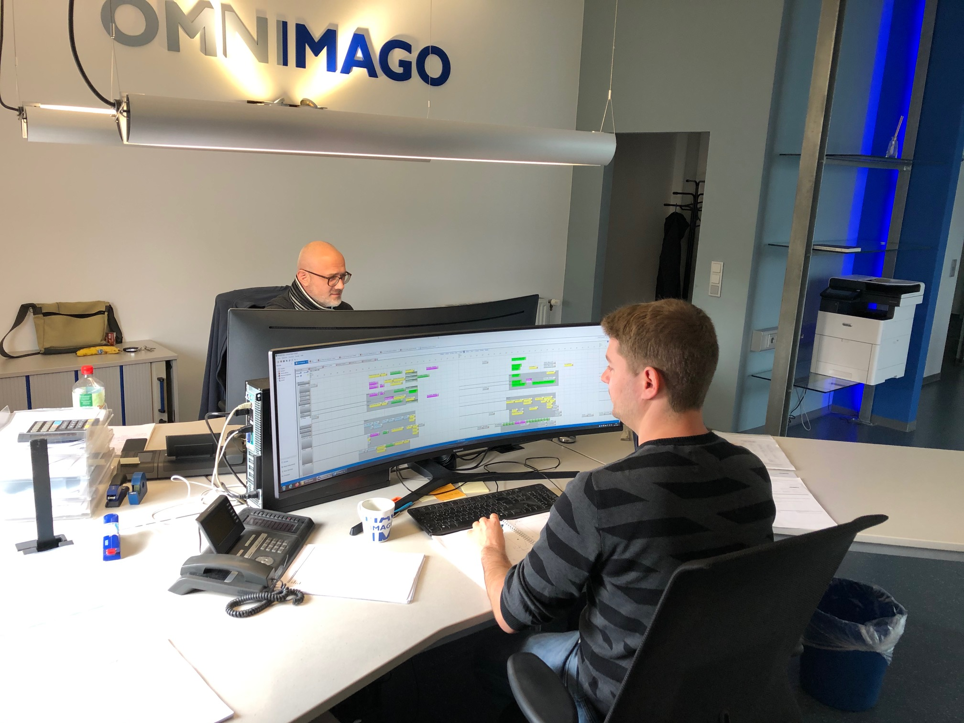
Ingelheim am Rheim, Germany, November 7, 2019 — German post-production specialist OMNIMAGO GmbH, has chosen Xytech’s MediaPulse resource management software as its go-to solution for its scheduling, billing and project management needs.
Recently released at IBC 2019, MediaPulse 2019 features an updated user interface developed to place targeted functionality in the hands of all users in an enterprise, including every staff member, freelancer and vendor to create a seamless end-to-end automated workflow accessible on any device connected to the internet.
All-in-One Solution
Headquartered in Ingelheim with a second location in Leipzig, OMNIMAGO is a leading media service company, working with public and commercial TV broadcasters, film and TV companies, and industrial enterprises. Its services range from classic post-production services for film and television companies to tap mass digitalization and digital film restoration projects for international film archives.

Given the variety of projects OMNIMAGO takes on, it was integral the company found a solution to contain the whole process, from bidding to invoicing, within the same system.

“This ensures all of the necessary information is easily available to all of the people and departments involved,” said Peter Fries, OMNIMAGO’s Managing Director. “MediaPulse has proven itself as the ultimate tool to support us during the administration process on all of our technical projects.”

Currently holding 45 MediaPulse licenses, OMNIMAGO has been using MediaPulse for almost 20 years and selected the software for its best-in-class efficiency.

“It fulfills all of our scheduling, billing and project management requirements in the best possible way,” Fries said. “We took a number of other established ERP systems into consideration, but nothing compared to the efficiency of MediaPulse.”

About Xytech
For more than 30 years, the world’s premiere media companies have depended on Xytech to run their businesses. MediaPulse is the only end-to-end solution for the complete content lifecycle. MediaPulse provides scheduling, automation, asset management, billing and cost recovery for broadcasters, media services companies and transmission facilities in a scalable platform-independent solution. For more information, visit xytechsystems.com.

Media Contacts:

Katie Kailus
Public Relations
Hummingbird Media
+1 (630) 319-5226
katie@hummingbirdmedia.com

Alexis Lipoff
Public Relations - EMEA
Hummingbird Media
alexis@hummingbirdmedia.com

Jeff Touzeau
Public Relations
Hummingbird Media
+1 (914) 602 2913
jeff@hummingbirdmedia.com

