For more information, please contact Marta de Paco
On +34 670 780 664 or email press@comunicahair.com

Important:
These images are only available for editorial content.
Credits must be included.
Notification of their publication is expected.

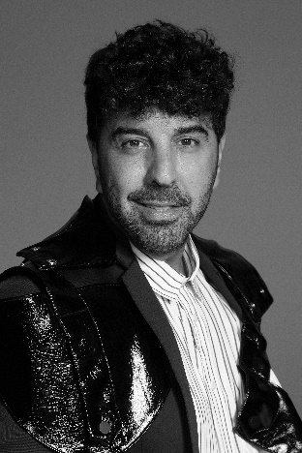
JOSE URRUTIA
1941 Collection

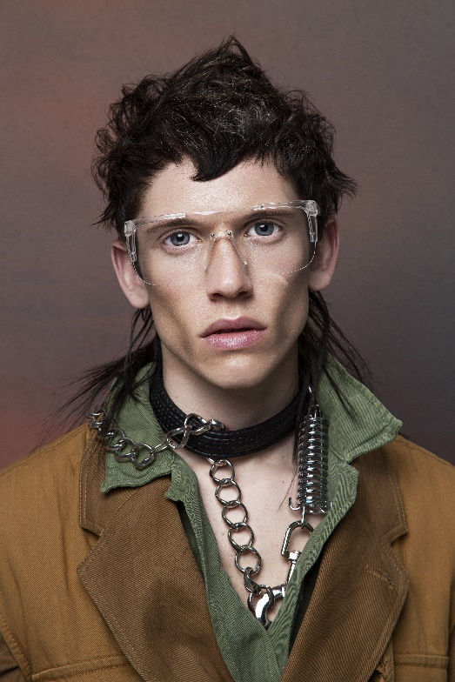
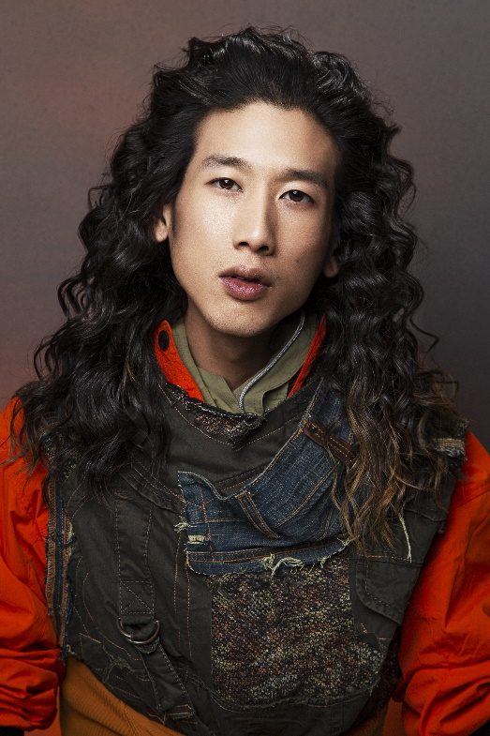
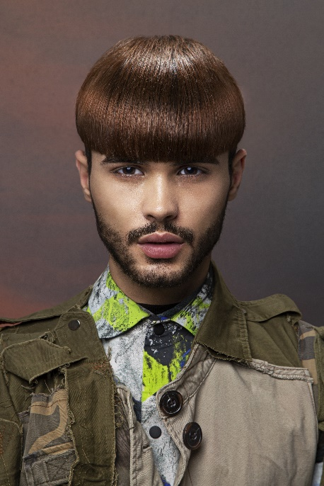
Hair: Jose Urrutia @Peluquería Jose Urrutia
Hair Instagram: @pjurrutia
Hair Assistant: Veronica Calpa Perugachi
Assistant Instagram: @calpaperugachi
Photography: Esteban Roca
Photography Instagram @esteban_roca_photo
Retouching: Esteban Roca
Retouching Instagram: @esteban_roca_photo
MUA: Nacho Sanz
MUA Instagram @nacho_sanz_makeup
Styling: Visori FashionArt
Styling Instagram @visorifashionartstudio
Products: Revlon Professional
Products Instagram @revlonprofessional_es

JOSE URRUTIA
1941 Collection

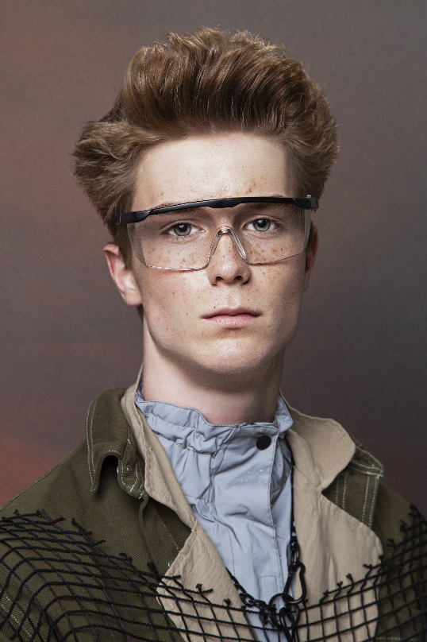

1941 is a review of our darkest past, the one in which humanity was exalted in violence. In this case, José Urrutia is inspired by the battle of Pearl Harbor, which on its 80th anniversary should make us reflect on the trauma that any war causes. Therefore, it is an anti-war chant that is reflected in disturbing looks, with clear references to the military world.

Curls that fall in an open and clear cascade like the effect of a bomb; haircuts with shiny and impeccable fringes, typical of the discipline of the army; tousled finishes and unstructured haircuts that remind us of those who suffer the devastating effects of war; and raised toupees that take us back to the aesthetics of a painful time.

