Synthax Hosts Daily Webinars for Live Sound, Broadcast & Recording Professionals

Featuring sessions on audio networking and IEM usage, two of the webinars qualify for (2) CTS RU credits
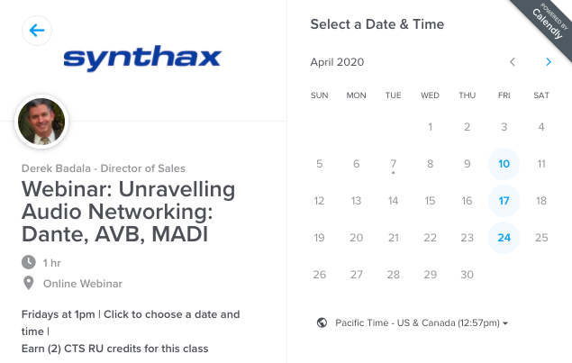
Fort Lauderdale, Florida, April 9, 2020 — Amidst the disruptions in the market caused by Covid-19, Synthax — distributor of RME audio solutions, Ferrofish audio converters, Digigram broadcast and streaming solutions, Appsys digital audio tools, and myMix personal monitor and mixer — has announced a series of free weekly webinars covering a variety of industry topics, from breaking down audio networking systems to the psycho-effects of IEM usage.
The free webinars will be hosted by several of Synthax’s key technical experts and offered Monday-Friday throughout the months of April, May and possibly longer, until further notice. The webinars are targeted to those who work in the live sound, broadcast and audio production markets. Those interested can register and find a full schedule with available times at: https://www.synthax.com/webinars/.
“With so many professionals currently waiting to go back to work, we thought this would be a perfect time to offer some advance learning opportunities,” Badala said. “These daily webinars offer Pro A/V professionals around the world the chance to make most of their time and advance their knowledge of different audio networking systems and solutions as well as receive up to 4 CTS RU credits for some of the sessions in the process.”
Learn from Home
On Fridays, attendees have the opportunity to receive earn (2) CTS RU credits during the 11am EST “Reliable Audio Over Unreliable Networks” webinar and 1pm EST “Unravelling Audio Networking: Dante, AVB & MADI” webinar which discusses the go-to networking systems and delves into the advantages each has to offer, while explaining how to best employ them in a user’s workflow.
The webinars will also cover how to get the most out of many of the leading products in the Synthax brand portfolio, including sessions on RME’s Babyface Pro FS and Digiface Dante and AVB audio interfaces, TotalMix FX mixing software and the ADI-2 Pro FS and ADI-2 DAC; Appsys Pro Audio’s Multiverter format converter; Digigram’s audio codecs; and the myMix personal monitor and mixer.
To register for any of the free webinars, visit: https://www.synthax.com/webinars/
For more information on Synthax, visit: https://www.synthax.com/
About Synthax, Incorporated
Synthax Inc. is the exclusive USA distributor for RME digital audio solutions, Digigram broadcast audio systems, Appsys digital audio tools, Ferrofish advanced audio applications, myMix personal monitoring systems and ALVA cableware. We supply a nationwide network of dealers with these products for professional audio, broadcast, music industry, commercial audio, theater, military and government applications. For additional information, visit the company online at http://www.synthax.com.
About Digigram
For over 30 years, Digigram has developed innovative digital systems that make modern broadcasters rapidly evolving operations more efficient, more reliable and more effective. Used by thousands of journalists, broadcasters and industrial users all over the world, Digigram’s sound cards, audio processing software and pioneering IP audio technologies are designed with a consistent attention to quality and reliability. Digigram (DIG) is publicly listed on the NYSE Euronext Paris stock exchange. More information is available at http://www.digigram.com/.

Media Contacts:
Katie Kailus
Public Relations
Hummingbird Media
+1 (630) 319-5226
katie@hummingbirdmedia.com

Jeff Touzeau
Public Relations
Hummingbird Media
+1 (914) 602 2913
jeff@hummingbirdmedia.com

