Please note that this information is strictly embargoed until 1 June 2021, 17:00 AEST

Evolution Wireless Digital
New, app-based solutions for corporate and education spaces

Sydney, Australia, 1 June 2021 – Wireless is meant to make things easier. It gives you freedom to move. It makes set-up times faster. But for many, setting up wireless microphones can be a nuisance or even intimidating. Now RF expert Sennheiser brings simplicity to wireless with Evolution Wireless Digital. The series introduces an easy, app-based workflow while retaining all the professionality, multi-channel capability and reliability that users have come to expect of UHF and 1G8 microphones. The systems are ideal for corporations looking for an easy wireless solution, and for schools who will find these mics to be equally at home in the classroom as well as on stage.

With an app-based workflow and many professional features under the hood, Evolution Wireless Digital makes wireless easy – whether in corporations or schools

“We talked with many users prior to the development of Evolution Wireless Digital,” explains Oliver Schmitz, product manager for Evolution Wireless Digital. “It turned out that in the run-up to a corporate or school event, the media admins do not have the time to do extensive frequency scans, they do not want to battle with settings – in brief: they do not want to be forced to become an RF expert to run a wireless microphone. All they want is a mic system that works right away and is reliable, so all they have to do is switch on and go.”

“This is why we came up with an app that does all the planning and guides users through the set-up,” adds Benny Franke, responsible for the software. “An app, where all the expertise is under the hood, and where you don’t have to be a mechanic to drive the car. There were many details that we sweated over so that users can keep their cool before, during and after the event.”

The engineer in your pocket: The Smart Assist App guides users through the set-up of their wireless microphone system | 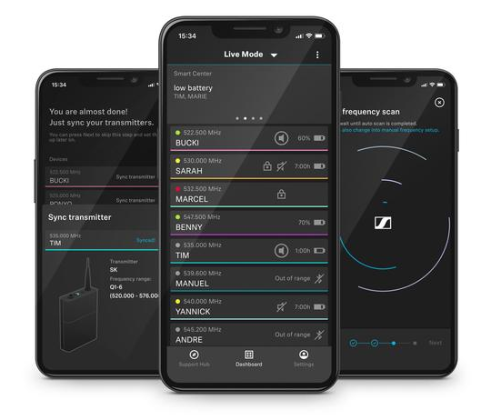
Why is it easy?
- The Smart Assist App
As the engineer in your pocket, the app guides users through the set-up in easy steps. “If someone can handle an app, they can handle the RF wireless set-up with ease,” says Benny Franke. An intelligent set-up automatically creates reliable wireless connections, no wireless expertise is required. The app gives access to all system settings, and channels can be named to keep organised. Bluetooth Low Energy allows for remote access to the system and makes sync’ing with the receiver convenient. The app also includes tutorial videos to get started and provides the operating instructions of the systems all in one place.

- Microphone transmitters that can handle any audio level
Evolution Wireless Digital transmitters have an input dynamic range of 134 dB, five times more than the usual 120 dB. This means that they can pick up everything from a very soft whisper to a jet engine at 50 yards’ distance – and this eliminates the need for a sensitivity setting on the transmitter entirely. The receiver has been set to a gain value covering most applications, which can easily be changed if required. A new user interface makes this an easy task – no complex sub-menus, everything is available at a glance.

- No frequency calculation – and more room to manoeuvre
Nowadays, more and more RF is appearing in venues but Evolution Wireless Digital (EW-D) takes on this complexity and helps users to go with the flow. The app will scan the environment to find open frequencies. And as EW-D has borrowed tech from Sennheiser’s top Digital 6000 and Digital 9000 series, the wireless microphone systems do not generate any significant intermodulation products. This not only makes for more room in a given frequency window, but the app can also simply set the wireless links at 600 kHz intervals without any frequency calculation and is therefore able to fit in more frequencies than a standard mic system would be able to.

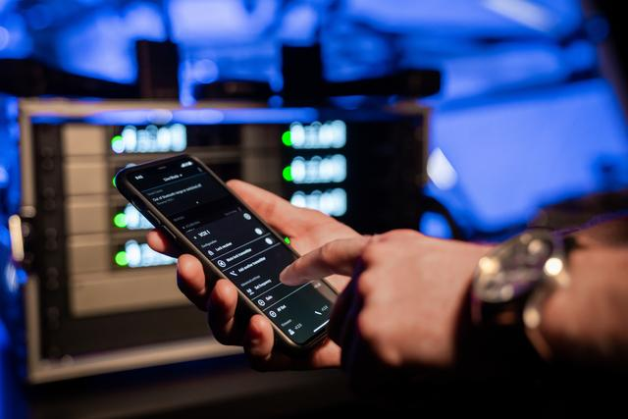 | Tech from higher Sennheiser series makes frequency calculation a thing of the past. Whether it’s the school’s band performing or a speech at a corporate event – the app will scan the room and help you find the best frequencies

- Exceptional specs in every detail
EW-D has a low latency of 1.9 milliseconds and a transmitter battery life of up to 12 hours with the BA 70 rechargeable battery pack, lasting all the way from rehearsing and soundcheck through to the event. A bandwidth of 56 MHz with up to 90 channels per band makes it easy to find space even in the most crowded of RF environments.

- Fantastic audio
As a digital system, EW-D does not use a compander. Gone are the associated noise floor and artefacts – the system will sound like it’s plugged in with a cable.

- Full range of pro accessories
From newly designed antennas to antenna splitters, boosters, charging sets – the system will grow with your demands to also accommodate larger multi-channel set-ups.

The ADP UHF remote antenna features cut-outs to reduce wind load

EW-D handheld transmitters couple with any Sennheiser or Neumann wireless capsule. This includes the Neumann KK 205 and KK 204, the new Sennheiser MM 435 and MM 445 as well as the Digital 9000 capsules – a first at this price level.

A perfect fit for schools and corporations
“Whether you are looking for a wireless microphone solution for corporations or for schools, Evolution Wireless Digital will deliver reliable audio. Evolution wireless systems have been praised as allrounders for music and speech. Using them has become easier than ever before, no matter if they support the school’s band, transmit a CEO speech or are used for web streaming live content,” concludes Oliver Schmitz.

Evolution Wireless Digital is available now, with a choice of handheld, instrument, lavalier, headmic, combo and base sets (see Appendix).

For your social media channels:
Sennheiser Evolution Wireless Digital – as easy as an app but fully professional.

Appendix:
Available Systems
Model |  | Delivery includes
EW-D 835-S SET  (MSRP: EUR 699) |  | - EW-D EM digital ½ 19” single-channel receiver  - EW-D SKM digital handheld transmitter  - MMD 835 mic head  - Microphone clip  - Power supply with country adapters  - Rack mount kit & AA batteries
EW-D CI1 SET  (MSRP: EUR 649) | 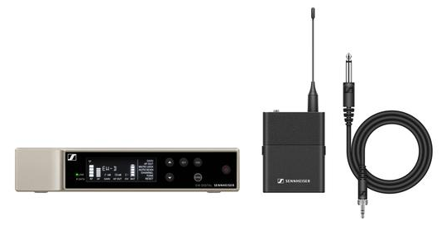 | - EW-D EM digital ½ 19” single-channel receiver  - EW-D SK digital bodypack transmitter  - Ci1 instrument cable  - Power supply with country adapters  - Rack mount kit & AA batteries
EW-D ME2 SET  (MSRP: EUR 699) | 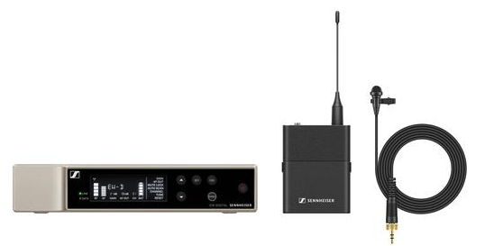 | - EW-D EM digital ½ 19” single-channel receiver  - EW-D SK digital bodypack transmitter  - New ME 2 lavalier mic (omni)  - Power supply with country adapters  - Rack mount kit & AA batteries
EW-D ME4 SET  (MSRP: EUR 699) | 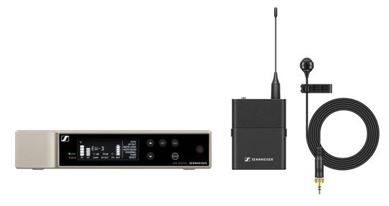 | As above but with new ME 4 lavalier mic (cardioid)
EW-D ME3 SET  (MSRP: EUR 749) | 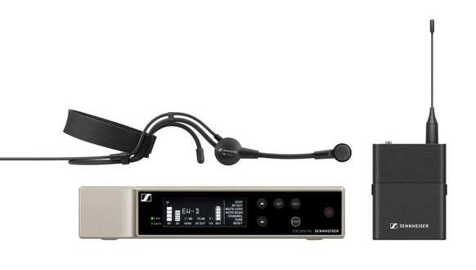 | As above but with new ME 3 headmic (cardioid)
EW-D SKM-S BASE SET  (MSRP: EUR 599) |  | - EW-D EM digital ½ 19” single-channel receiver  - EW-D SKM digital handheld transmitter  - Microphone clip  - Power supply with country adapters  - Rack mount kit & AA batteries
EW-D SK BASE SET  (MSRP: EUR 599) | 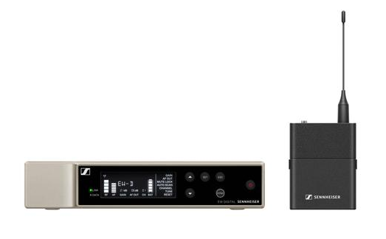 | - EW-D EM digital ½ 19” single-channel receiver  - EW-D SK digital bodypack transmitter  - Power supply with country adapters  - Rack mount kit & AA batteries
EW-D ME2/ 835-S SET  (MSRP: EUR 999) | 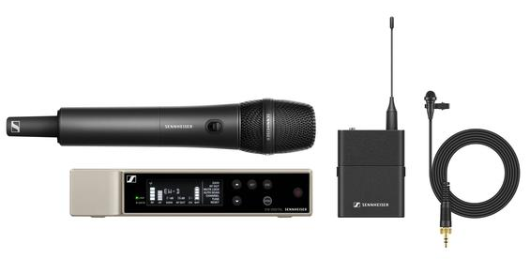 | - EW-D EM digital ½ 19” single-channel receiver  - EW-D SKM-S digital handheld transmitter  - EW-D SK digital bodypack transmitter  - MMD 835 mic head  - Microphone clip  - New ME 2 lavalier mic (omni)  - Power supply with country adapters  - Rack mount kit & AA batteries

Download links
Download product and system specifications
Download high-resolution product photos
Download accessory images
Download high-resolution music application photos
Download high-resolution education and corporate application photos

www.sennheiser.com/ew-d-business

About Sennheiser
Shaping the future of audio and creating unique sound experiences for customers – this aim unites Sennheiser employees and partners worldwide. Founded in 1945, Sennheiser is one of the world’s leading manufacturers of headphones, loudspeakers, microphones and wireless transmission systems. Since 2013, Sennheiser has been managed by Daniel Sennheiser and Dr. Andreas Sennheiser, the third generation of the family to run the company. In 2019, the Sennheiser Group generated turnover totaling €756.7 million. www.sennheiser.com

Global Press Contact

Stephanie Schmidt
Stephanie.schmidt@sennheiser.com
+49 (5130) 600 – 1275

