Your audio signal … reborn
Dear Reality releases new MIYA plugin

Düsseldorf, 10 May 2023 – MIYA, Dear Reality’s latest wavelet distortion plugin for audio signals, follows a radically different approach to distortion by creating a wide range of permutations of the original input using adjustable harmonics. Users can re-synthesize their audio and ‘sculpt’ their sounds like on a synthesizer, ranging from slight alterations and subtle textures to gnarly distortion and even massive sub-harmonics.

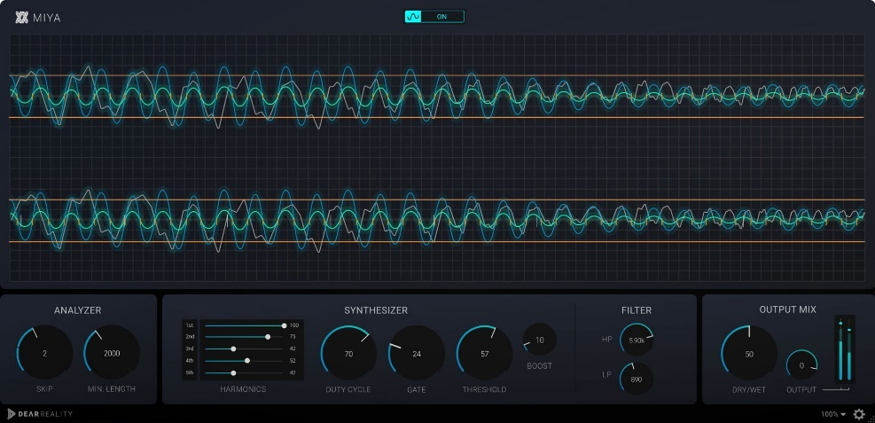 | Dear Reality’s MIYA plugin is a completely new take on distortion

Unlike ordinary distortion effects, MIYA processes the original input by detecting zero-crosses and replacing the original signal between them with additively synthesized waveforms. “We are specialists in spatial audio, but we are also passionate about exciting audio algorithms outside of our spatial audio focus,” explains Felix Lau, product owner at Dear Reality. “A perfect example of this is MIYA’s unique digital distortion technology, in which the listener can recognize both the footprint of the original and the synthesized sound.”

With MIYA, users can spice up any sounds, add texture, or again wreck the original signal to recreate it from scratch with precisely tuned wavelets.

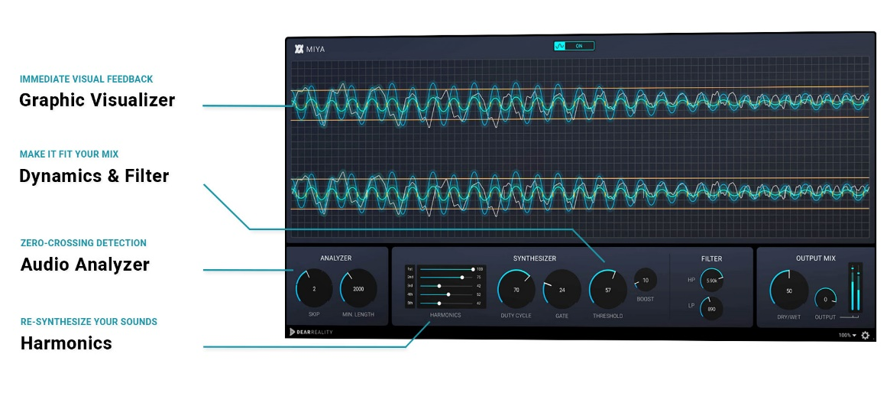

MIYA's real-time visualizer provides immediate feedback using four different colors. Short orange vertical lines indicate detected zero-crosses, while a grey line shows the incoming original signal. A blue line plots the generated signal, and a green line visualizes the output from the plugin, a mix of wet and dry signals.

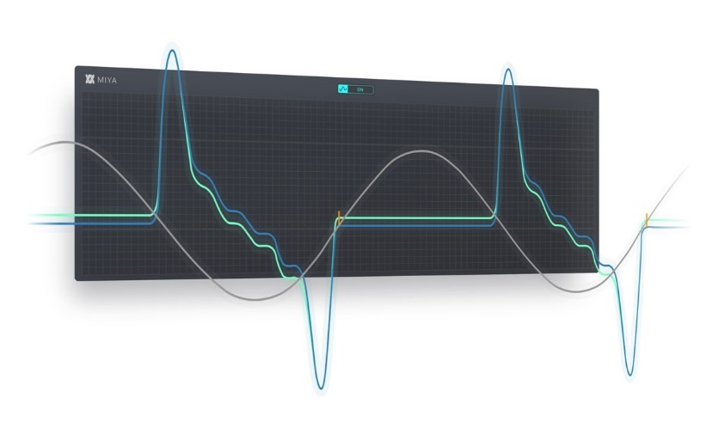 | MIYA's real-time visualizer

MIYA allows users to go from rich textures to gnarly glitches: In the Analyzer section, they can define the length of the wavelets and create unique resonances by discarding detected zero-crossings – the longer the wavelet, the lower the synthesized tone. The generated signal can be adjusted individually, with the five Harmonics sliders creating a variety of harmonics ranging from 1st to 5th.

The Harmonics sliders precisely set the harmonics and sub-harmonics of the additively synthesized signal | 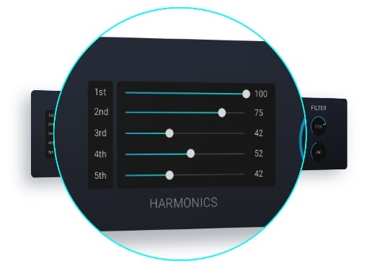

MIYA’s internal gate provides enhanced input signal control, allowing users to eliminate quieter sounds like background noise or to emphasize rhythmic aspects of the original signal. Furthermore, the signal generated by the additive synthesizer can be boosted based on the amplitude of the initially detected wavelet.

MIYA’s gate, boost, and filter section adjust the generated signal | 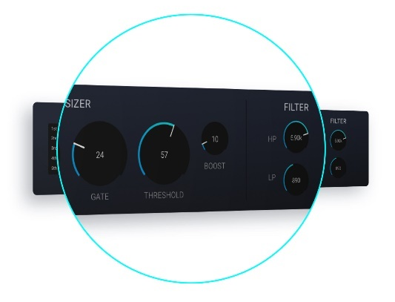

MIYA is available now in the Dear Reality store for USD 49 (+ local VAT).

(Ends)

The images accompanying this press release can be downloaded here.

About Dear Reality
Dear Reality is a leading company in the field of immersive audio controllers, best known for its binaural, Ambisonics, and multi-channel encoders with totally realistic room virtualization. The company's products are used worldwide by sound engineers, sound designers, broadcasters, and musicians. Founded in 2014 by Achim Fell and Christian Sander, Dear Reality strives to deliver high-quality, cutting-edge 3D audio software for interactive and linear audio production. Since 2019, Dear Reality has been proud to be a part of the Sennheiser Group.

Local Press Contact Global Press Contact
Kai Detlefsen
press@dear-reality.com

