EMBARGOED UNTIL 10AM EST / 3PM GMT:
January 16, 2018

JACK WHITE ANNOUNCES NORTH AMERICAN,
UK & EUROPEAN HEADLINE TOUR DATES
IN SUPPORT OF BOARDING HOUSE REACH
INCLUDES HEADLINE FESTIVAL PERFORMANCES
AT GOVERNORS BALL, SHAKY KNEES & BOSTON CALLING
TICKETS ON SALE JANUARY 26
NEW ALBUM BOARDING HOUSE REACH OUT MARCH 23
FIRST SINGLE "CONNECTED BY LOVE" AVAILABLE NOW

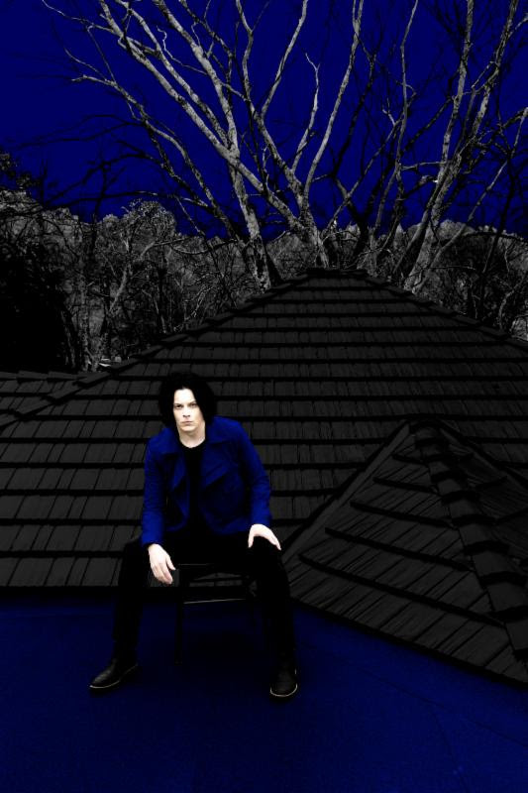
Photo credit: David James Swanson
[High Res images HERE]

Hot on the heels of announcing his new album BOARDING HOUSE REACH (out March 23 via Third Man/XL Recordings) and releasing the first single, "Connected by Love," Jack White has unveiled an extensive run of North American headline tour dates, along with shows in London, Paris, and Amsterdam. These dates, spanning from April to August, also include stops at the previously announced festivals -- Governors Ball, Shaky Knees, and Boston Calling. The full list of tour dates can be found below.

Tickets for the just-announced headline dates will go on sale to the general public on January 26 at 10am local time. Third Man Records Vault members will have access to the very first pre-sale starting on January 22 at 10am local time. Sign up for Vault Package #35 featuring the ONLY limited edition version of the album + to gain ticket pre-sale access FIRST here.
Fans will also have the opportunity to purchase tickets in advance of the public on sale during the Ticketmaster Verified Fan pre-sale to ensure tickets get directly into the hands of the fans. Registration for Ticketmaster Verified Fan is currently open and continues until January 19 at 11:59 PM ET. Verified Fan registration is available at http://jackwhite.tmverifiedfan.com/. For more information on all of the tour dates, visit http://jackwhiteiii.com.
Additionally, every online ticket purchased in North America for the new headline shows will include a physical copy of BOARDING HOUSE REACH on CD. Fans will also have the option to upgrade their CD to the standard black vinyl LP.
BOARDING HOUSE REACH sees Jack White expanding his musical palate with perhaps his most ambitious work thus far, a collection of songs that are simultaneously timeless and modern. Written and conceived while holed up in a spartan apartment with no outside distractions, White replicated the identical environment and used the same gear as when he was a 15 year old (a quarter-inch four-track tape recorder, a simple mixer, and the most basic of instrumentation) to pen sketches of the album’s songs. The album explores a remarkable range of sonic terrain -- crunching rock 'n' roll, electro and hard funk, proto punk, hip hop, gospel blues, and even country -- all remapped and born anew to fit White's matchless vision and sense of restless experimentation. BOARDING HOUSE REACH is a testament to the breadth of Jack White's creative power and his bold artistic ambition.
BOARDING HOUSE REACH is heralded by the rapidly acclaimed new single, "Connected By Love" b/w "Respect Commander," which is available now digitally worldwide and as a physical 7-inch vinyl single pressed at Third Man Pressing in Detroit, MI.
"Connected By Love" is accompanied by a brand-new music video from director Pasqual Gutierrez -- watch it now HERE. The single was greeted with rapturous global applause upon its arrival, with Billboard declaring the song "a classic White confessional blues burner," and Entertainment Weekly calling it "a searing, organ-lined plea to a former flame." NPR's Bob Boilen wrote, "it's a blend of old guitar blues that is simultaneously on the edge of rock's horizon." "The four-year wait is over," says Rolling Stone -- Jack is back with the "blistering first single" from BOARDING HOUSE REACH.

JACK WHITE 2018 TOUR DATES

April 19: Little Caesars Arena - Detroit, MI
April 20: Eagles Ballroom - Milwaukee, WI
April 21: 20 Monroe - Grand Rapids, MI
April 23: Baxter Arena - Omaha, NE
April 24: Providence Medical Center Amphitheater - Bonner Springs, KS
April 25: Chaifetz Arena - St. Louis, MO
April 27: Bomb Factory - Dallas, TX
April 29: Bomb Factory - Dallas, TX
April 30: Revention Music Center - Houston, TX
May 1: Revention Music Center - Houston, TX
May 2: Austin360 Amphitheater - Austin, TX
May 4 - 6: Shaky Knees Music Festival - Atlanta, GA *
May 25 - 27: Boston Calling Music Festival - Boston, MA *
May 27: Brewery Ommegang - Cooperstown, NY
May 29: The Anthem - Washington, DC
June 1 - 3: Governors Ball Music Festival - New York, NY *
June 4: Express Live! Outdoor Amphitheater - Columbus, OH
June 6: Jacobs Pavilion at Nautica - Cleveland, OH
June 7: Dome Arena - Rochester, NY
June 8: Artpark Mainstage Theater - Lewiston, NY
June 9: Budweiser Stage - Toronto, ON
June 27: London, UK - Hammersmith Apollo
June 28: London, UK - Hammersmith Apollo
July 2: AFAS Live - Amsterdam, NL
July 3: L'Olympia - Paris. FR
July 4: L'Olympia - Paris. FR
August 6: The Armory - Minneapolis, MN
August 8: 1st Bank Center - Broomfield, CO
August 9: SaltAir - Salt Lake City, UT
August 11: Veterans Memorial Coliseum - Portland, OR
August 12: Rogers Arena - Vancouver, BC
August 13: WAMU Theatre - Seattle, WA
August 15: Bill Graham Civic Auditorium - San Francisco, CA
August 19: Santa Barbara Bowl - Santa Barbara, CA
August 21: Viejas Arena - San Diego, CA
August 22: Comerica Theatre - Phoenix, AZ
August 23: The Chelsea @ The Cosmopolitan - Las Vegas, NV

BOARDING HOUSE REACH Standard Album Cover. High Res HERE

BOARDING HOUSE REACH TRACK LIST
1. Connected By Love
2. Why Walk A Dog?
3. Corporation
4. Abulia and Akrasia
5. Hypermisophoniac
6. Ice Station Zebra
7. Over and Over and Over
8. Everything You've Ever Learned
9. Respect Commander
10. Ezmerelda Steals The Show
11. Get In The Mind Shaft
12. What's Done Is Done
13. Humoresque

JackWhiteIII.com
ThirdManRecords.com

###

