4 – Developing Mojo Stories
By Ivo Burum

In 1993, while working in television, I taught select groups from our audiences to use small digital video (DV) cameras to tell their own personal stories for self-shot TV series.

In 2007, the advent of the iPhone was another game changer. It became apparent, at least to me, that mobile technology, like DV cameras, would redefine the way we produced TV, even the way we did investigative video journalism. It was a lightbulb moment.

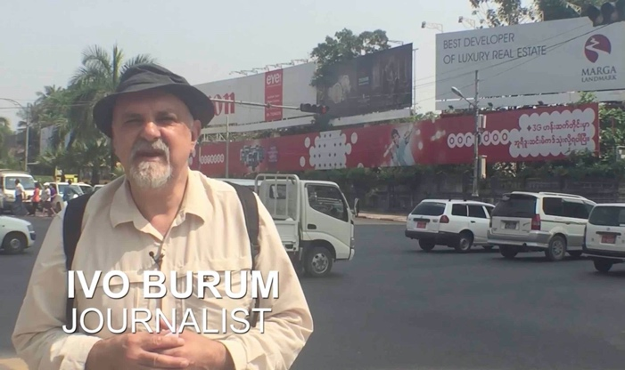 | Figure 1  The Author working as a mojo doing a piece to camera (PTC) in Yangon
By 2010, we were completing the whole production process, even the all-important edit, on the phone. This gave mojo stories their own diverse and unique voice.

This is especially critical in a world, “where the state, politicians and agenda-driven publishers try to muzzle media and free speech,” says Rana Sabbagh, MENA editor for OCCRP.

Nearly all types of video stories can be shot and edited using a smartphone. But working solo has drawbacks as well as advantages. Journalists might consider the following development and workflow points when working in the mobile story space.

The Story Focus
Story is everything, without it you’ll lose your audience and without that you may as well do something less demanding.

Philip Bromwell, a video journalist from Ireland’s RTÉ, who works in the mobile space, says: “My job requires me to tell stories, and we have to remember the audience doesn’t really care how content is created, but they will engage with a good story.” Bromwell’s focus on the audience and story, ahead of the technology, is important. “Although I can film and I can edit, my primary skill is as a storyteller,” he says. “I am certainly not a ‘techie’ and I am not as obsessed as others are with having the very latest piece of mojo gear.”

Having a story focus enables the mojo to choose the right gear. For example, shooting sport may require a hybrid DSLR and long lens kit to be able to shoot the required shots from a distance. Conversely, in war-torn Yemen, a small mojo kit can make a journalist less of a target.

So, how do you find the story? First, you need to follow your passion, then you decide if you have an audience for your idea, next you need to know who the good guys and bad guys are, understand their journey and have access to all the players.

Before you develop your idea choose a topic, know your market and ask the following:

- Who’s the audience? Why is the story being told, who’s watching, what is the demographic, what’s the political and the cultural imperative?
- What’s the angle? What’s the focus and how will this be best achieved creatively and editorially?
- What’s the style? Is it a current affairs form, a series of short stories, a long investigative exposé, and is it narration, or interviewee-driven?
- What’s the structure? What is the beginning, middle and end; who will speak when and what elements will be required to support the story structure?

As the concept gets more of a story focus, I complete a more specific SCRAP check list:

- Story: what is it and why is it being told?
- Characters: who is best to tell it and why?
- Resolution: what’s the structure and why?
- Actuality: what will be filmed, when and why?
- Production: where is it happening, what are the logistics and how will I produce it?

SCRAP helps answer journalism’s 5Ws — who, what, when, where, why and how. To better understand these relationships between your story and its audience, consider the following:

- Currency of the story.
- Significance of the story will be impacted by its Currency.
- Proximity of the story will impact Significance.
- Prominence of story talent can trump Proximity.
- Human interest can increase with Prominence.

A Character Focus
Mojo news stories may be breaking and unplanned, so it’s even more important to quickly determine a story focus and the best characters/interviewees to help tell the story. Knowing who to film is important when planning a mojo video production. Unlike print, you can’t just call everyone on the phone — mojos need pictures. For example, we can’t ring someone for a quick phone interview — they need to be on camera, so managing time and expectations is critical.

For example, who do I interview at the scene of an accident and, importantly, who do I interview first? Can I ask the ambulance driver for a comment while he is inserting an IV line into an injured person’s arm? If not, how do I cover this as B roll, so that I can ask my questions when the paramedic is free? What’s most relevant in a breaking story at a Bosnian war grave? More bodies, longer interviews with a witness, or the man with photographs of his missing family, who he believes are among the dead? Do I need it all? If so, how will I record it all and how will I include it all in a short video story? The best way to decide who’s relevant is to:

- Map your potential interviewees against your structural plan (see below) and your audience expectation.

Once you firm up interviewees, you might need to rejig your structure and how you will use your talent:

- Will the story begin with actuality from the interviewee or B roll with narration?
- When in the story will we hear from the main interviewee?
- Who will I use to tell the climax and how will I create and build to this?
- Who will I use to close the story?
- Do I have clearances?
- Do I have B roll to introduce my interviewees and cover their edited interview moments and my narration?

You can generally work the above out once you begin mapping your structure.

Ivo’s tip: If it’s a choice between a smart interviewee and an engaging one, choose the latter, if you can’t have both. You can always add the factual smarts using narration and B roll.

Structural Focus
Next, I create a simple five-point structural road map of how my story might go. This guide does three important things: (a) it articulates the various plot points and (b) acts as a story and character checklist and (c) is the beginning of my edit plan.

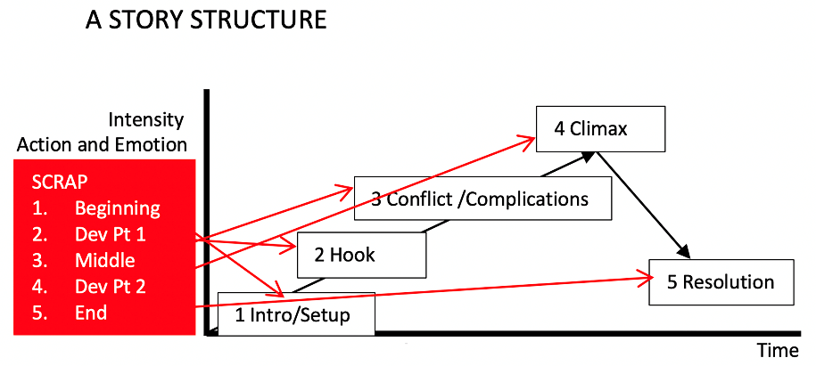 | Figure 2  Structural matrix  by Ivo Burum

Because real research happens on the ground, and because story changes, you need to understand your options and be prepared to shift your views on location. That’s where a simple structural plan helps. Rather than being prescriptive, a plan keeps the story focused and the mojo open to new ideas. A plan is also a checklist to help decide if everything is covered before wrapping location.

The Story Character Matrix
Story is built around an EVENT that impacts our CHARACTER. Through a CHARACTER’S eyes we witness action, strife, emotion, visual and dramatic development corralled in the place holder we call an EVENT.

Video works best when it’s centred around EVENTS (that provide currency), told through the eyes of a CHARACTER (that makes it real, personal and emotive), who RISKS losing everything (the stakes and the drama).

One of the mobile journalist’s jobs is to design a STRUCTURE around EVENTS that tell a STORY and give rise to certain EMOTIONS. In essence, what we as mojo’s do in telling STORY, is capture a CHARACTER’S emotive JOURNEY.

A story event creates change in a character that’s expressed in terms of value (impact) and often achieved through an attempt to overcome an obstacle (a conflict). As mobile journalists we need to look for that CHANGE, and in particular, the RISK experienced by our CHARACTER(s).

Ask: What does our character stand to lose if s/he does not get what they want?

Go mojo…

