
bettergamingagency.prowly.com

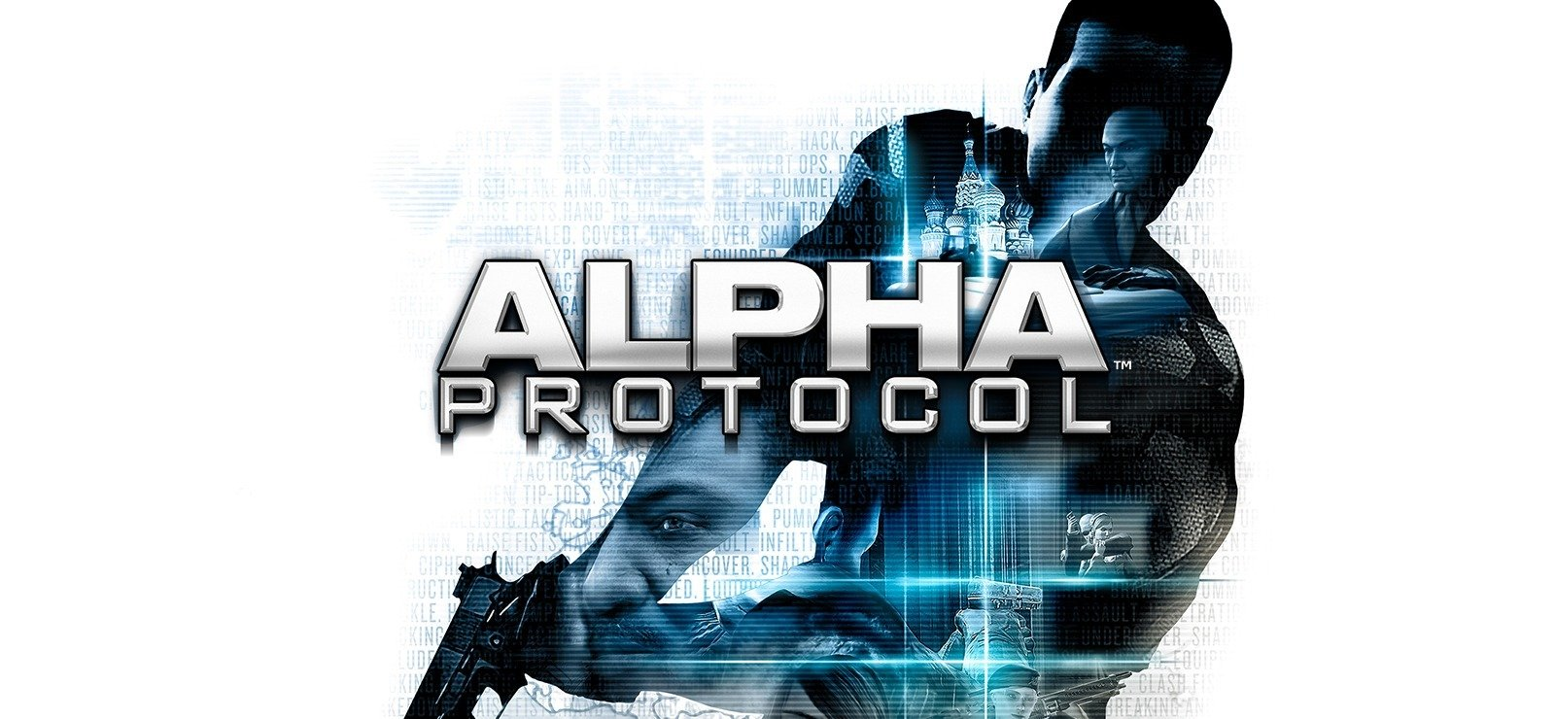

After years in IP limbo, Alpha Protocol is back! Check out Obsidian’s cult classic on GOG.com

Fourteen years after its initial release and following disappearance from digital storefronts, Alpha Protocol, an espionage RPG from the legendary Obsidian team, is now back for players to enjoy. The title is brought back on GOG.com, where both veterans and newcomers alike can infiltrate a world-threatening conspiracy.

Alpha Protocol is one of those classic games that seemed lost to modern audiences. The title was initially released in 2010 by Obsidian, the team behind Fallout: New Vegas or The Outer Worlds, but it has been taken down from digital storefronts for some time.

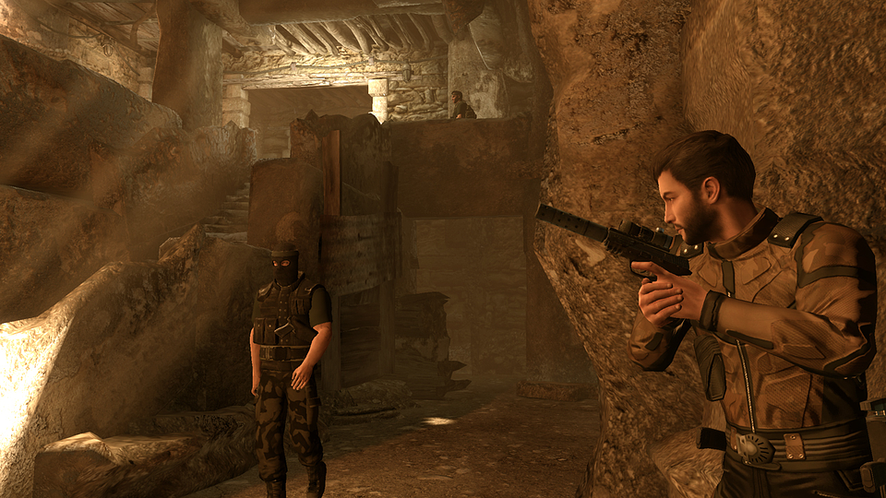

As Michael Thorton, a covert agent, players travel around the globe executing black ops operations to uncover a conspiracy that threatens the world. With RPG elements known from other games made by the studio, the protagonist will not only influence geopolitics but also his own character, making each playthrough unique and consequential.

GOG.com, as part of their ongoing mission to preserve classic titles for future generations, put a lot of effort into bringing this cult game back to life after years of being unavailable for modern audiences. Like all titles on the platform, the game comes DRM-free and packed with additional goodies and features for gamers to enjoy, such as:

● A licensed soundtrack
● Achievements support
● Full controller support (Dualsense, DualShock 4, Nintendo Switch Pro, Xbox Series, or Xbox One controller)
● Localization support
● Compatibility with modern operating systems
● Cloud saves support

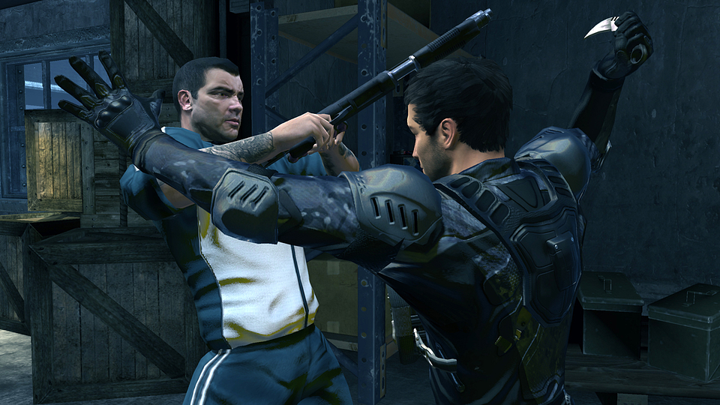

Alpha Protocol - key features:

●Advanced quest system: each mission players undertake may lead to different endings based on their actions, leading to 3 completely different finales
●Meaningful dialogue system: Michael can approach NPCs in different ways, influencing their attitude towards him and leading to various outcomes
●Class and perk system: being the legends of the RPG genre, Obsidian introduces 5 character classes to choose from. Combined with an extensive perk and ability system, the game puts heavy emphasis on RPG elements
●Action RPG at its finest: stealth or brute force? It’s your choice. All approaches are viable, and you can adapt the gameplay to your playstyle
●Travel around the world: with a global conspiracy leading to World War 3, you will have to visit various places to stop the evil plot—from Rome, Moscow, and Taipei, each pose unique challenges for your espionage skills

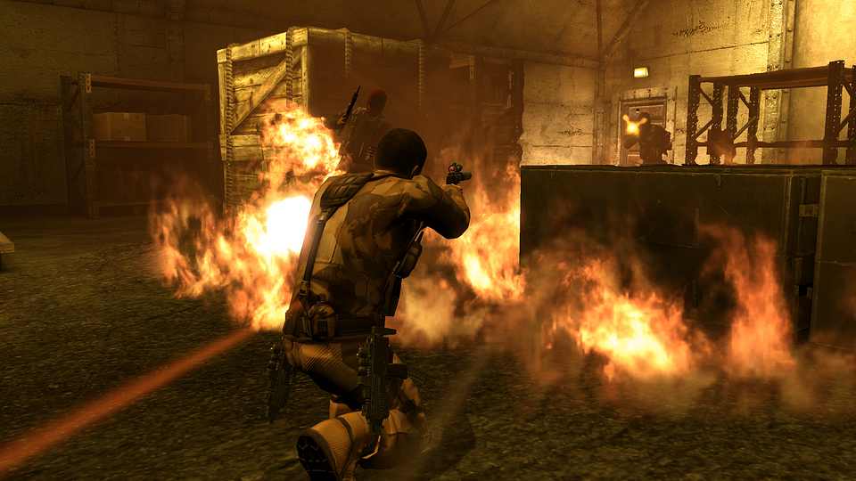

Alpha Protocol is already available on GOG.com. Here you can find a press kit.



Jakub Smolak
PR Specialist at better. gaming agency
jakub.smolak@bettergaming.pro
Twitter

